# **Intain Markets Documentation :- V6**

**Intain Markets Documentation :- V6 1**

1. Issuer: 5

1.1 Pool (Landing Page) 5

1.1.1 Setup Pool 6

1.1.2 View Pool Details 7

1.1.2.1 Mapped Loans : Accepted 8

1.1.2.2 Mapped Loans : Pending 9

1.1.2.3 Delete Loans 10

1.1.2.4 Mapped Loans : Reconsider 11

1.1.2.5 Accept the Rejection 12

1.1.2.6 Reject the Rejection 13

1.1.2.7 Add / View the feedback 14

1.1.2.8 Mapped Loans : LoanTape 15

1.1.2.8.1 As of date 16

1.1.2.9 Mapped Loans: Strat 17

1.1.2.10 Mapped Loans: Summary 18

1.1.3 Document 18

1.1.3.1 Add Document 19

1.1.3.2 Edit Document: 19

1.1.3.3 Delete Document: 20

1.1.4 Submit 21

1.1.4.1 Submit for Preview 21

1.1.4.2 Submit for Underwriter 22

1.2 Loans 24

1.2.1 Add Loans 25

1.2.1.1 Map Fields 25

1.2.2 Filter Option 26

1.2.2.1 Filtered Loans 27

1.2.3 Actions: 28

1.2.3.1 Map to Pool 28

1.2.3.2 Submit for verification 29

1.2.4 Delete Loans 30

1.3 Deals 31

1.3.1 If Securitization deal 32

1.3.2 If Whole loan deal 33

1.3.3 Approve the Issuance: 34

1.3.4 Publish 35

1.4 User Profile 36

1.4.1 Payment Setting 38

1.4.1.1 Off-Chain 38

1.4.1.2 On-chain 39

1.4.2 View Profile 39

1.4.2.1 Dark and Light 40

1.5 Pool delete 41

2. UnderWriter: 42

2.1 Preview - Pools 42

2.1.1 View Preview Pool Details: 43

2.1.1.1 Download Document 45

2.1.1.2 Reject Loan 45

2.1.1.3 Submit to Investors 46

2.2 Pool 47

2.1.1 If Securitization pools, 48

2.2.1.1 Accept 48

2.2.1.2 Reject 49

2.1.2 If Whole Loan pool, 50

2.1.3 View Pool Details: 51

2.3 Deals 53

2.3.1 View Deal Details 54

2.3.1.1 If Securitization Deal: 54

2.3.1.1.1 view tranches 55

2.3.1.2 If Whole Loan deal 56

2.3.2 Tools 57

2.3.2.1 If Securitization Deal: 57

2.3.2.1.1 General 58

2.3.2.1.2 Tranches 59

2.3.2.1.3 Fees 60

2.3.2.1.4 Expenses 61

2.3.2.1.5 Account 61

2.3.2.1.6 Tests 63

2.3.2.1.7 Variable 64

2.3.2.1.8 Payment Rules 65

2.3.2.1.9 Files 66

2.3.2.2 If Whole Loan deal: 66

2.3.2.2.1 General 67

2.3.2.2.2 Files 68

2.3.2.2.2.1 Publish Deal to Issuer 69

2.3.3 More 70

2.3.2.1 Account and Transaction Details 70

2.3.2.2 Add Account 71

2.3.2.3 Edit Account 72

2.3.2.4 Delete Account 74

2.3.2.5 Add Transaction 74

2.3.2.6 Edit Transaction 76

2.3.2.7 Delete Transaction 77

2.3.2.8 General Settings 77

3. Rating Agency 79

3.1 Preview - Pools 79

3.1.1 View Preview Pool Details: 80

3.2 Pool 81

3.3 Deal 82

3.3.1 View Deals Details 82

4. Investor: 83

4.1 Preview Pools 83

4.1.1 View Preview Pool Details 84

4.2 Portfolio 85

4.2.1 Chart View 86

4.2.2 Investor Report 87

4.2.2.1 View Report 88

4.2.3 Deal Analytics 89

4.3 Opportunities 90

4.3.1 View Securitization Deal Details 90

4.3 1.1 Commit 91

4.3.1.2 Invest 92

4.3.2 View Whole Loan Deal: 94

4.3.2.1 Commit 94

5. Servicer: 95

5.1 Deals 95

5.1.1 If Securitization Deal 95

5.1.1.1 Process Loan Tape: 96

5.1.1.2 Preview Loantape 97

5.1.1.3 Map Fields 98

5.1.1.4 Preview Map Fields 99

5.1.1.5 Summarize 100

6. Paying Agent 101

6.1 View Securitization Deal Details 102

6.1.1 Issue FT 103

6.2 View Whole Loan Deal details 104

6.2.1 Issue NFT 105

6.3 Loans 106

6.3.1 View Aggregate Summary 106

6.4 Deal Recurring 107

6.5 Deal Creation 108

6.5.1 Reporting 110

7. Verification agent 110

7.1 Batch 110

7.1.1.Accept 111

7.1.2 Reject 112

7.1.3 View Loans 113

7.1.3.1 Review 114

7.1.3.2 Certify 115

7.1.4 Verify 116

8. Registration: 117

8.1 Sign In 117

8.2 Sign up 118

8.2.1 Create Account (⅓) :- User Role 119

8.2.2 Create Account(⅔) - Personal Information 120

8.2.3 Create Account(3/3) - Organizational Details (All Users except Underwriter) 121

8.2.3 Create Account(3/3) - Organizational Details (Underwriter) 122

8.2.4 Terms and Conditions 123

8.2.4.1 Welcome page 123

8.2.4.2 Attestations 124

8.2.4.2 Type Of Investor 125

8.2.4.2.1 Qualified Institutional buyer 126

8.2.4.2.2 Accredited Investor 127

8.2.4.3 Default Popup 128

**9. OverAll Flow 129**

9.1. Preview Flow 129

9.2.Verification Flow 130

9.3.Securitization Flow 130

9.4.Whole Loan flow 133

**10. Status 134**

10.1. Pool Status 134

10.2.Deal Status 134

10.3.Loan Status 135

10.4.Loan Verified and Batch Status 135

# 1. Issuer:

## 1.1 Pool (Landing Page)

**Purpose:**

The Pool Landing Page is the main dashboard where issuers can manage all their pools easily. It gives a clear view of all pools and lets users quickly do important tasks like creating new pools, checking pool details, managing loans and deals, and updating user profiles. This page helps make pool management simple and shows the issuer’s current activities.

* Welcome to the Issuer Dashboard, where you can easily view and manage all your created pools.
* There are two types of transactions: **Whole** **Loan** and **Securitization**. You can add and remove loans as needed. After uploading, loans move to the preview stage for review. Once reviewed, they are submitted to the Underwriter for final approval.

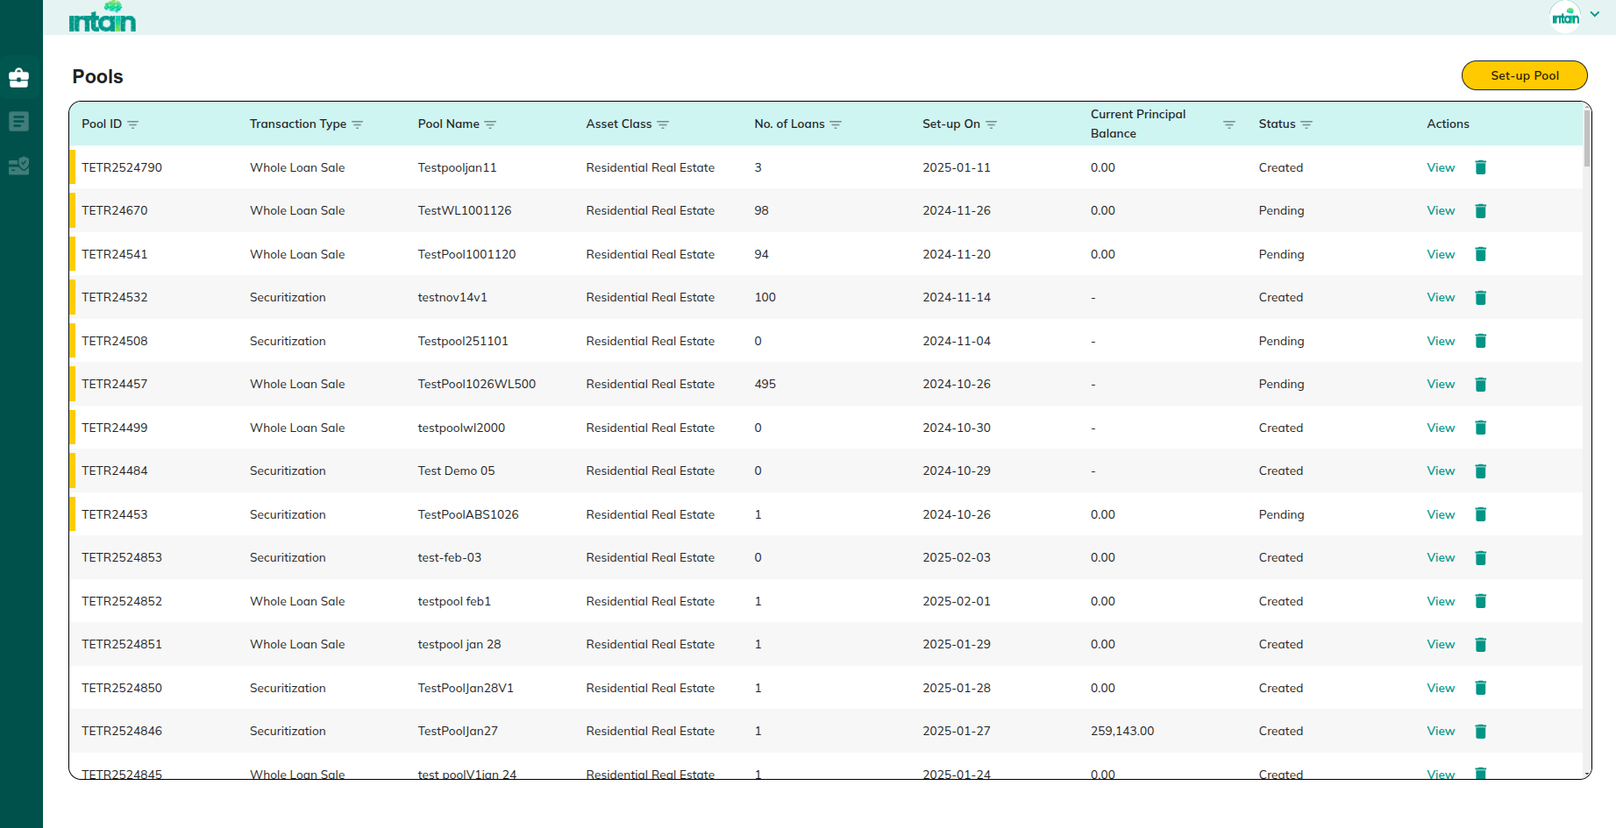

**Actions:**

* **Setup Pool**

Redirect to 1.1.1 Setup Pool

* **View Details**

Redirect to 1.1.2 View Pool Details

* **Loans**

Redirect to 1.2 Loans

* **Deals**

Redirect to 1.3 Deals

* **User Profile**

Redirect to 1.4 User Profile

* **Pool delete**

Redirect to 1.4.3 Pool delete

#### 1.1.1 Setup Pool

**Purpose:**This screen allows issuers to create a new pool by entering key details such as the pool name, asset class, transaction type, and a brief description. The purpose of this screen is to ensure all required information is collected in a structured manner before a pool is set up, maintaining data accuracy and consistency.

After clicking the **'Set Up Pool'** button, a table opens where you need to enter the required details:

* **Pool Name**
* **Asset Class**
* **Transaction Type**
* **Description**

Once all details are filled in, click the **'Set-Up'** button to create the pool.

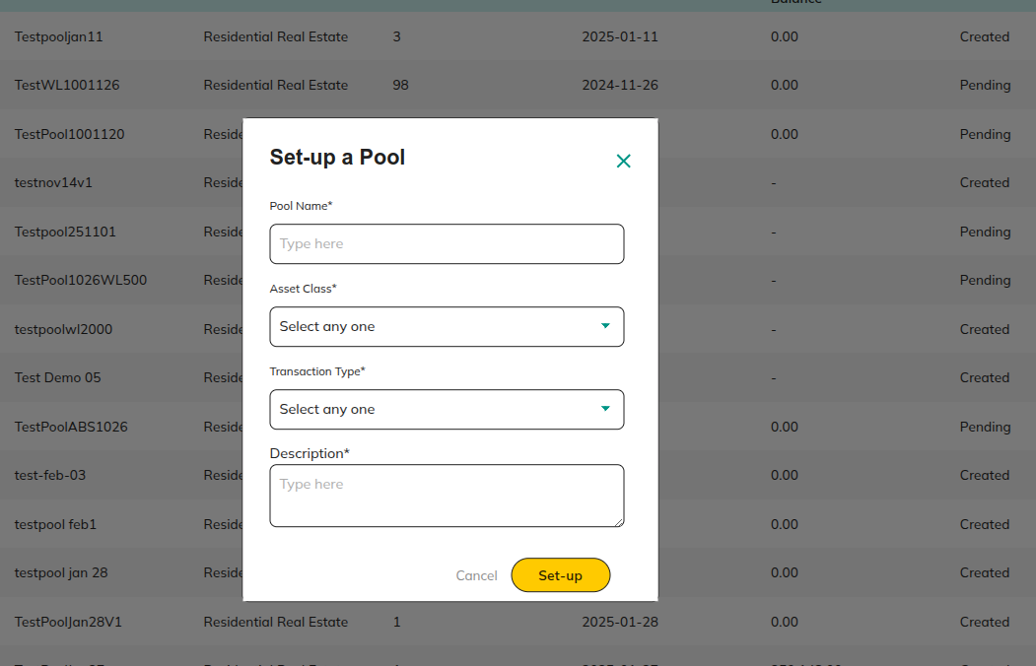

**Actions:**

* **Cancel**

Redirect to 1.1 Pool (Landing Page)

* **Set-up**

Redirect to 1.1 Pool (Landing Page)

### 1.1.2 View Pool Details

**Purpose:**

This screen provides detailed information about a selected pool, including its structure, associated loans, uploaded documents, and the current status in the workflow. The primary purpose is to give issuers a comprehensive overview of each pool’s specifics, allowing them to review, edit, and submit the pool for further stages like preview or underwriting.

Details related to Pool, Loan Tape, and Uploaded Documents will be displayed for your reference.

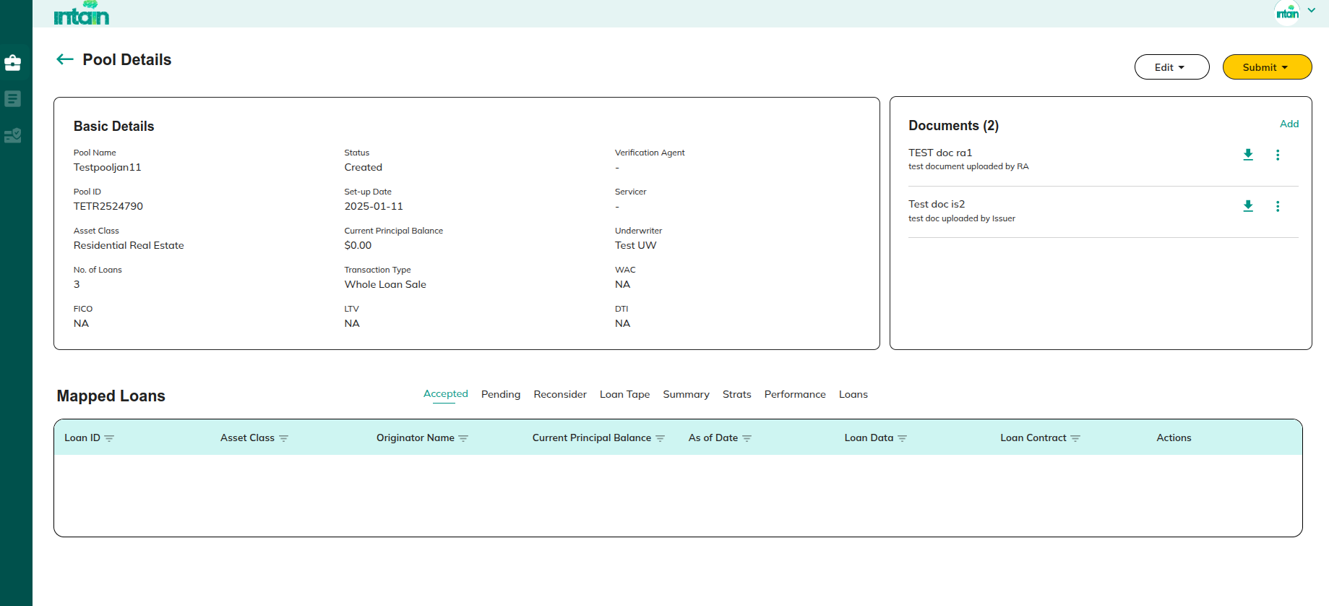

**Actions:**

* **Edit** 
  + **Pool Details**

Based on Preview / verification pool stage , page will be directed to either 1.1.2.5.1 Submit for Preview or *1**.1.2.5.2 Submit for Underwriter*

* **Submit**
  + **Submit for Preview**

Redirect to 1.1.2.5.1 Submit for Preview

* + **Submit for Underwriter**

Redirect to 1.1.2.5.2 Submit for Underwriter

* **Add Document**
  + Redirect to 1.1.2.4.1 Add Document
  + Redirect to 1.1.2.4.2 Edit Document
  + Redirect to 1.1.2.4.2 Delete Document:
* **Mapped Loans**
  + Redirect to 1.1.2.1 Mapped Loans : Accepted

##### 1.1.2.1 Mapped Loans : Accepted

**Purpose:**

This screen displays a list of loans that have been successfully verified and accepted by the verification agent. Its purpose is to provide issuers with a clear view of all loans that are confirmed as valid and are officially part of the pool.

Details related to **Loans** that have been verified and accepted by the **Verification Agent** will be displayed in the **Accepted** section

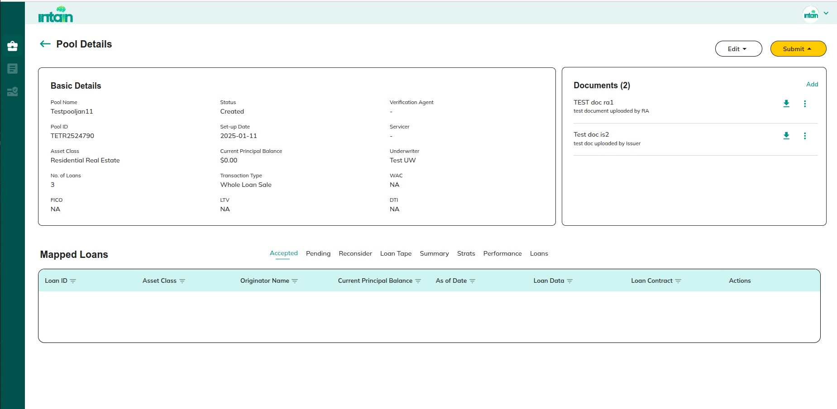

##### 1.1.2.2 Mapped Loans : Pending

**Purpose:**

This screen lists loans that are currently under review during the pool preview stage. It helps issuers track the status of these loans, identify which ones require additional attention, and ensure that all loans are reviewed before submission for final approval.

Details of the **Uploaded Loan Tape** will be available in the **Pending** section during the **Pool Preview Stage** for easy tracking and review.

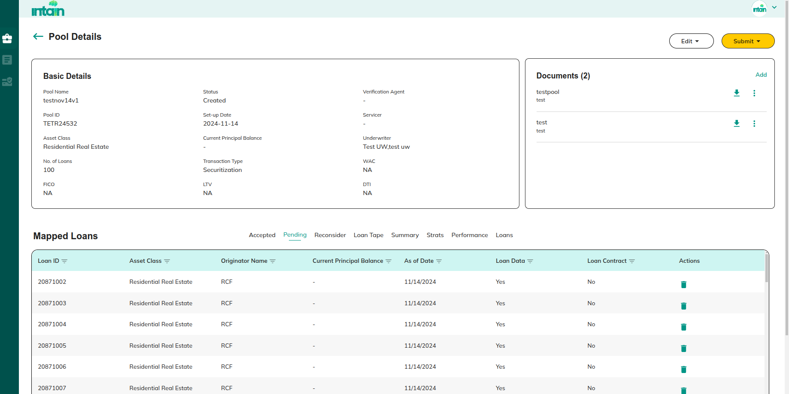

**Actions:**

* **Delete**

Redirect to 1.1.2.2 Delete Loans

##### 1.1.2.3 Delete Loans

**Purpose:**

This screen allows issuers to confirm the removal of a loan from the pool. Once accepted, the loan will be unmapped or deleted from the current pool.

Once you accept this, the loan will be unmapped or removed from this pool.

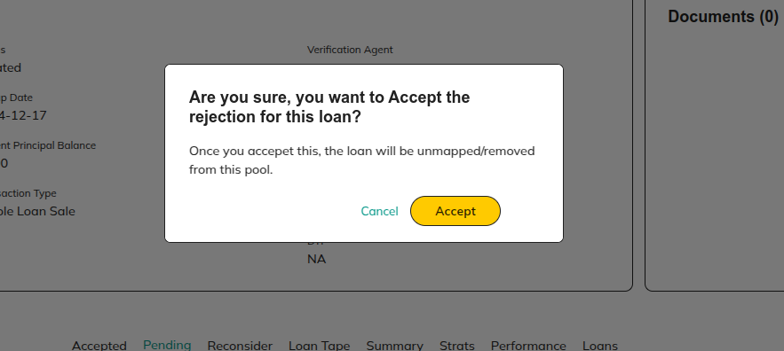

**Actions:**

* **Accept**

Redirect to 1.1.2 View Pool Details

* **Cancel**

Redirect to 1.1.2 View Pool Details

##### 1.1.2.4 Mapped Loans : Reconsider

**Purpose:**This screen lists loans that were rejected by underwriters during the pool preview stage. It allows issuers to review these rejections, make updates if needed, and decide whether to accept or reject the underwriter’s decision.

During the **Pool Preview Stage**, loans that have been **rejected by underwriters** will be displayed in the **Reconsider** section for further review and potential updates.

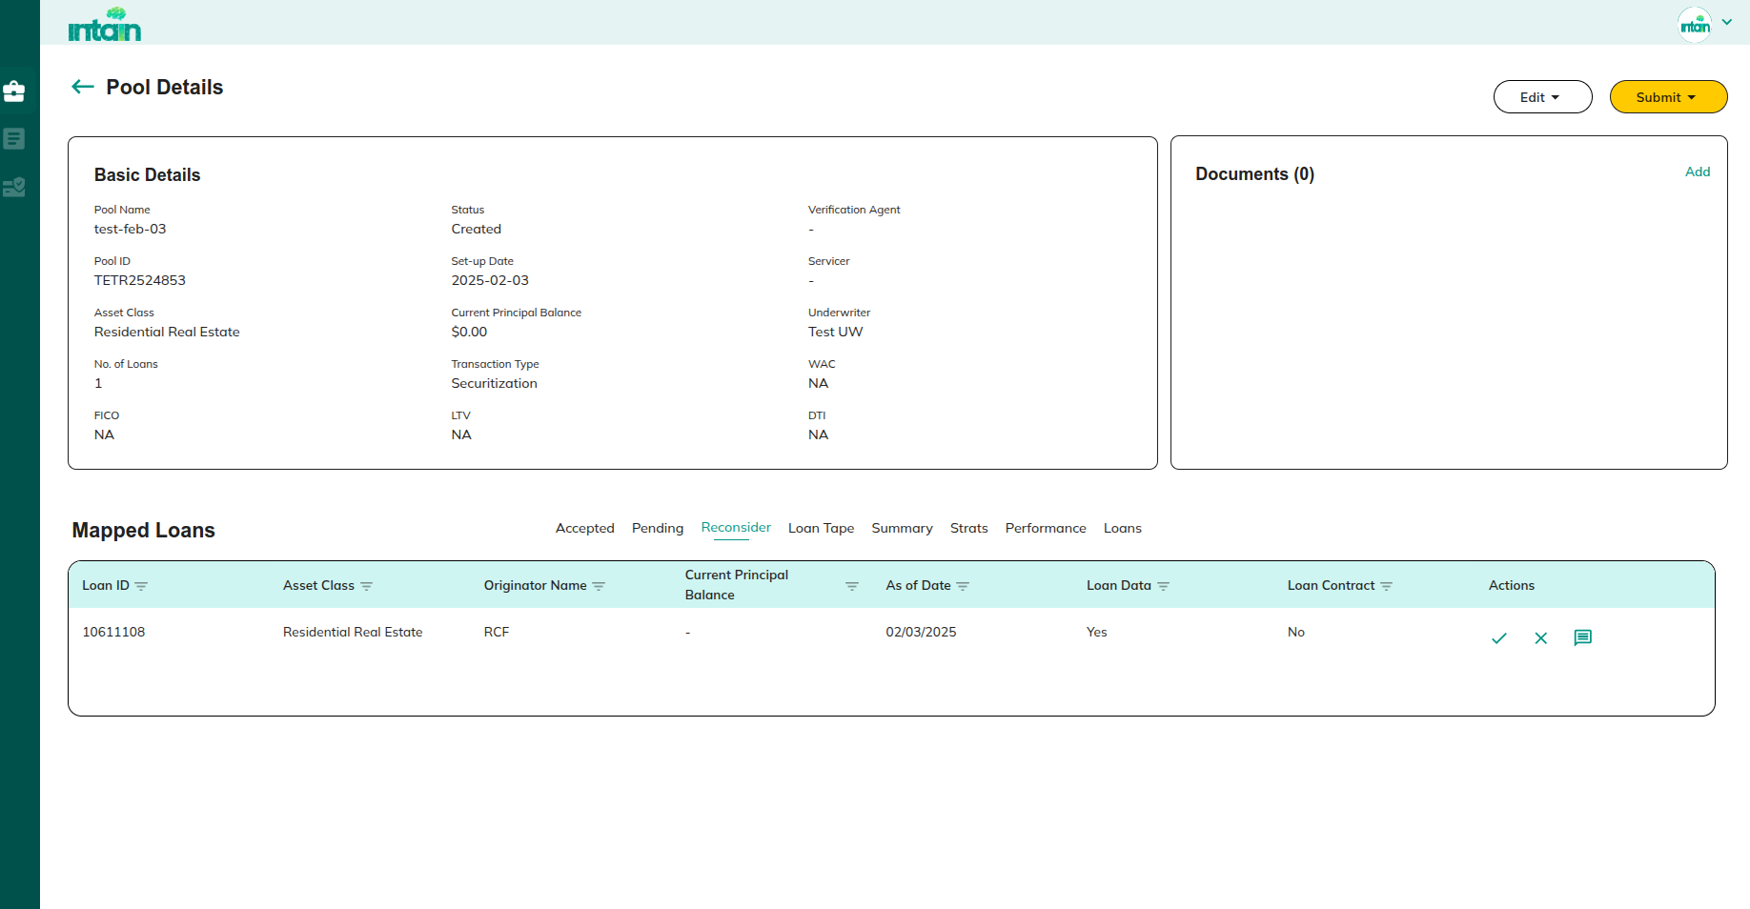

**Actions:**

* **Accept**

Redirect to 1.1.2.3.1 Accept the Rejection

* **Reject**

Redirect to 1.1.2.3.2 Reject the Rejection

* **Feedback**

Redirect to 1.1.2.3.3 Add / View the feedback

##### 1.1.2.5 Accept the Rejection

**Purpose:**

This screen lets issuers confirm and finalize the underwriter’s request to reject a loan. Accepting this means the loan will be officially removed from the pool.

Clicking on **Accept** will confirm and finalize the **rejection request** submitted by the underwriter.

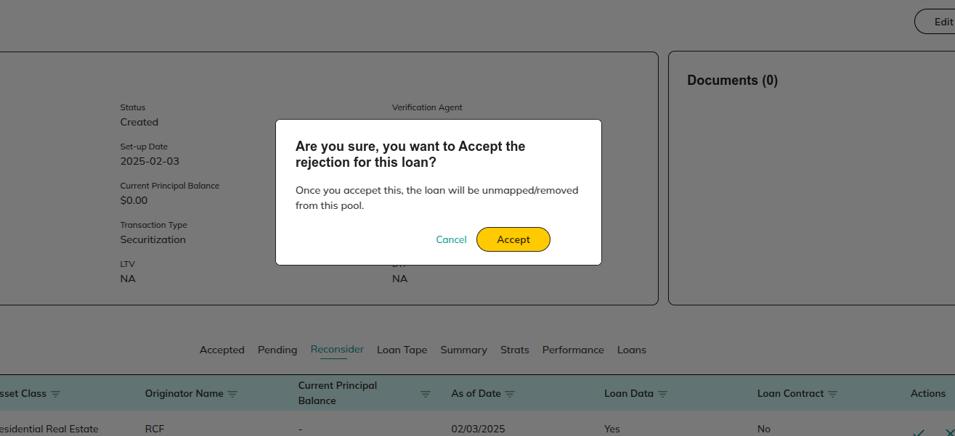

**Actions:**

* **Cancel**

Redirect to 1.1.2 View Pool Details

* **Accept**

Redirect to 1.1.2 View Pool Details

##### 1.1.2.6 Reject the Rejection

**Purpose:**This screen allows issuers to reject the underwriter’s suggestion to remove a loan from the pool. Declining the rejection keeps the loan mapped to the pool.

Clicking on the **Reject** icon will decline the **suggestion to remove the loans** made by the underwriter.

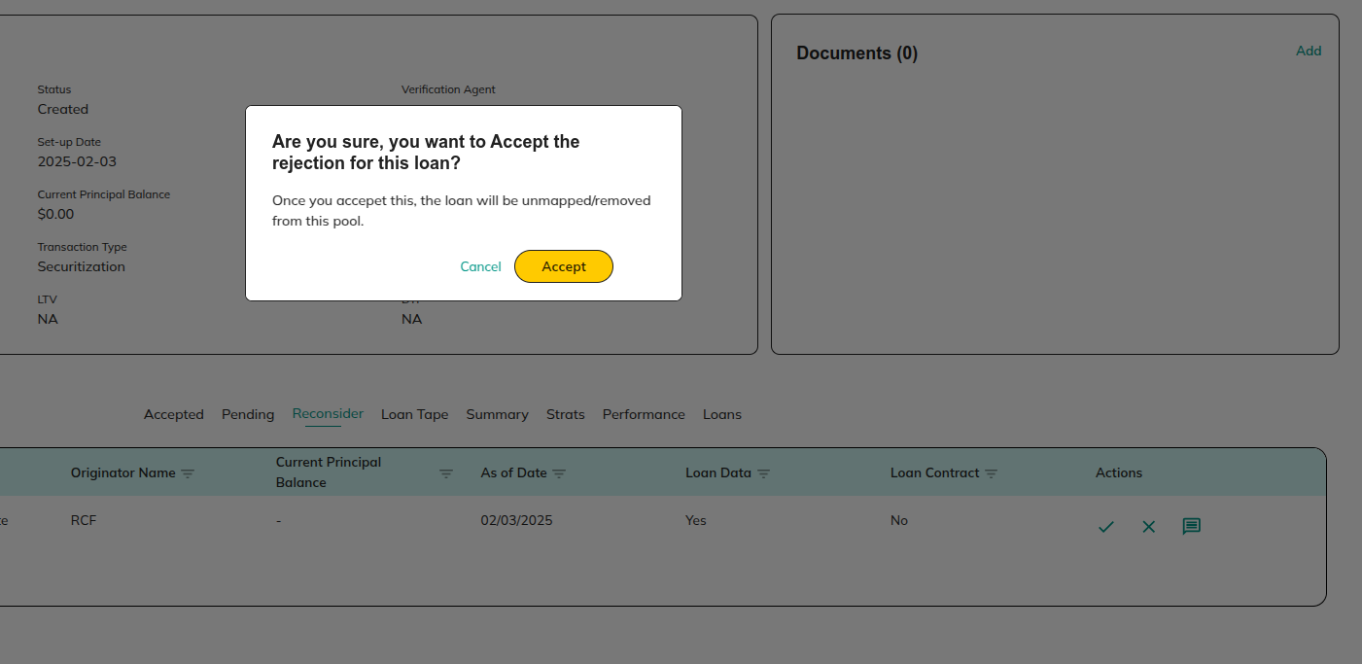

**Actions:**

* **Cancel**

Redirect to 1.1.2 View Pool Details

* **Accept**

Redirect to 1.1.2 View Pool Details

##### 1.1.2.7 Add / View the feedback

**Purpose:**

This screen enables issuers to view all feedback related to a loan and add new feedback. It improves communication between issuers and underwriters, helping track the reasoning behind decisions and actions taken on specific loans.

Using the **Feedback** icon, you can **view all the feedback** added for the loan as well as **add new feedback** for better communication and record-keeping.

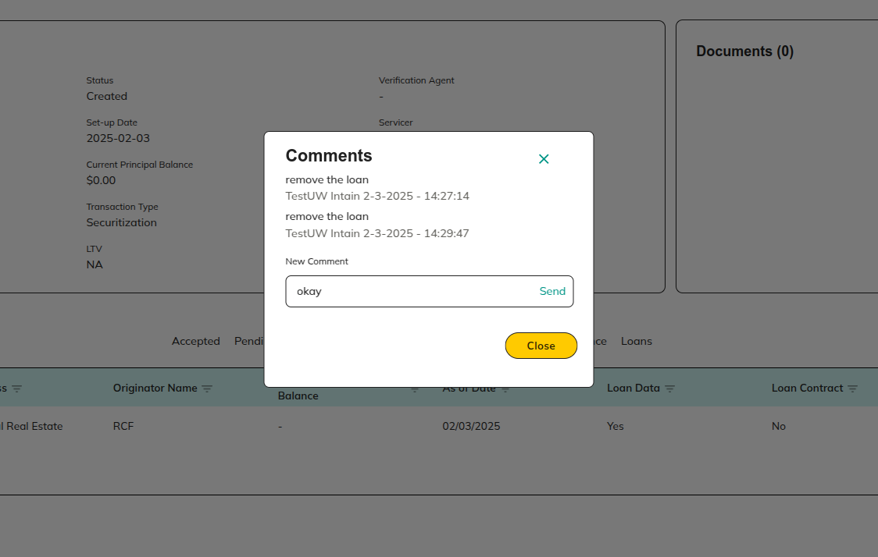

**Actions:**

* **Send**

Redirect to 1.1.2 View Pool Details

* **Close**

Redirect to 1.1.2 View Pool Details

##### 1.1.2.8 Mapped Loans : LoanTape

**Purpose:**

This screen displays the details of the uploaded Loan Tape for easy reference and review. It helps issuers verify loan data and ensure accuracy before moving to the next stages.

Uploaded **LoanTape** details are displayed in the **LoanTape** section for easy reference and review.

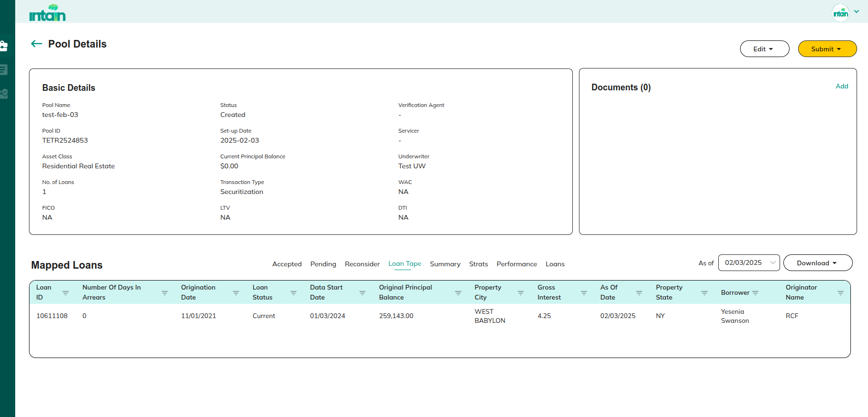

**Actions:**

* **Download:** Clicking on **Download** will allow the file to be downloaded to the user's local device.
* **As of date**

Redirect to 1.1.2.4 .1 As of date

###### 1.1.2.8.1 As of date

**Purpose:**This screen allows issuers to filter loan tape data based on a specific date. It helps in analyzing loan information as of a particular date.

* Based on the date we can FIlter the loan tape.

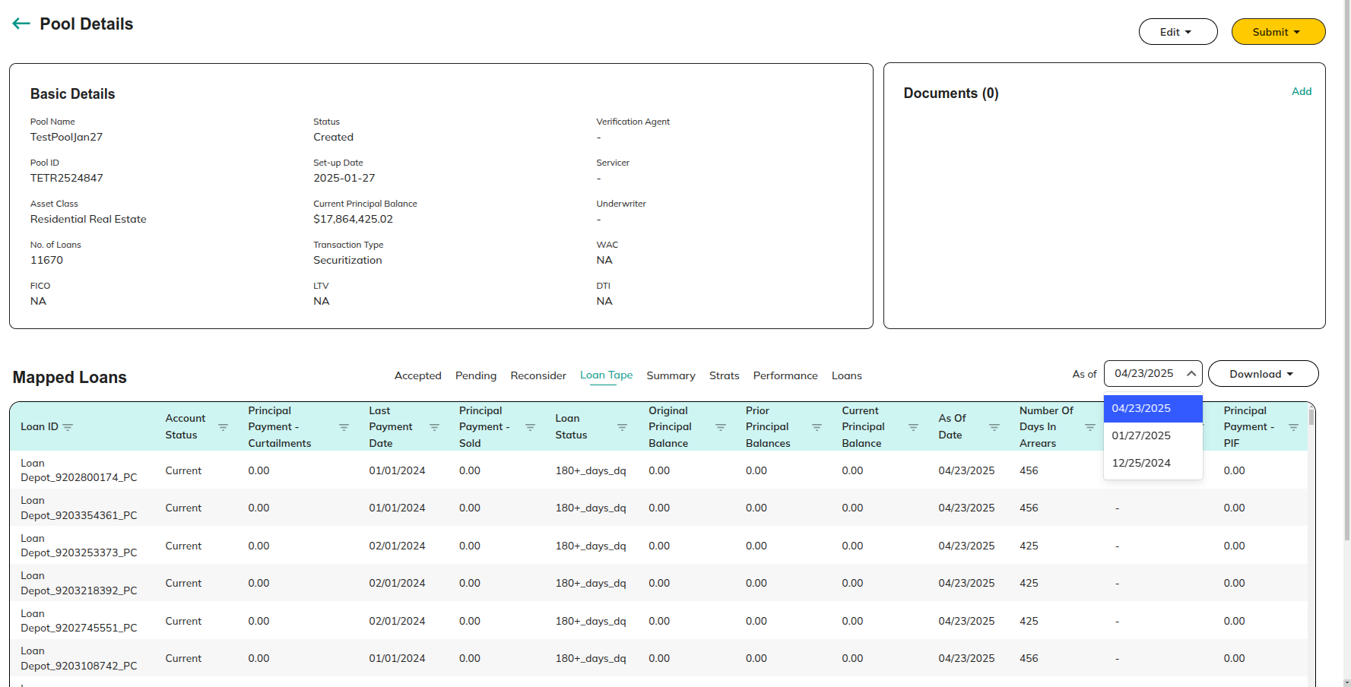

**Actions:**

* **Download:** Clicking on **Download** will allow the file to be downloaded to the user's local device.

##### 1.1.2.9 Mapped Loans: Strat

**Purpose:**

An **analytical section** where **data visualization** of the uploaded **Loan Tape** is provided for comprehensive analysis.

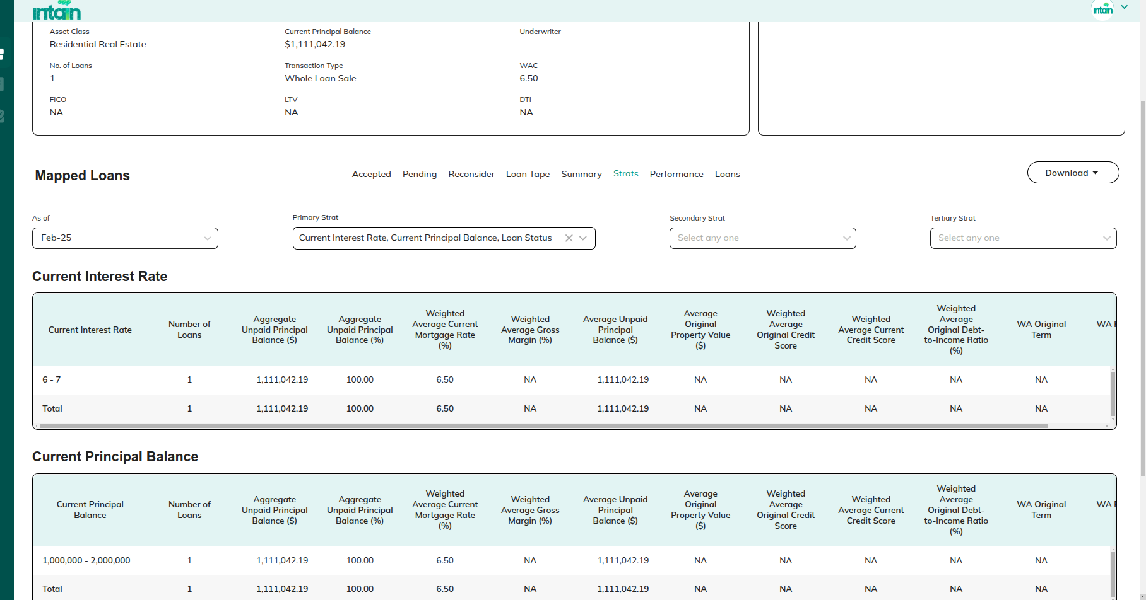

##### 1.1.2.10 Mapped Loans: Summary

**Purpose:**

An **analytical section** that offers a **summary visualization** of the uploaded **Loan Tape** to highlight key insights.

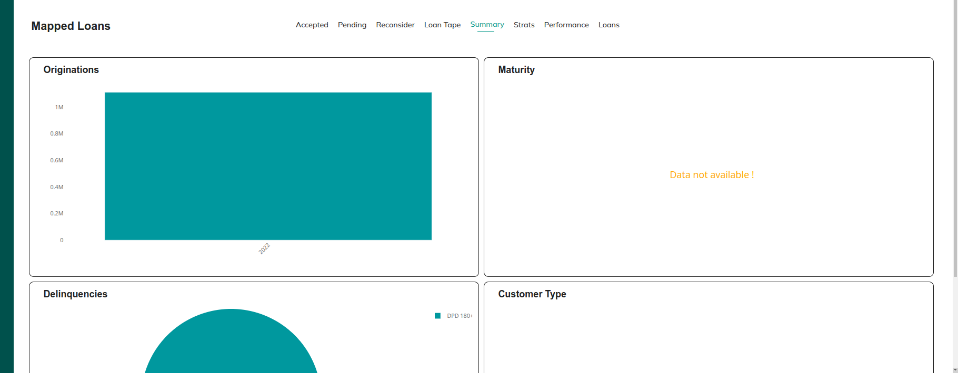

### 1.1.3 Document

**Purpose:**

Pool-related documents can be uploaded using the Document section. Here, you can also edit and delete documents.

###### **1.1.3.1 Add Document**

**Purpose:**

Use this section to **upload pool-related documents** for record-keeping and verification.

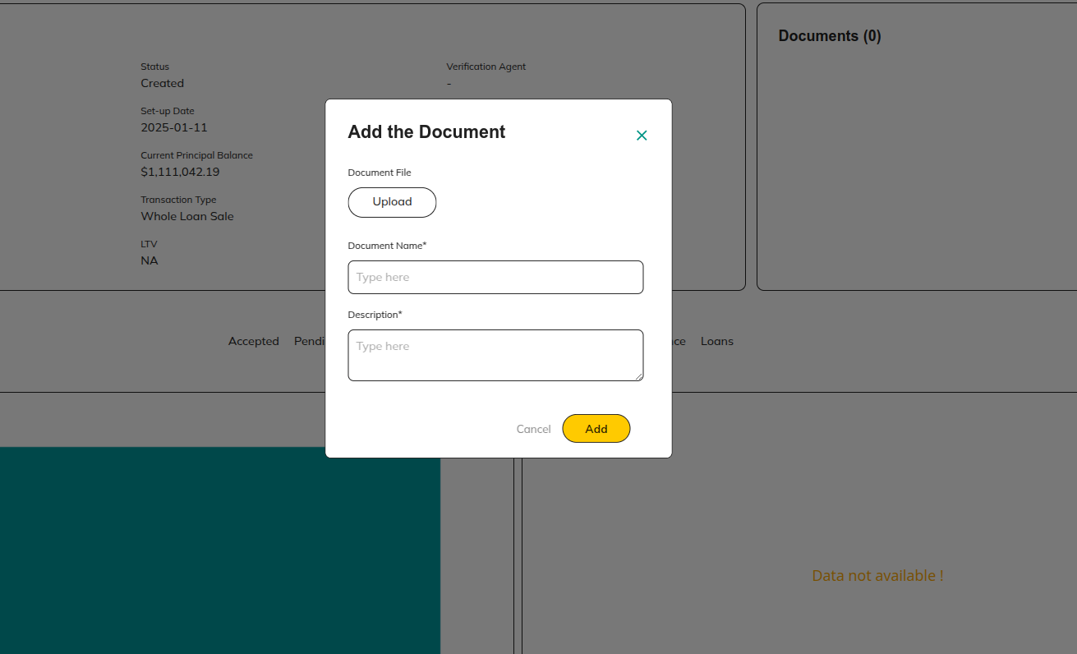

**Actions:**

* **Add**

Redirect to 1.1.2 View Pool Details

* **Cancel**

Redirect to 1.1.2 View Pool Details

###### **1.1.3.2 Edit Document:**

**Purpose:**

This screen allows users to update or modify the details of previously uploaded documents. It ensures that any errors can be corrected and that documents remain current and accurate.

Previously **uploaded document details** can be **edited** using this section.

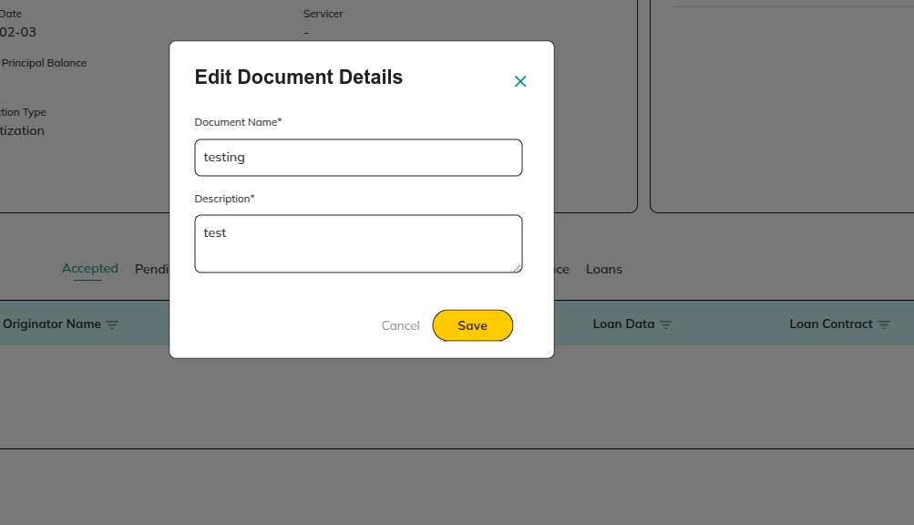

.

**Actions:**

* **Save**

Redirect to 1.1.2 View Pool Details

* **Cancel**

Redirect to 1.1.2 View Pool Details

###### **1.1.3.3 Delete Document:**

**Purpose:**

This section enables issuers to delete previously uploaded documents that are no longer needed or contain incorrect information. It helps keep the document repository clean and relevant.

Previously **uploaded document details** can be **Delete** using this section.

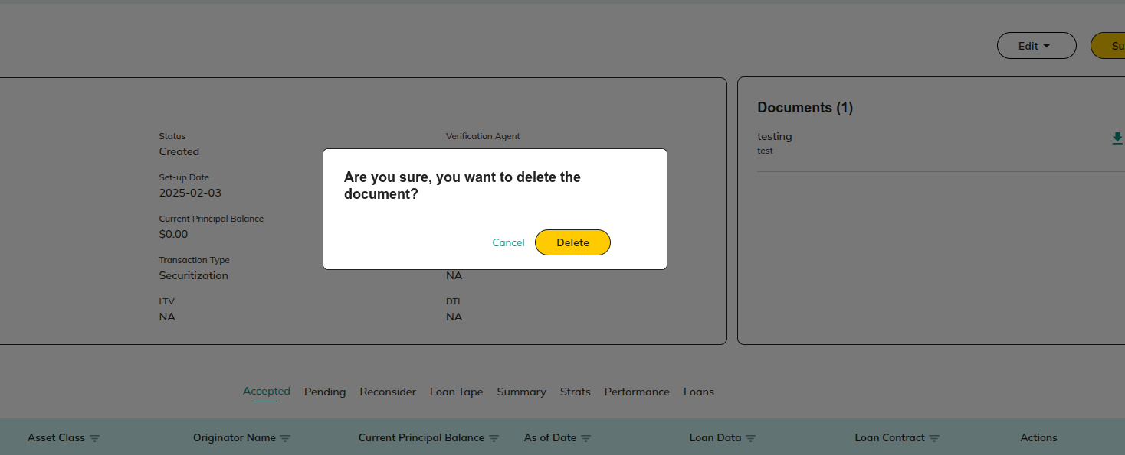

* **Delete**

Redirect to 1.1.2 View Pool Details

* **Cancel**

Redirect to 1.1.2 View Pool Details

### 1.1.4 Submit

**Purpose:**

This section handles the submission process of the created pool, either for preview or final underwriting approval. It ensures that the pool follows the correct workflow, moving from review stages to final approval.

##### 1.1.4.1 Submit for Preview

**Purpose:**

This screen allows issuers to submit the created pool for an initial review by assigned users, including the Underwriter, Investor, and Rating Agency. The goal is to collect feedback on individual loans and the overall pool before final submission.

The **Submit for Preview** page allows the **Issuer** to submit the created pool to the **Underwriter**, **Investor**, and **Rating Agency**. Assigned users can preview the pool and provide feedback for individual loans.

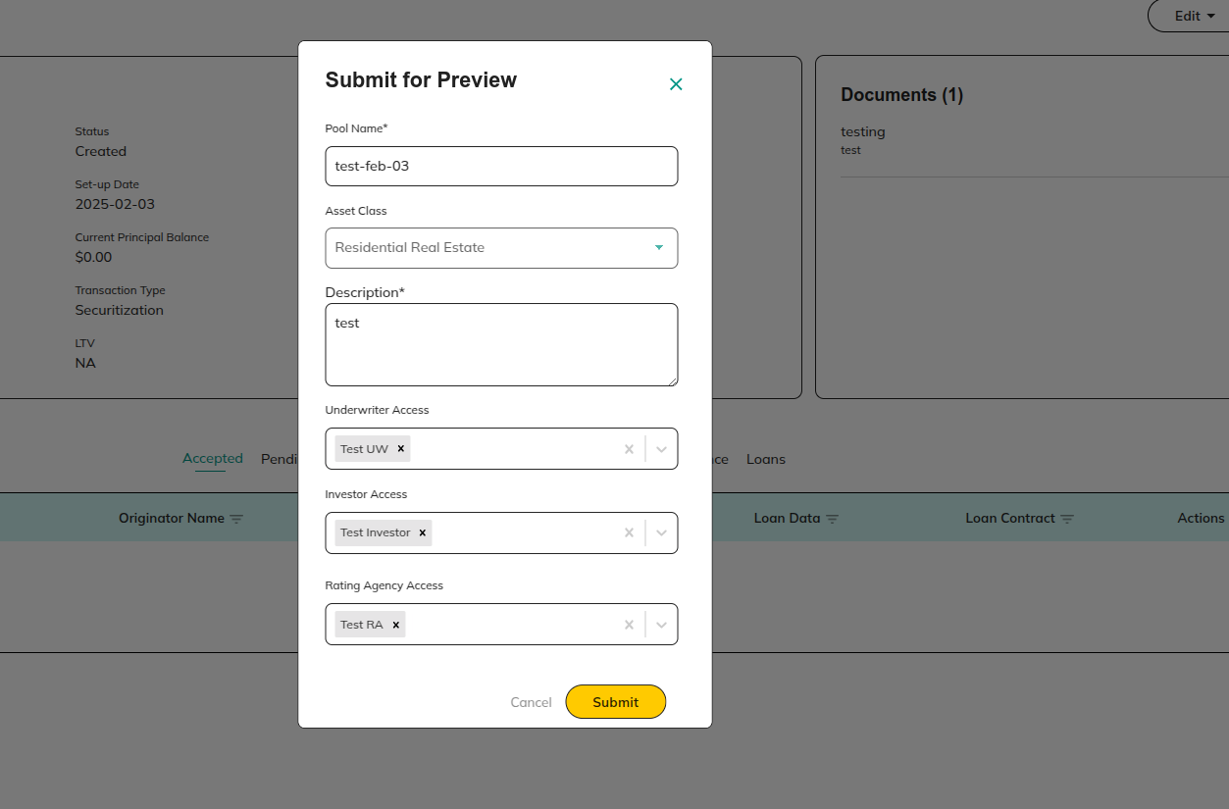

**Actions:**

* **Cancel**

Redirect to 1.1.2 View Pool Details

* **Submit**

Redirect to 1.1.2 View Pool Details

##### 1.1.4.2 Submit for Underwriter

**Purpose:**

This screen is used to submit the pool for final review and approval by the Underwriter. Once submitted, the pool transitions from the preview stage to the underwriting stage, where detailed assessments are performed through the Standard Underwriting (UW) Platform.

Submitting the pool will transition it from the **Preview Stage** to the Underwriter. At this stage, **Pool** and **Loan** details will be shared with the **Standard UW Platform**.

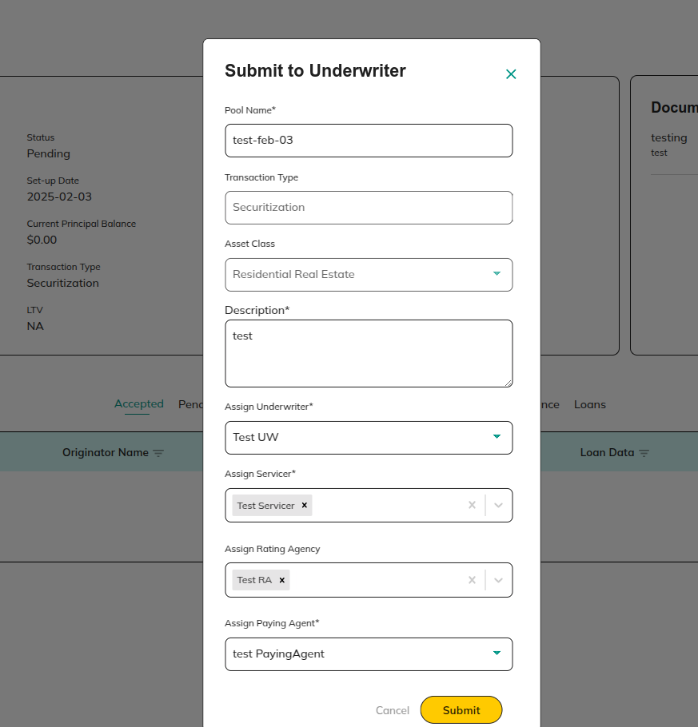

**Actions:**

* **Cancel**

Redirect to 1.1.2 View Pool Details

* **Submit**

Redirect to 1.1.2 View Pool Details

## 1.2 Loans

**Purpose:**This screen displays all onboarded loan details, providing issuers with a centralized location to view, manage, and perform actions on their loans. It helps issuers track loan status, add new loans, delete existing ones, filter data for easy navigation, and map or verify loans as needed.

Onboarded loan details are displayed in the **Loans** section.

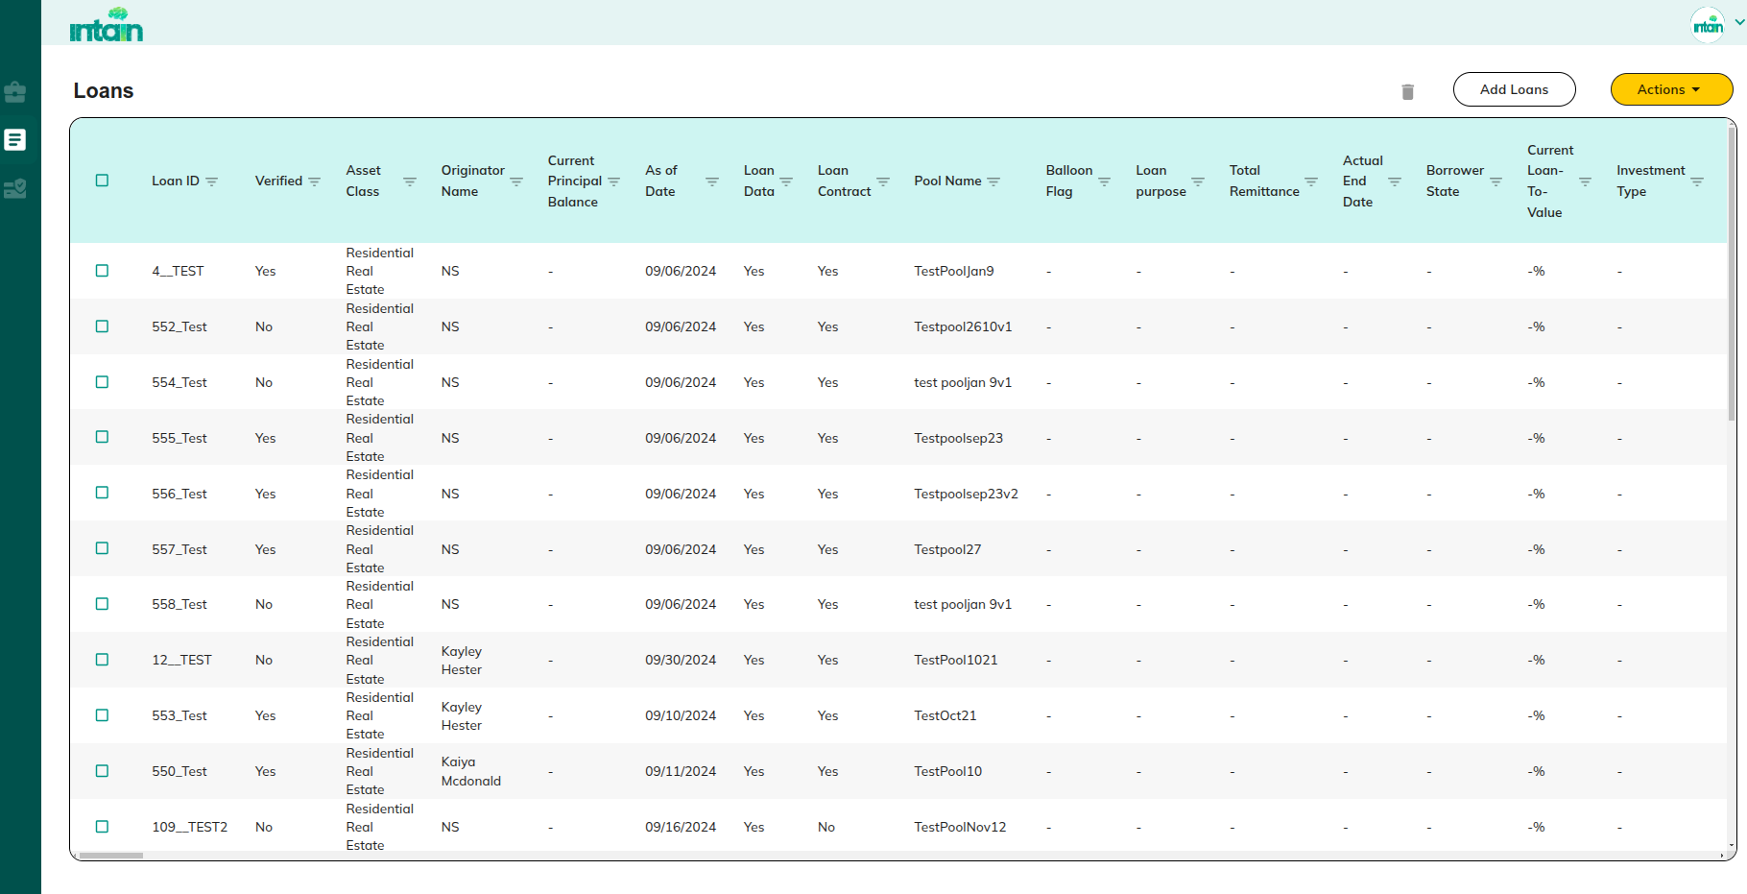

**Action:**

* **Delete**

Redirect to 1.2.6 Delete Loans

* **Filter**

Redirect to 1.2.2 Filter Loans

* **Add Loans**

Redirect to 1.2.1 Add Loans

* **Actions**
* Map to pool/Verify loans

Redirect to 1.2.3.1 Map to Pool and 1.2.3.2 Submit for verification

#### 1.2.1 Add Loans

**Purpose:**This section allows issuers to onboard new loans by uploading Loan Tape files (in Excel format). It simplifies the process of adding multiple loans at once, ensuring quick and efficient data entry.

To onboard loans, the **Issuer** can use the **Add Loans** section. Clicking on **Add Loans** opens a popup where users can upload **Loan Tape (XL file)**.

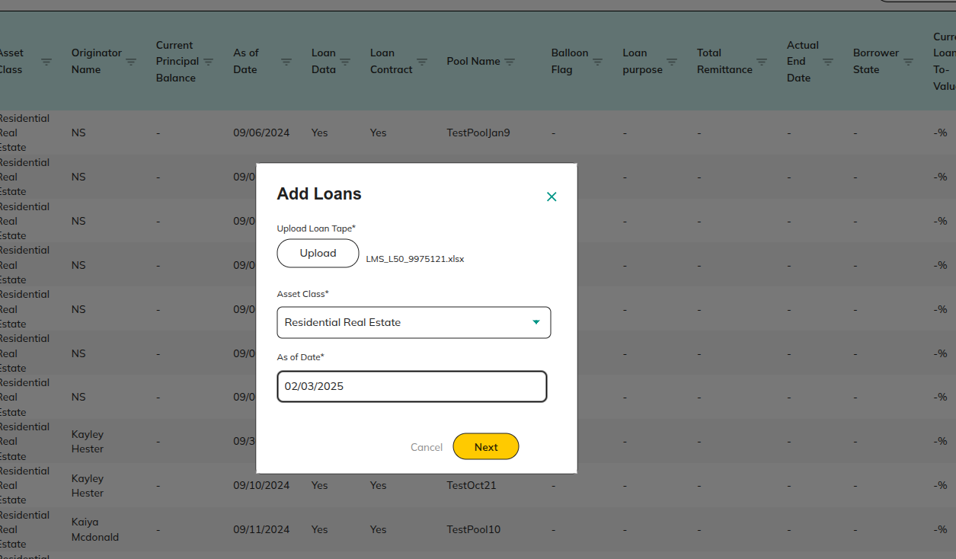

**Actions:**

* **Cancel**

Redirect to 1.2 Loans

* **Next**

Redirect to 1.2.1.1 Map Fields

##### 1.2.1.1 Map Fields

**Purpose:**

After uploading the Loan Tape, this screen allows issuers to map the fields from their Excel file to the standard fields required by the platform.

After uploading the XL file, map the fields from the uploaded file to the standard **Intain Fields**.

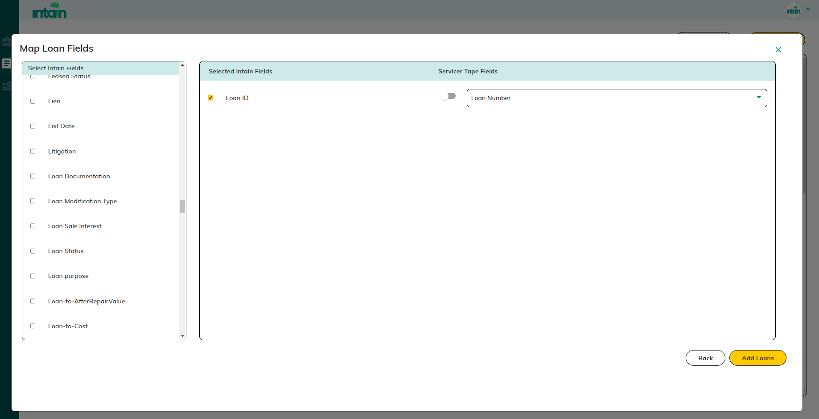

**Actions:**

* **Back**

Redirect to 1.2.1 Add Loans

* **Add Loans**

Redirect to 1.2 Loans

#### 1.2.2 Filter Option

**Purpose:**This screen enables issuers to apply filters to specific columns in the loan data. It helps in narrowing down the loan list based on specific criteria, making it easier to find and manage relevant loans.

Using the Filter option, any column on the platform can be filtered individually.

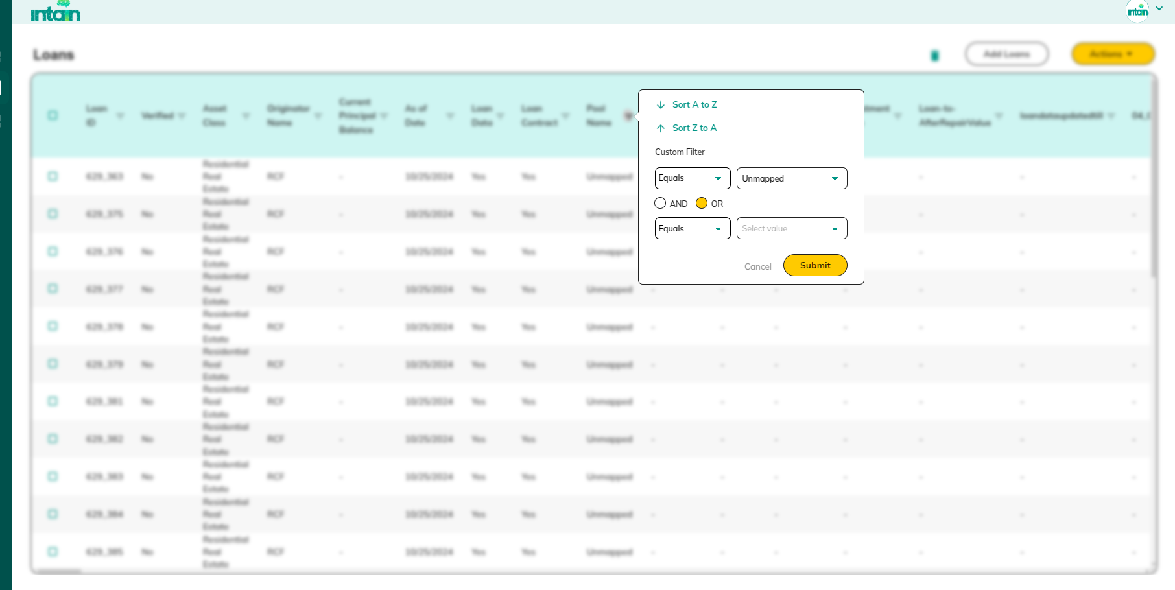

**Action:**

* **Cancel**

Redirect to 1.2 Loans

* **Submit**

Redirect to 1.2.2.1 Filtered Loans

##### 1.2.2.1 Filtered Loans

**Purpose:**Based on the applied conditions, a list of **Loans** will be displayed.

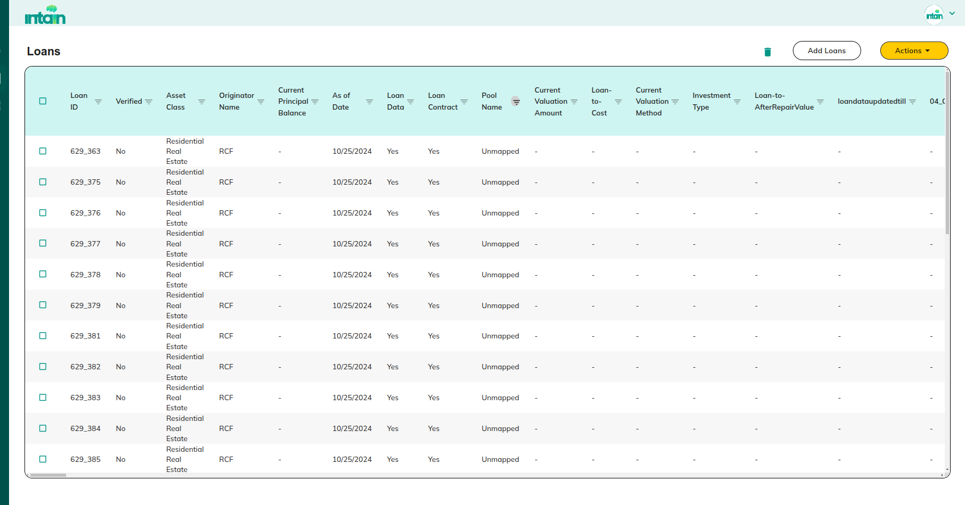

**Actions:**

* **Map to Pool**

Redirect to [1.2.3.1 Map to Pool](https://docs.google.com/document/d/1YhbEes8AEAzp13QS6QHfZjBtCCSb0vYA0LjwGQO0i1w/edit?pli=1#heading=h.fa4czijgq3r4)

* **Verify Loans**

Redirect to [1.2.3.2 Submit for verification](https://docs.google.com/document/d/1YhbEes8AEAzp13QS6QHfZjBtCCSb0vYA0LjwGQO0i1w/edit?pli=1&tab=t.0#heading=h.ht8er6jqfyd8)

#### 1.2.3 Actions:

**Purpose:**

If the user wants to map loans to pools or submit loans for verification then this action popup is used.

**Actions:**

* **Map to Pool**

Redirect to 1.2.3.1 Map to Pool

* **Verify Loans**

Redirect to 1.2.3.2 Submit for verification

##### 1.2.3.1 Map to Pool

**Purpose:**This screen allows issuers to map selected unmapped loans to a specific pool. It helps organize loans under the right pool for better tracking and management.

Selected **Unmapped Loans** will be mapped to a pool.

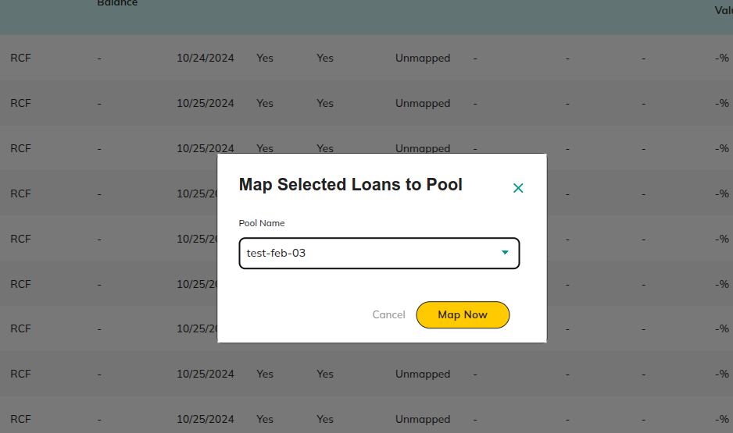

**Actions:**

* **Cancel**

Redirect to 1.2 Loans

* **Map Now**

Redirect to 1.1.2 View Pool Details

##### 1.2.3.2 Submit for verification

**Purpose:**

This screen is used to submit selected loans to the verification agent for review. It ensures that loans are validated for accuracy and compliance before submitting them to the underwriter.

The loans have been submitted to the verification agent.

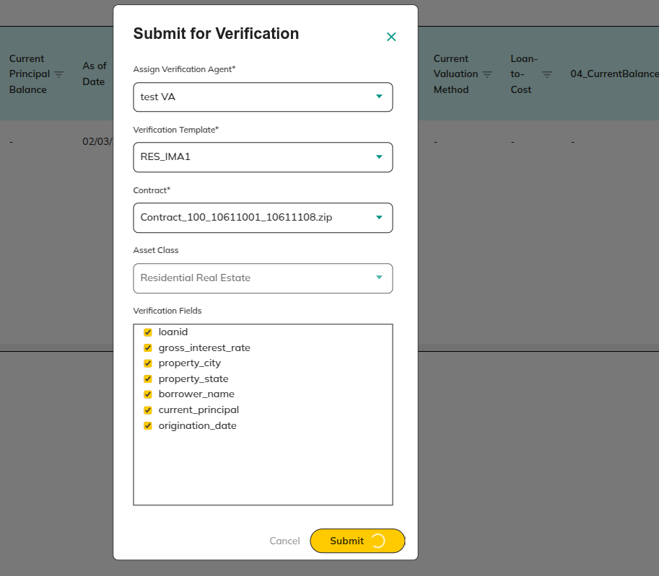

* **Cancel**

Redirect to 1.2 Loans

* **Submit**

Redirect to 1.1.2 View Pool Details

#### 1.2.4 Delete Loans

**Purpose:**

This screen lets issuers delete loans from the platform. It helps remove incorrect or unnecessary loan data to keep the information accurate.

Using the **Delete** icon, onboarded loans can be deleted from the platform.

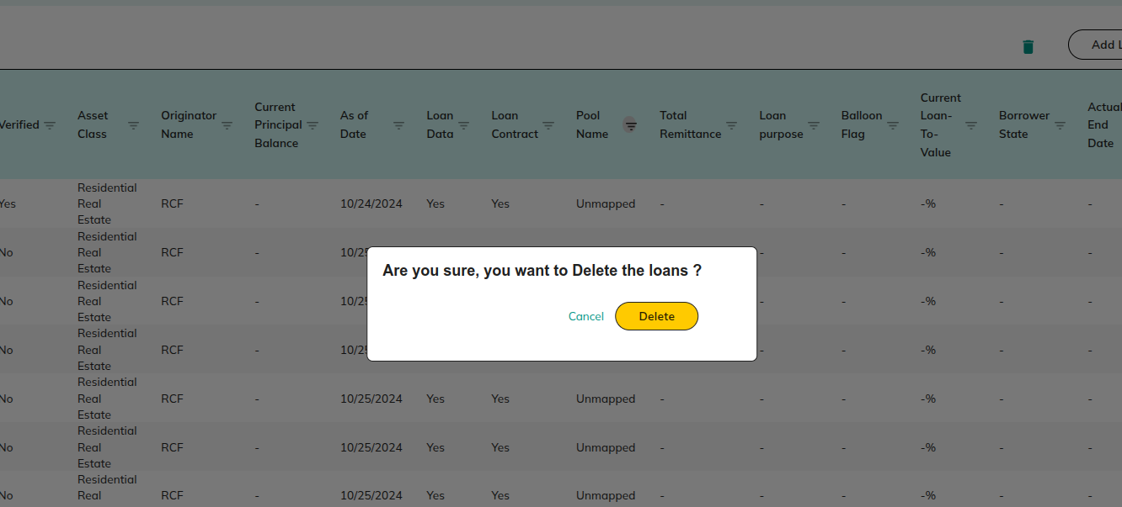

**Actions:**

* **Cancel**

Redirect to [1.2 Loans](https://docs.google.com/document/d/1YhbEes8AEAzp13QS6QHfZjBtCCSb0vYA0LjwGQO0i1w/edit?pli=1#heading=h.wxk79p8zrs49)

* **Delete**

Redirect to [1.2 Loans](https://docs.google.com/document/d/1YhbEes8AEAzp13QS6QHfZjBtCCSb0vYA0LjwGQO0i1w/edit?pli=1#heading=h.wxk79p8zrs49)

## 1.3 Deals

**Purpose:**

This screen displays all the deals created by the issuer. It allows users to view details of each deal, whether it's a securitization deal or a whole loan deal. From here, issuers can review, publish, and manage the approval process of their deals.

If we click on the Deal section, it will display this page.

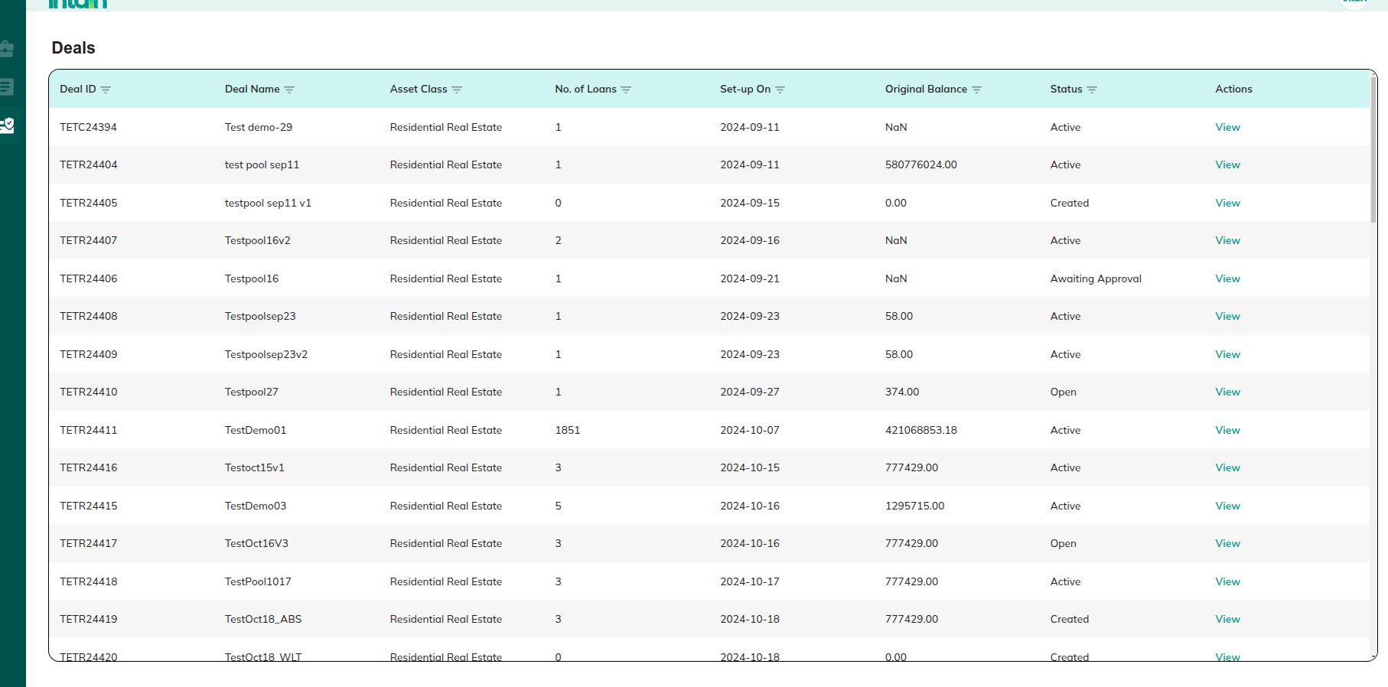

**Actions:**

* View Deal Details

Redirect to 1.3.1 If securitization deal,and 1.3.2 If whole loan deal,

### 1.3.1 If Securitization deal

View Securitization Deal Details

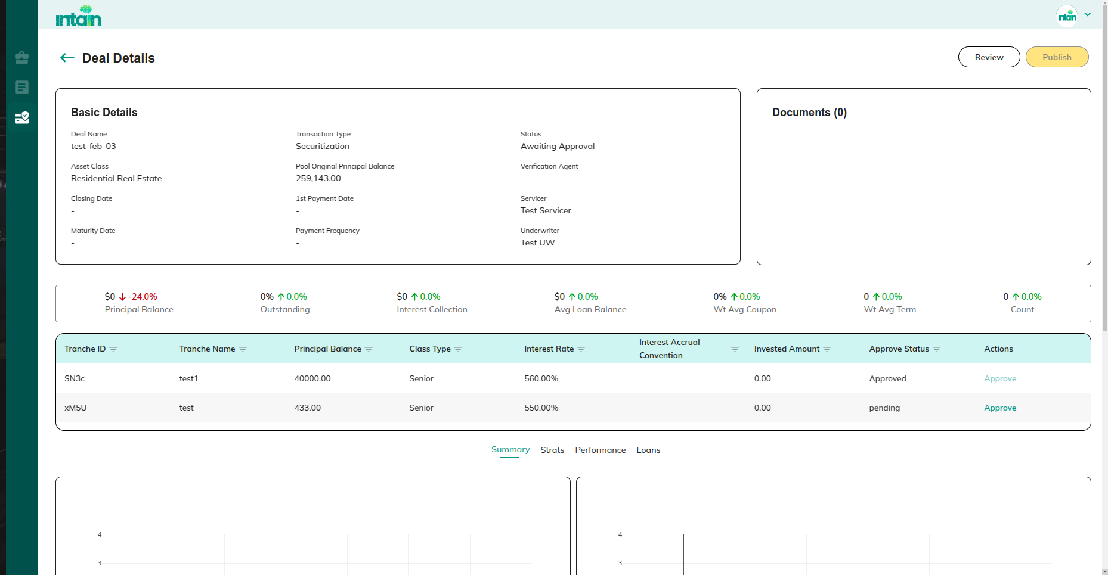

* Review

Redirect to 2.3.1.2 Tools

* Publish

Redirect to 1.3.4 Publish

* Approve

Redirect to 1.3.3 Approve the Issuance:

### 1.3.2 If Whole loan deal

View Whole Loan Deal Details

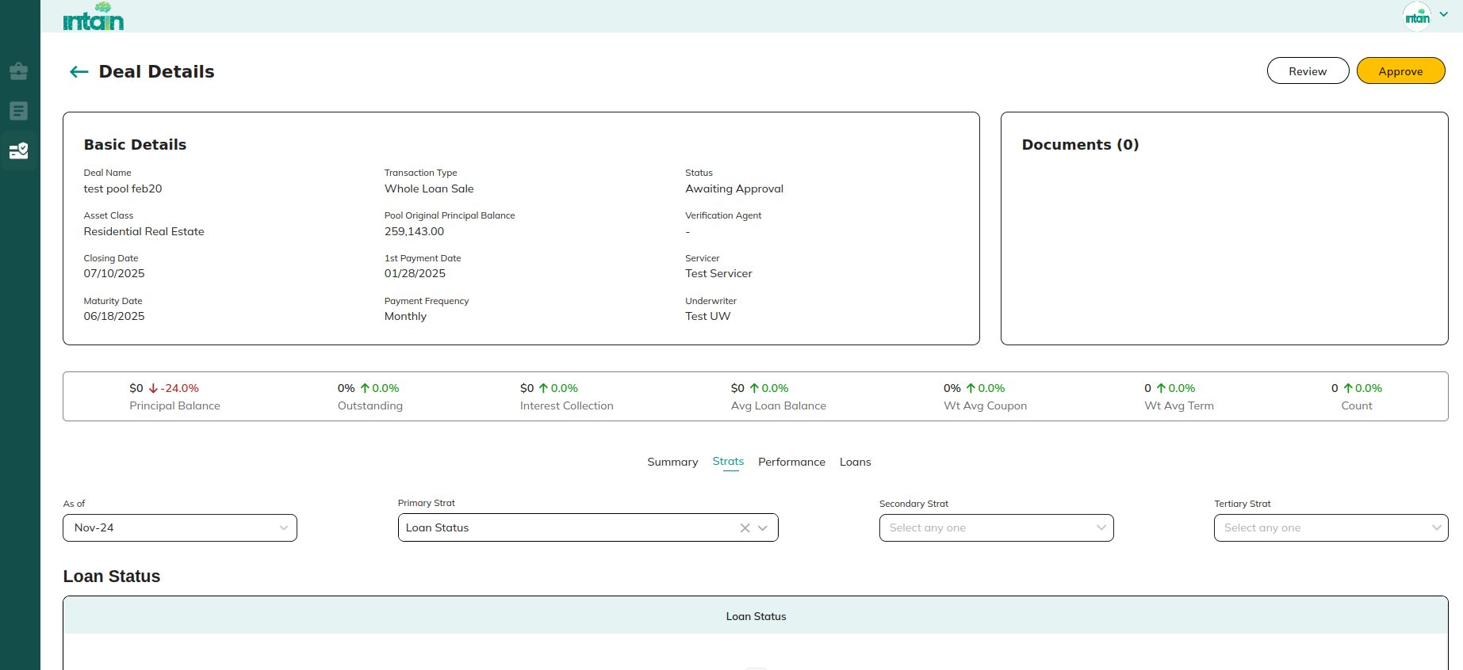

**Actions:**

* **Review**

Redirect to 2.3.1.9 If Whole Loan deal:

* **Publish** / Approve

If Publish Redirect to 1.3.2 Publish

If Approve Redirect to 1.3.3 Approve the Issuance:

### 1.3.3 Approve the Issuance:

**Purpose:**

Using the **Approve** option, the **Issuer** can provide access to the **Intain C-Chain Account** to transfer **FTs/NFT’s** on behalf of the issuer. The user needs to either enter the **private key** or upload the **JSON file** for the respective **C-Chain Account** to approve the transaction.

**Note:** The **C-Chain Address** is set up in the **Payment Setting** section.

## 

**Actions:**

* **Cancel**

Redirect to 1.1.2 View Pool Details

* **Approve**

Redirect to 1.1.2 View Pool Details

### 1.3**.4 Publish**

**Purpose:**

This screen is used to publish deals to investors after all tranches / NFT have been approved. Publishing makes the deal visible and available for investment opportunities.

Once tranches are approved, the **Deal** can be published to investors for investment.

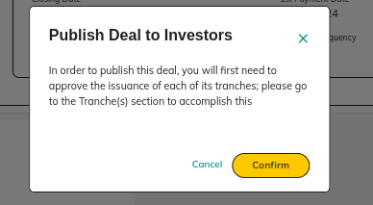

**Actions:**

* **Cancel**

Redirect to 1.1.2 View Pool Details

* **Confirm**

Redirect to 1.1.2 View Pool Details

## 1.4 User Profile

**Purpose:**

This screen allows users to view and manage their personal profile settings. Users can update payment details, switch between dark and light modes, and log out from the current session.

From the **User Profile** section, the user can **view their profile**, **update payment details**, and **logout** from the current session.

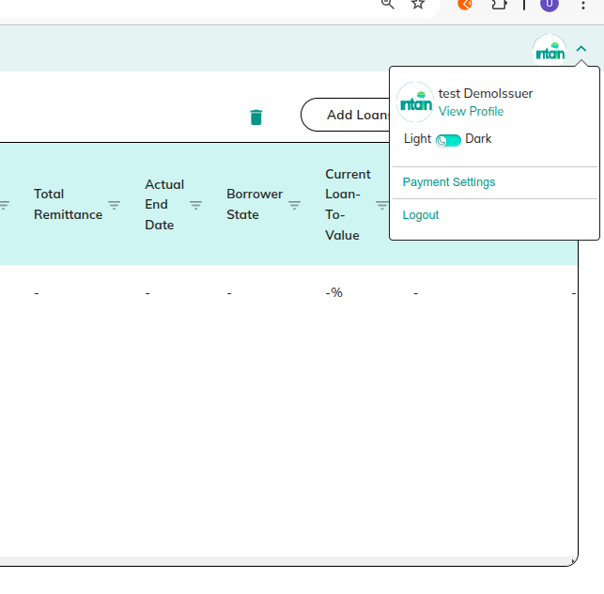

**Actions:**

* **View Profile**

Redirect to 1.4.2 View Profile

* **Payment Settings**

Redirect to 1.4.1 Payment Setting

* **Dark and Light**

Redirect to 1.4.3 Dark and Light

* **Logout**

Redirect to 8.1 Signin

### 1.4.1 Payment Setting

The user can update the **on-chain/off-chain bank details** in the **Payment Setting** screen.

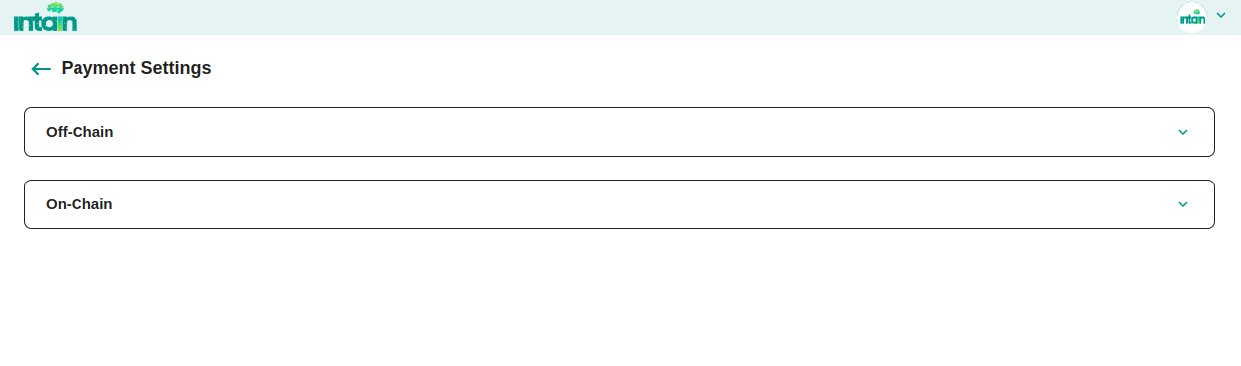

**Actions:**

* **Off-chain**

Redirect to1.4.1.1 Off-Chain

* **On-chain**

Redirect to 1.4.1.2 On-chain

#### 1.4.1.1 Off-Chain

View or update the **Off-Chain Payment Bank** related details.

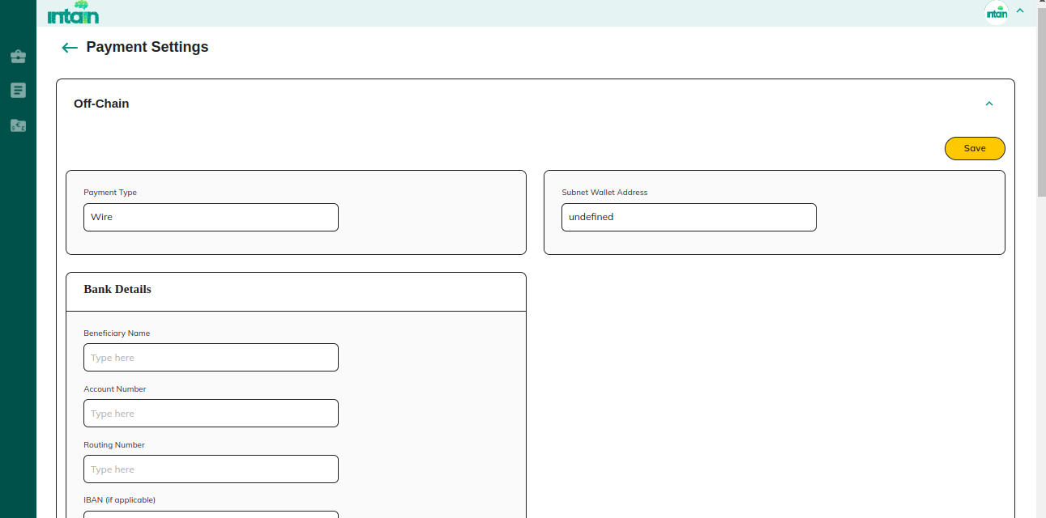

**Actions:**

* **Save**

Save the details and Redirect to 1.4.1 Payment Setting

#### 1.4.1.2 On-chain

View or update the **On-Chain Payment** related details.

**Note:** Currently, this section is **not in use**.

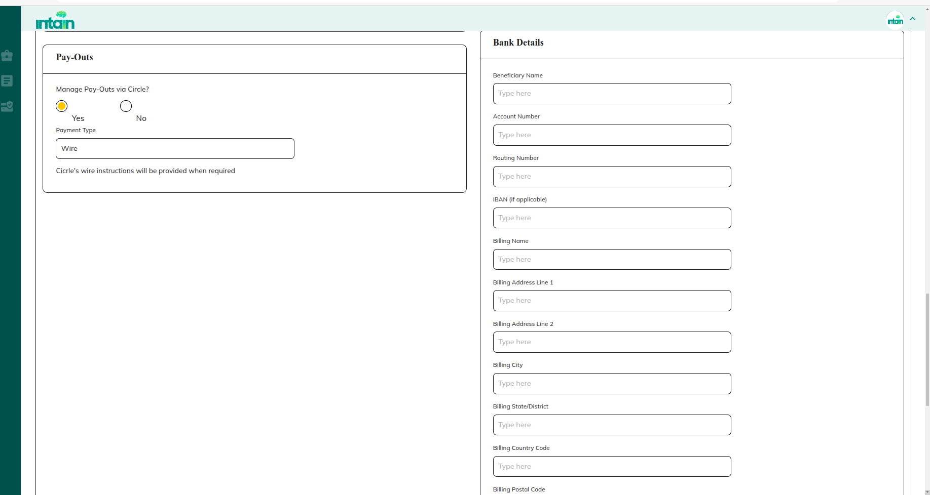

**Actions:**

* **Save**

Save the entered details and Redirect to 1.4.1 Payment Setting

### 1.4.2 View Profile

From the **Profile** section, the user can **upload their user logo**.

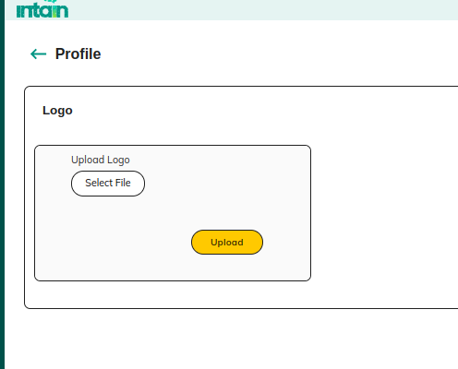

**Actions:**

* **Upload**

Upload the logo and Redirect to 1.4.2 View Profile

#### 1.4.2.1 Dark and Light

**Purpose:**This screen provides an option to switch between dark mode and light mode for the platform interface. It enhances user experience by allowing them to choose their preferred display theme.

Here, we have an option to switch between Dark and Light modes.

#### 

### 1.5 Pool delete

**Purpose:**This screen allows users to delete a specific pool from the platform. It helps in removing unnecessary pools to keep the data clean and relevant.

Here, we can delete a specific pool using the Delete option.

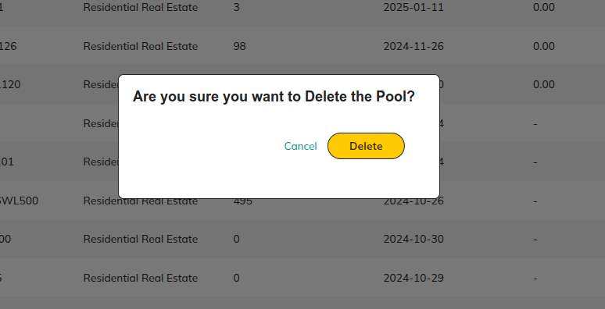

**Actions:**

* **Delete**

Redirect to 1.1 Pool (Landing Page)

* **Cancele**

Redirect to 1.1 Pool (Landing Page)

## 2. UnderWriter:

## 2.1 Preview - Pools

**Purpose:**

* View a comprehensive list of pools currently in the Preview Stage. This section allows users to review pool details, accept or reject pools, and navigate to related functionalities.

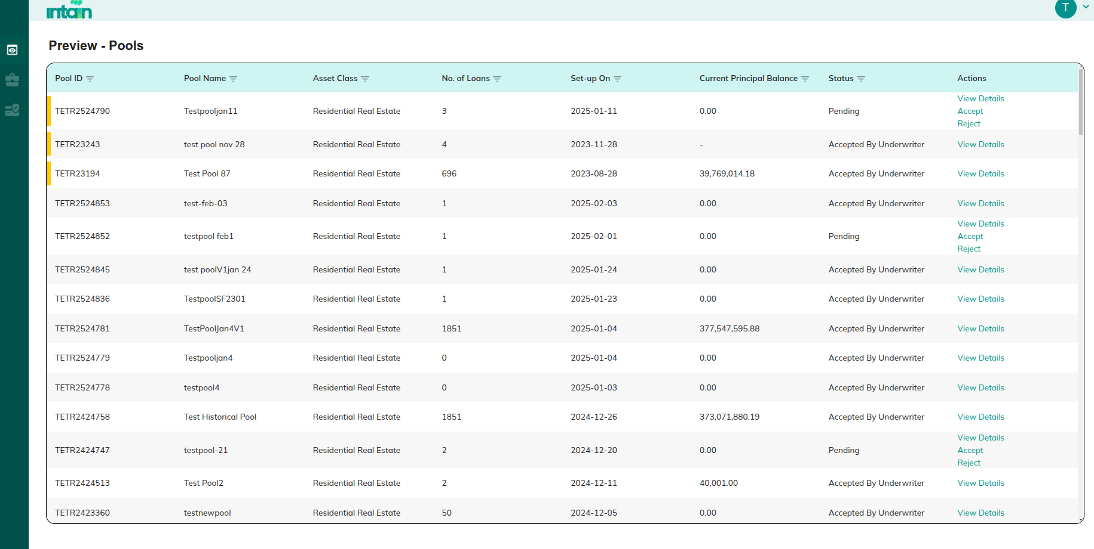

**Actions:**

* **View Details**

Redirect to 2.1.1 View Preview Pool Details:

* **Accept**

Accept the pool and Redirect to 2.1.1 View Preview Pool Details:

* **Reject**

Reject the submitted pool and Redirect to 2.1.1 View Preview Pool Details:

* **Pools**

Redirect to 2.2 Pool

* **Deals**

Redirect to 2.3 Deals

* **View Profile**

Redirect to 1.4.2 View Profile

### 2.1.1 View Preview Pool Details:

**Purpose:**This screen displays detailed information about a specific pool in the preview stage. It allows underwriters to review loan details, submit the pool to investors, reject individual loans, add feedback, and download relevant documents for further analysis.

Provides detailed information about a specific preview pool.

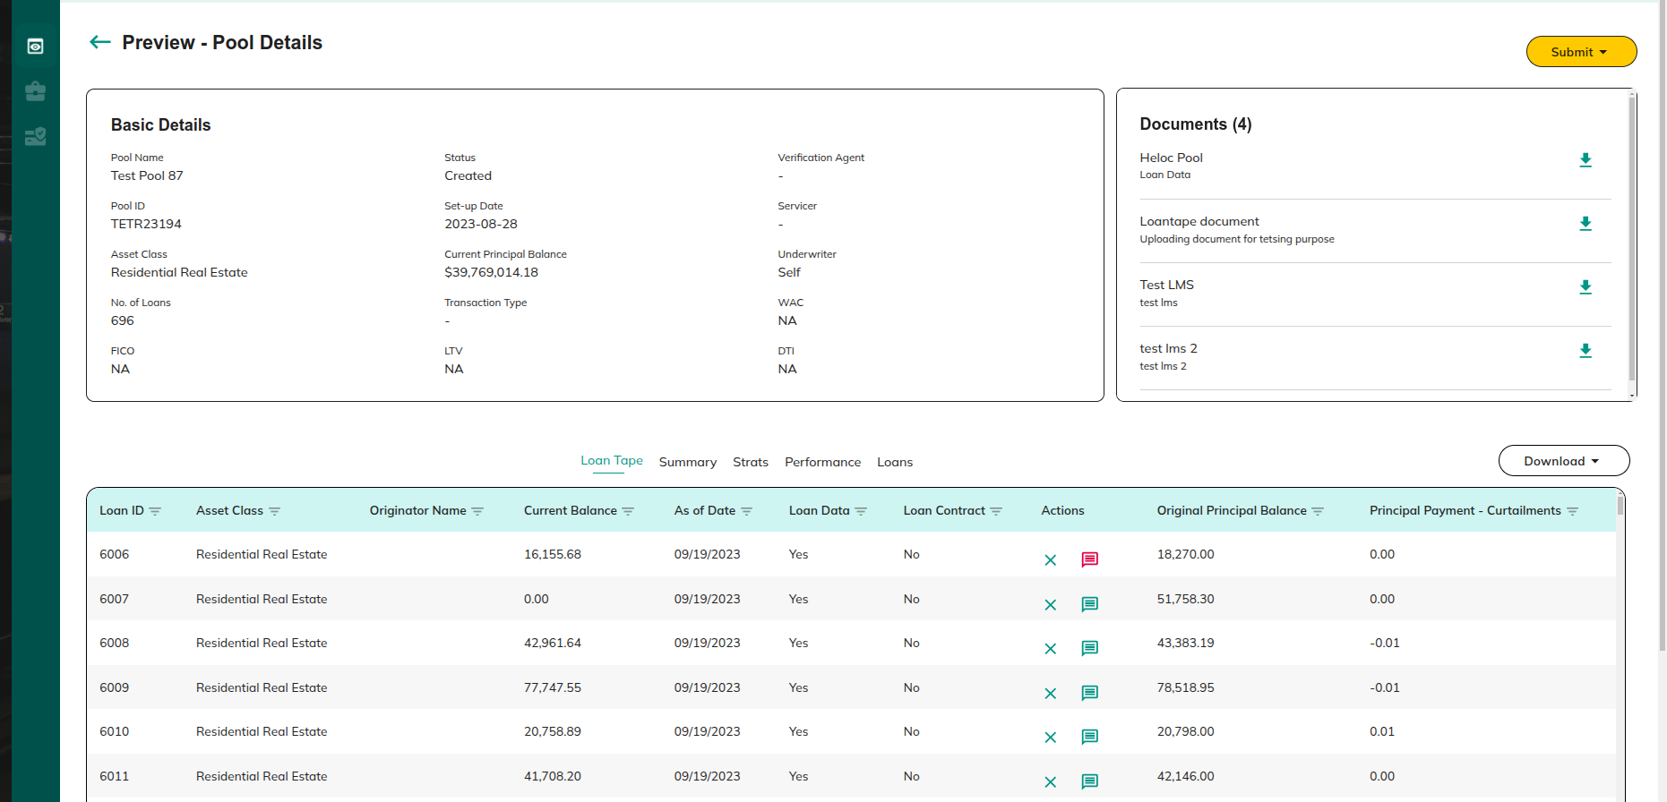

**Actions:**

* **Submit**

Redirect to 2.1.1.2 Submit to Investors

* **Download**

Download the loantape details in xl/CSV format

* **Reject Loan**

Redirect to 2.1.1.1 Reject Loan

* **View / Add Feedback**

Redirect to 1.1.2.3.3 Add / View the feedback

* **Download Document**

Redirect to 2.1.1.1.1Download Document

#### 2.1.1.1 Download Document

**Purpose:**

This screen allows underwriters to download documents related to the pool.

Here, you can download pool-related documents from the Download section.

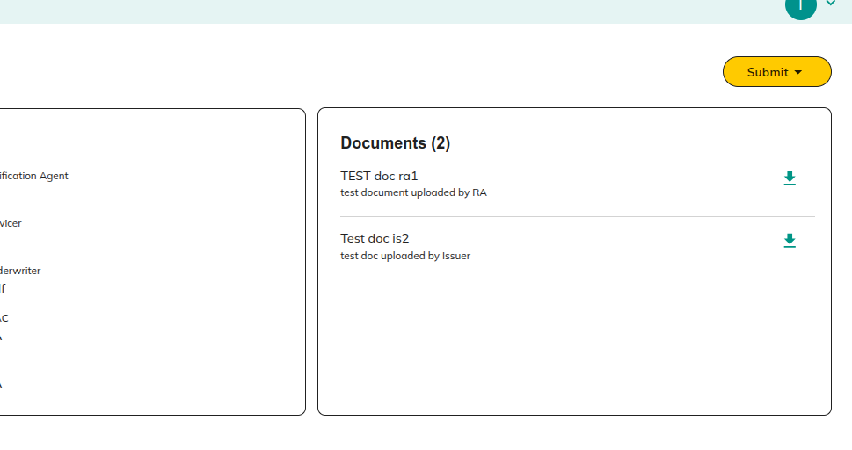

**Actions:**

* **Download the pdf document**

#### 2.1.1.2 Reject Loan

**Purpose:**

This screen allows underwriters to reject specific loans from a pool. The underwriter can provide reasons for rejection in the comment section, helping issuers understand the rationale and make necessary corrections.

Clicking on the reject icon, the Underwriter can request the Issuer to remove a loan from the specific pool. The reason for the request can be added in the comment section.

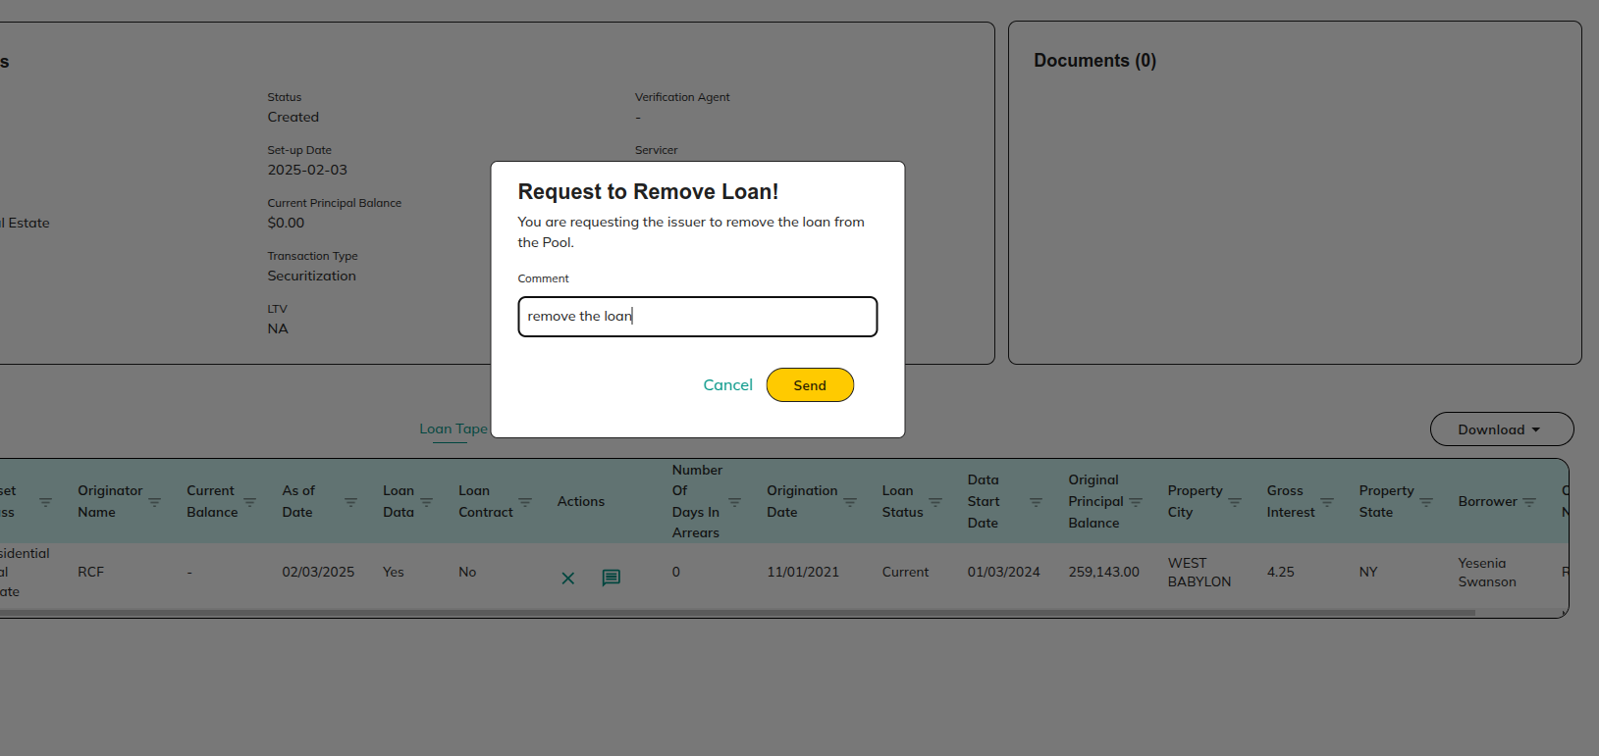

**Actions:**

* **Cancel**

Redirect to 2.1.1 View Preview Pool Details:

* **Send**

Redirect to 2.1.1 View Preview Pool Details:

#### 2.1.1.3 Submit to Investors

**Purpose:**

This screen enables underwriters to submit previewed pools to investors for review and potential investment

The Underwriter can share the preview **pools with investors.**

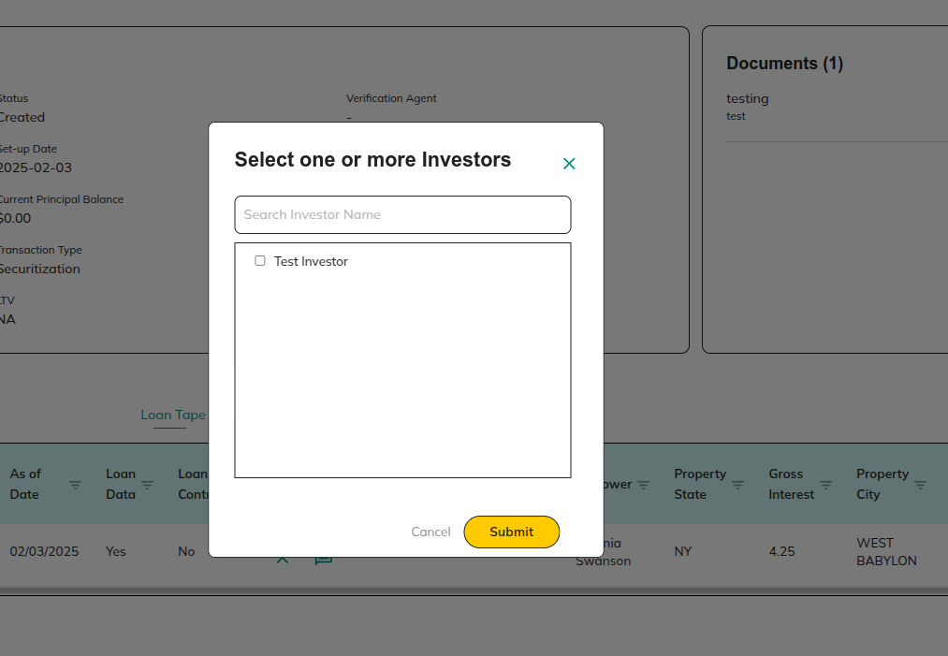

**Actions:**

* **Cancel**

Redirect to 2.1.1 View Preview Pool Details:

* **Submit**

Redirect to 2.1.1 View Preview Pool Details:

## 2.2 Pool

**Purpose:**

This screen displays a list of pools that have been verified by the underwriter. It allows users to view detailed information about these pools, accept or reject them for underwriting, and apply filters to manage and track specific pools efficiently.

Displays a list of **pools** that have been **verified** by the **Underwriter.**

### 2.1.1 If Securitization pools,

All pools related to the Securitization pools are shown.

* + 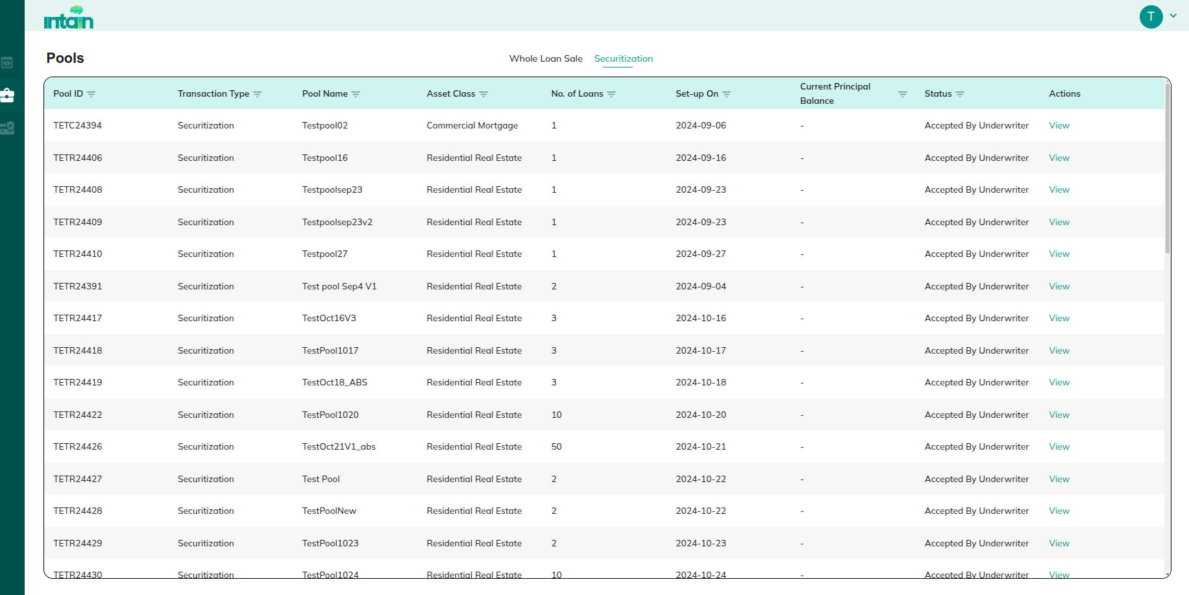

**Actions:**

* **Accept/reject**

Redirect to 2.2.1.1 Accept

* **View**

Redirect to 2.1.3 View Pool Details:

* **Filter**

Redirect to 1.2.3 Filter Option

#### 2.2.1.1 Accept

Once accepted, this Pool will be converted into a Deal, and the Issuer will be notified that you have agreed to underwrite this Deal.

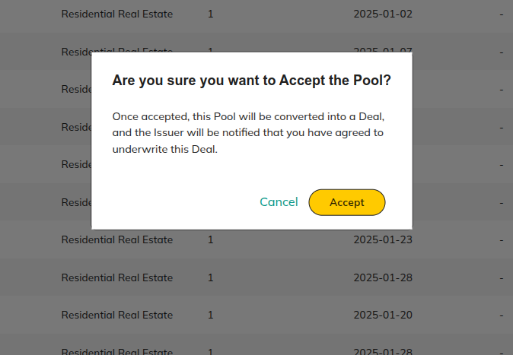

**Actions:**

* **Accept**

Redirect to 2.2 Pool

* **Cancel**

Redirect to 2.2 Pool

#### 2.2.1.2 Reject

Once rejected, the Issuer will be notified that you have denied to underwriter this Deal.

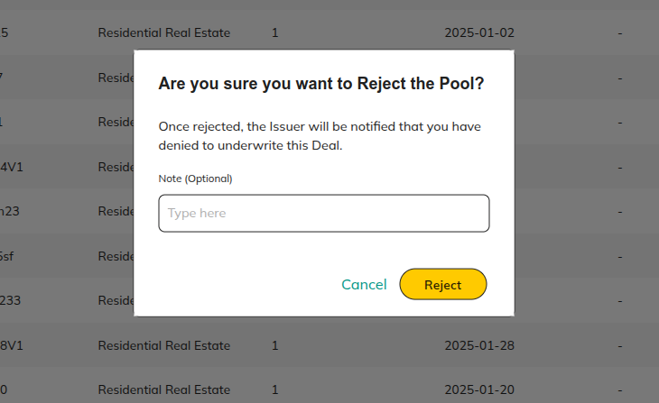

**Actions:**

* **Accept**

Redirect to 2.2 Pool

* **Cancel**

Redirect to 2.2 Pool

### 2.1.2 If Whole Loan pool,

All pools related to the Whole Loans are shown.

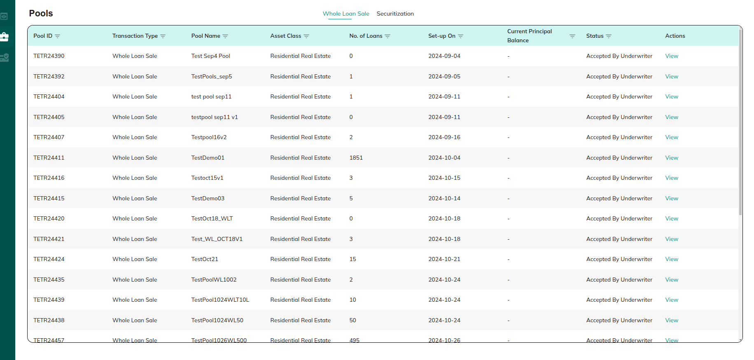

**Actions:**

* **Accept**

Redirect to 2.2.1.1 Accept

* **Reject**

Redirect to 2.2.1.2 Reject

* **View Details**

Redirect to 2.1.3 View Pool Details:

* **Filter**

Redirect to 1.2.3 Filter Option

### **2.1.3 View Pool Details:**

**Purpose:**This screen provides detailed information about a specific pool. It allows underwriters to review loan tapes, pool summaries, strats, and documents related to the pool. The screen is read-only, meaning the underwriter can view but not edit the pool details.

Provides detailed **information** about a specific **pool**.

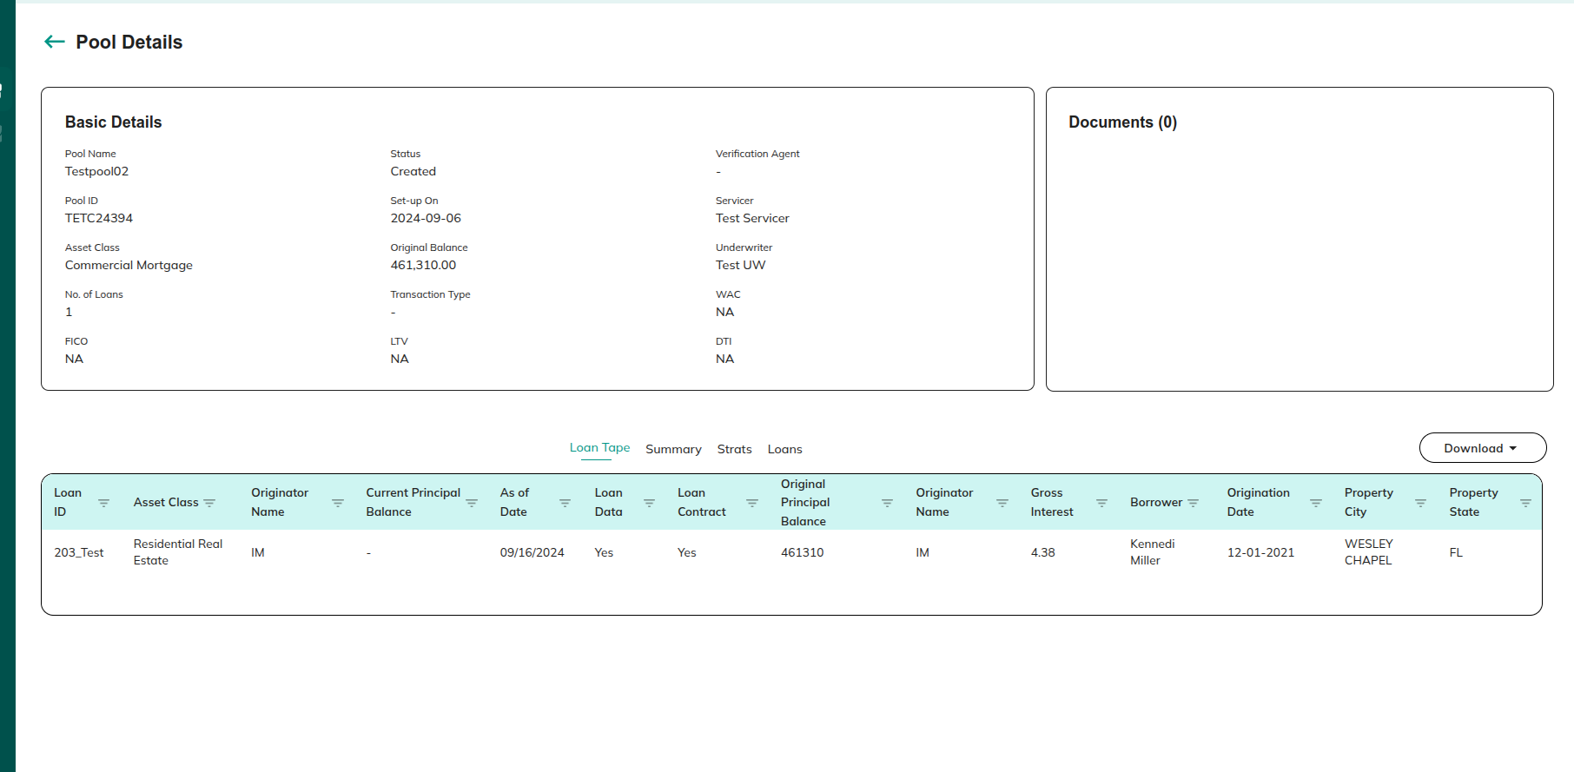

**Actions:**

* **Download**

Download the loantape in xl/ csv format.

* **Summery**

Here, you are only able to view the details and cannot edit them.

* **Strats**

Here, you are only able to view the details and cannot edit them.

* **Loans**

Here, you are only able to view the details and cannot edit them.

* **Download document**

Redirect to2.1.1.1.1 Download Document

* **Delete Document**

Redirect to 1.1.2.4.2 Delete Document:

* **Edit Document**

Redirect to 1.1.2.4.2 Edit Document:

## 2.3 Deals

**Purpose:**

This screen displays a list of all deals, allowing users to manage and monitor their status, structure, and details. It helps underwriters and issuers track deal progress, view specific deal information.

View a **list of deals** to manage and monitor their **status, structure, and details**.

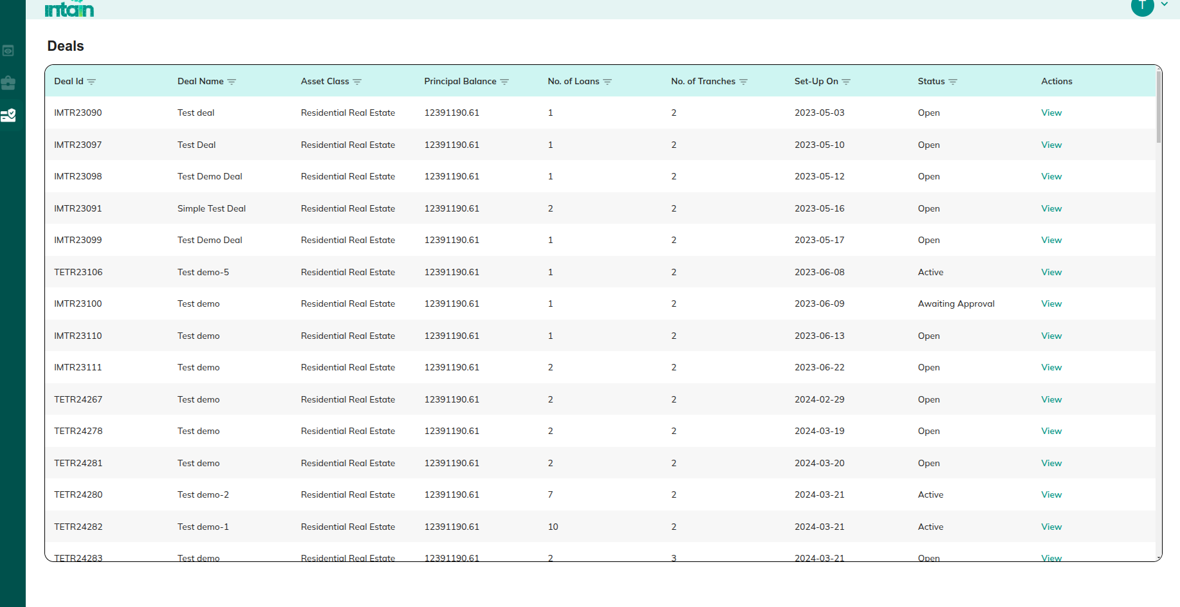

**Actions:**

* View details

Redirect to 2.3.1 View Deal Details

* **Filter**

Redirect to 1.2.3 Filter Option

### 2.3.1 View Deal Details

**Purpose:**This screen provides detailed information about a specific deal, whether it's a securitization deal or a whole loan deal. Users can review deal structures, access tools, view summaries and stratifications, and manage documents related to the deal.

* **If it's a securitization deal:** Users can view tranches to see individual investor investments and the deal’s tranche structure. Redirect to 2.3.1.1 If Securitization Deal:
* **If it's a whole loan deal:** Tranches are not applicable, and users will only see deal-related information without any tranche details. 2.3.1.2 If Whole Loan deal

### 2.3.1.1 If Securitization Deal:

* Tranches will be present.

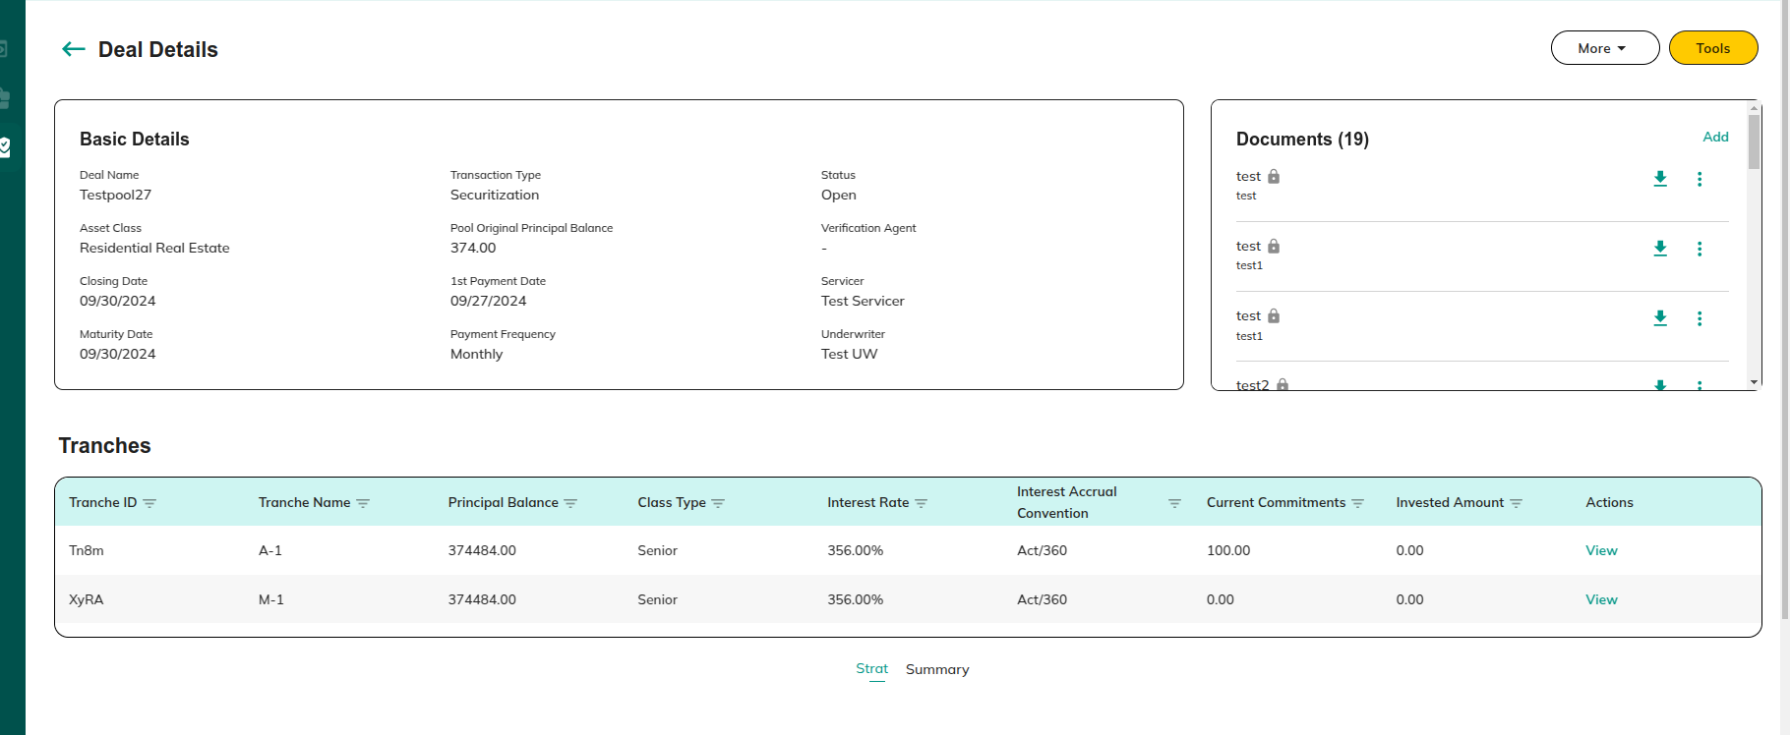

**Actions:**

* **View**

Redirect to 2.3.1.1.1 view tranches

* **Tools**

Redirect to 2.3.1.2 Tools

* **More**

Redirect to 2.3.1.3 More

* **Strat**

Redirect to 1.1.2.4 Mapped Loans: Strat

* **Summary**

Redirect to 1.1.2.5 Mapped Loans: Summary

* **Add Document**

Redirect to 1.1.2.4.1 Add Document

* **Delete Document**

Redirect to 1.1.2.4.2 Delete Document:

* **Edit Document**

Redirect to 1.1.2.4.2 Edit Document:

##### 2.3.1.1.1 view tranches

**Purpose:**

This screen displays individual investor investments within a securitization deal.

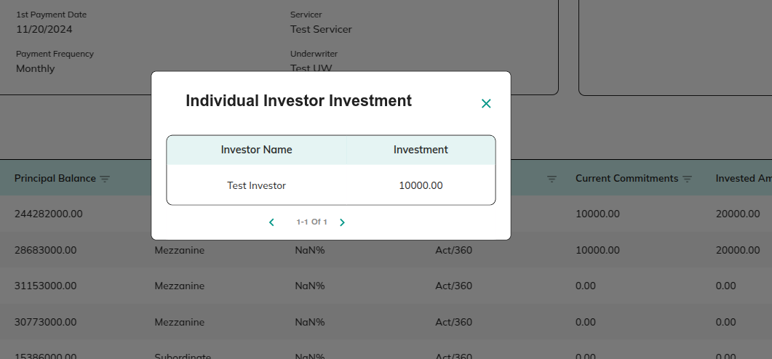

### 2.3.1.2 If Whole Loan deal

**Purpose:**This screen shows details for whole loan deals. Unlike securitization deals, whole loan deals do not have tranches, but users can still access deal tools, summaries, and documents.

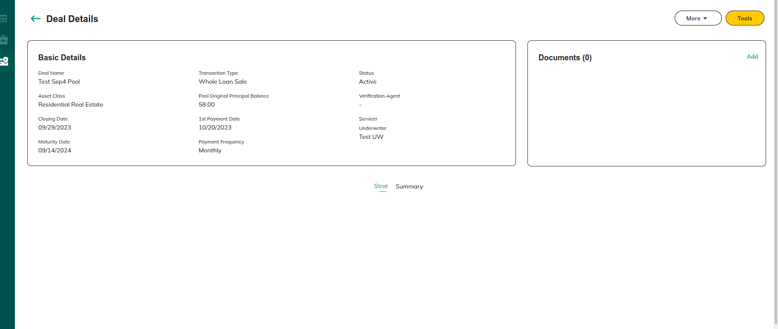

**Actions:**

* **Tools**

Redirect to 2.3.1.2 If Whole Loan deal and 2.3.2.2 If Whole Loan deal:

* **More**

Redirect to 2.3.1.3 More

* **Strat**

Redirect to 1.1.2.4 Mapped Loans: Strat

* **Summary**

Redirect to 1.1.2.5 Mapped Loans: Summary

* **Add Document**

Redirect to 1.1.2.4.1 Add Document

* **Delete Document**

Redirect to 1.1.2.4.2 Delete Document:

* **Edit Document**

Redirect to 1.1.2.4.2 Edit Document:

#### 

### 2.3.2 Tools

In the **Tools section**, deals XL can be **uploaded**, and the Underwriter can later **publish it to the Issuer for tranche approval**.

#### 2.3.2.1 If Securitization Deal:

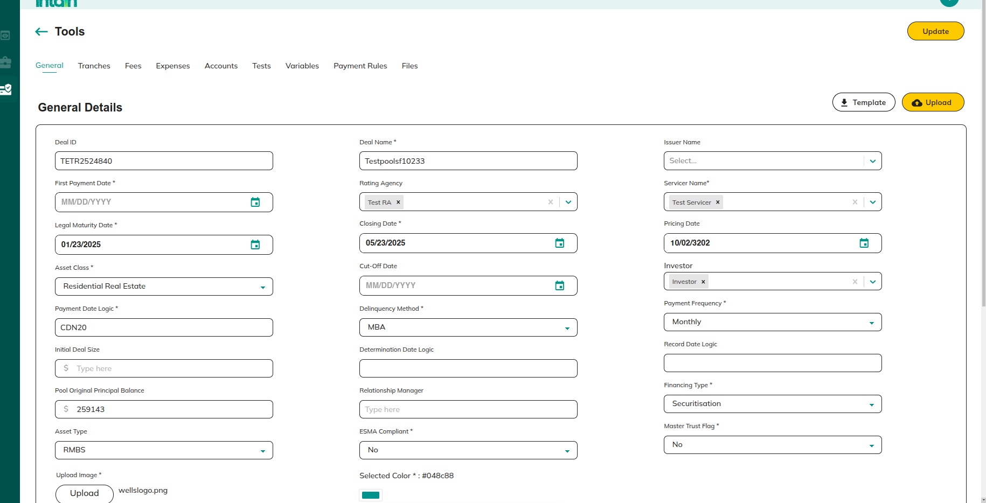

**Actions:**

* **General**

Redirect to 2.3.1.2 General

* **Tranches**

Redirect to2.3.1.2.2 Tranches

* **Fees**

Redirect to 2.3.1.2.3 Fees

* **Expenses**

Redirect to 2.3.1.2.4 Expenses

* **Accounts**

Redirect to 2.3.1.2.5 Account

* **Tests**

Redirect to 2.3.1.2.6 Tests

* **Variables**

Redirect to 2.3.1.2.7 Variable

* **Payment Rules**

Redirect to 2.3.1.2.7 Payment Rules

* **Files**

Redirect to 2.3.1.2.8 Files

* **Download template**

You can download the Excel template using the Download option.

##### 2.3.2.1.1 General

In the General section, where we need to fill in the general details.

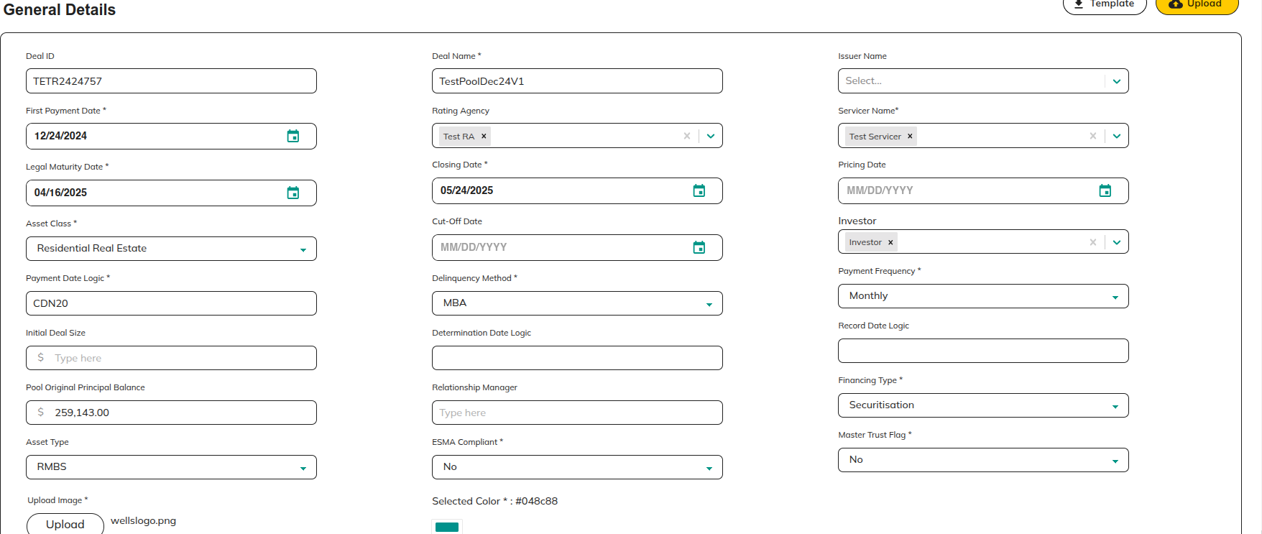

**Actions:**

* **Next**

Redirect to 2.3.1.2.2 Tranches

##### 2.3.2.1.2 Tranches

In the Tranches section, where we need to fill in the tranches details.

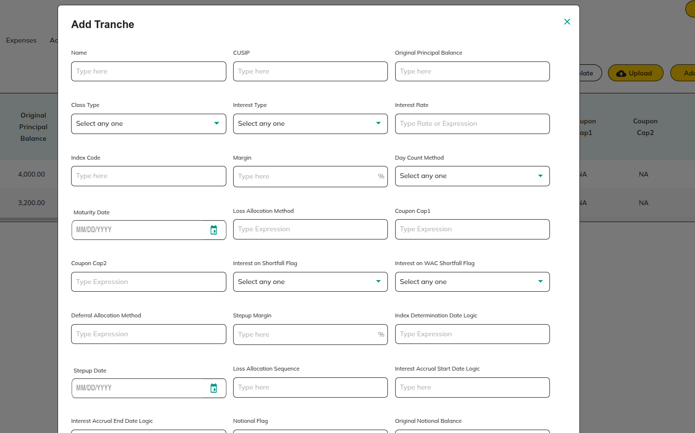

**Actions:**

* **Next**

Redirect to 2.3.1.2.3 Fees

* **Edit**

Redirect to 2.3.1.2.2 Tranches

* **Delate**

Redirect to 2.3.1.2.2 Tranches

##### 2.3.2.1.3 Fees

In the Fees section, where we need to fill in the Fees details.

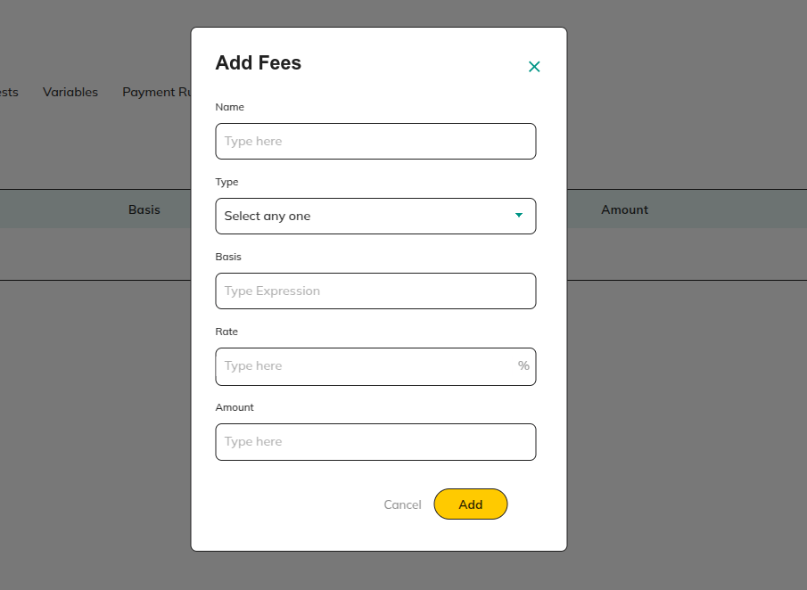

**Actions:**

* **Next**

Redirect to 2.3.1.2.4 Expenses

* **View**

Redirect to 2.3.1.2.3 Fees

* **Edit**

Redirect to 2.3.1.2.3 Fees

* **Delete**

Redirect to 2.3.1.2.3 Fees

##### 2.3.2.1.4 Expenses

In the Expenses section, where we need to fill in the Expenses details.

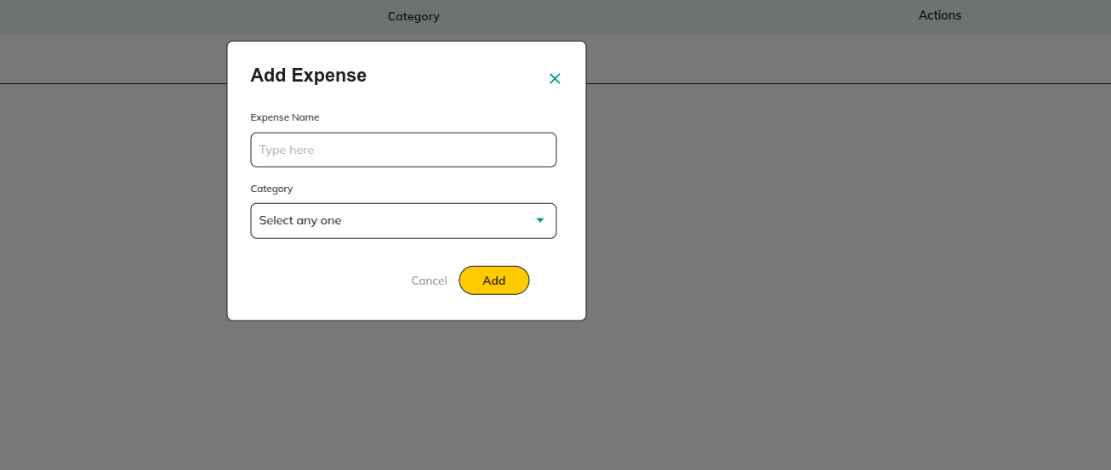

**Actions:**

* **Next**

Redirect to 2.3.1.2.5 Account

* **Edit**

Redirect to 2.3.1.2.4 Expenses

* **Delete**

Redirect to 2.3.1.2.4 Expenses

##### 2.3.2.1.5 Account

In the Account section, where we need to fill in the Account details.

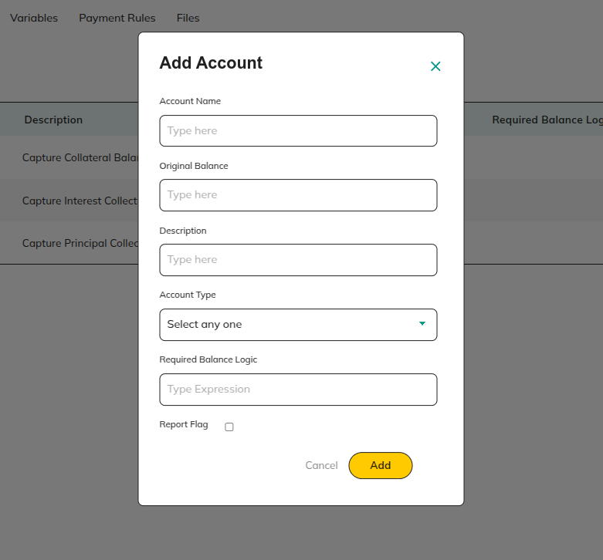

**Actions:**

* **Next**

Redirect to 2.3.1.2.6 Tests

* **Edit**

Redirect to 2.3.1.2.5 Account

* **Delete**

Redirect to 2.3.1.2.5 Account

##### 2.3.2.1.6 Tests

In the Tests section, where we need to fill in the Tests details.

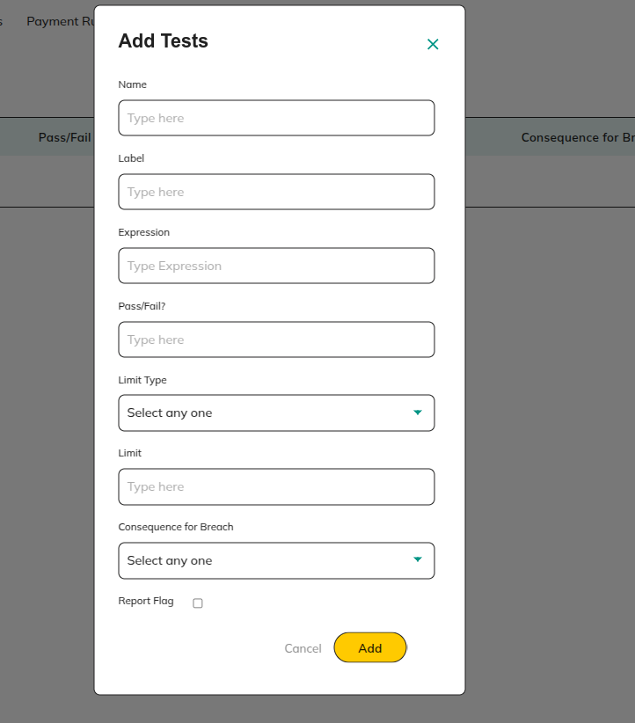

**Actions:**

* **Next**

Redirect to 2.3.1.2.7 Variable

* **Edit**

Redirect to 2.3.1.2.6 Tests

* **Delete**

Redirect to 2.3.1.2.6 Tests

##### 2.3.2.1.7 Variable

In the variable section, where we need to fill in the variable details.

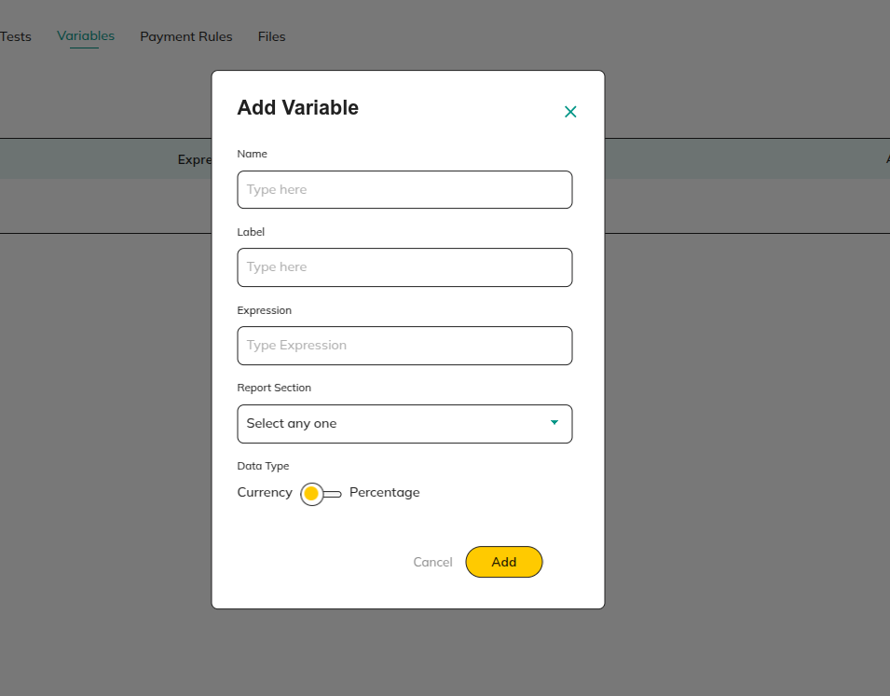

**Actions:**

* **Next**

Redirect to 2.3.1.2.7 Payment Rules

* **View**

Redirect to 2.3.1.2.7 Variable

* **Edit**

Redirect to 2.3.1.2.7 Variable

* **Delete**

Redirect to 2.3.1.2.7 Variable

##### 2.3.2.1.8 Payment Rules

In the Payment Rules section, where we need to fill in the Payment Rules details.

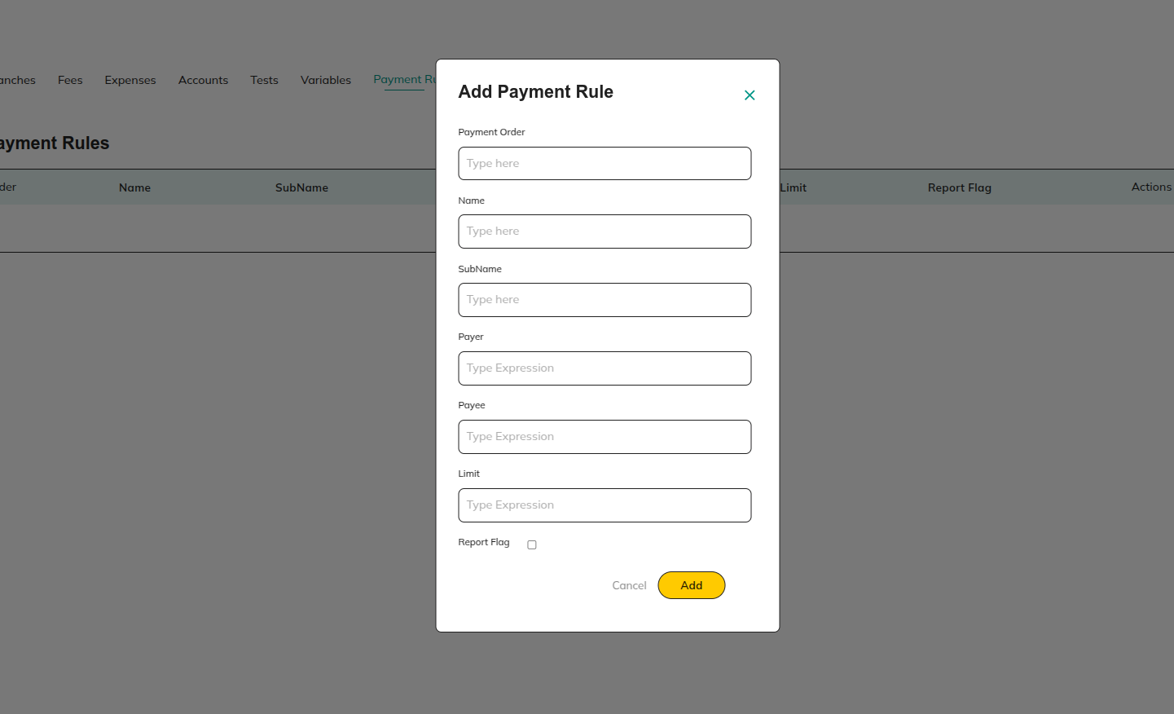

**Actions:**

* **Next**

Redirect to 2.3.1.2.8 Files

* **View**

Redirect to 2.3.1.2.7 Payment Rules

* **Edit**

Redirect to 2.3.1.2.7 Payment Rules

* **Delete**

Redirect to 2.3.1.2.7 Payment Rules

##### 2.3.2.1.9 Files

In the Files section, underwriter can upload deal xl sheet.

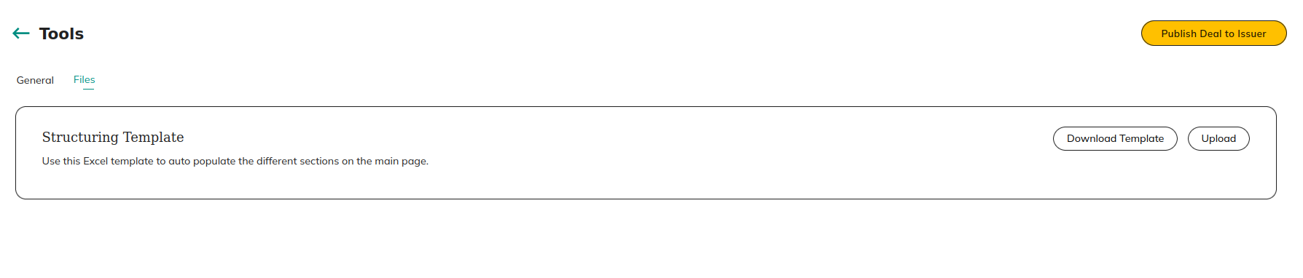

**Actions:**

* **Download**

Download the underwriter xl upload template

* **Upload**

Upload deal related xl.

* **Publish Deal to Issuer**

Redirect to  2.3.2.2.1 Publish Deal to Issuer

### 2.3.2.2 If Whole Loan deal:

In the **Tools section**, underwriter can update the deal details and publish to the issuer for NFT approval.

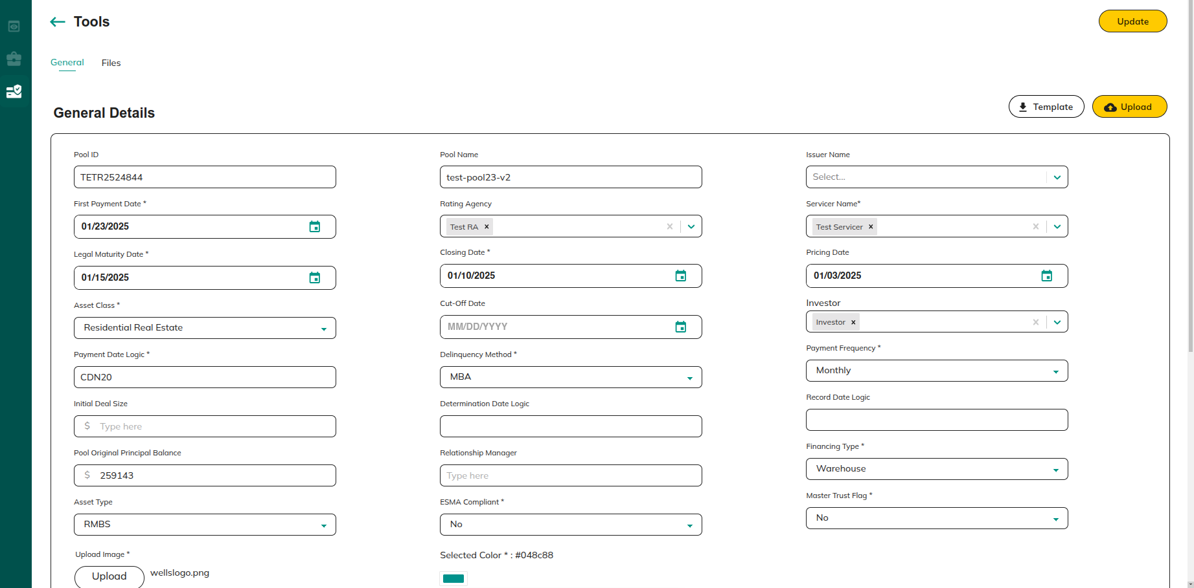

**Actions:**

* **General**

Redirect to 2.3.1.2.1 General

* **Files**

Redirect to [2.3.1.2.9 Files](https://docs.google.com/document/d/1YhbEes8AEAzp13QS6QHfZjBtCCSb0vYA0LjwGQO0i1w/edit?pli=1&tab=t.0#heading=h.6zhziqfg92cr)

#### 2.3.2.2.1 General

In the General section, where we need to fill in the general details.

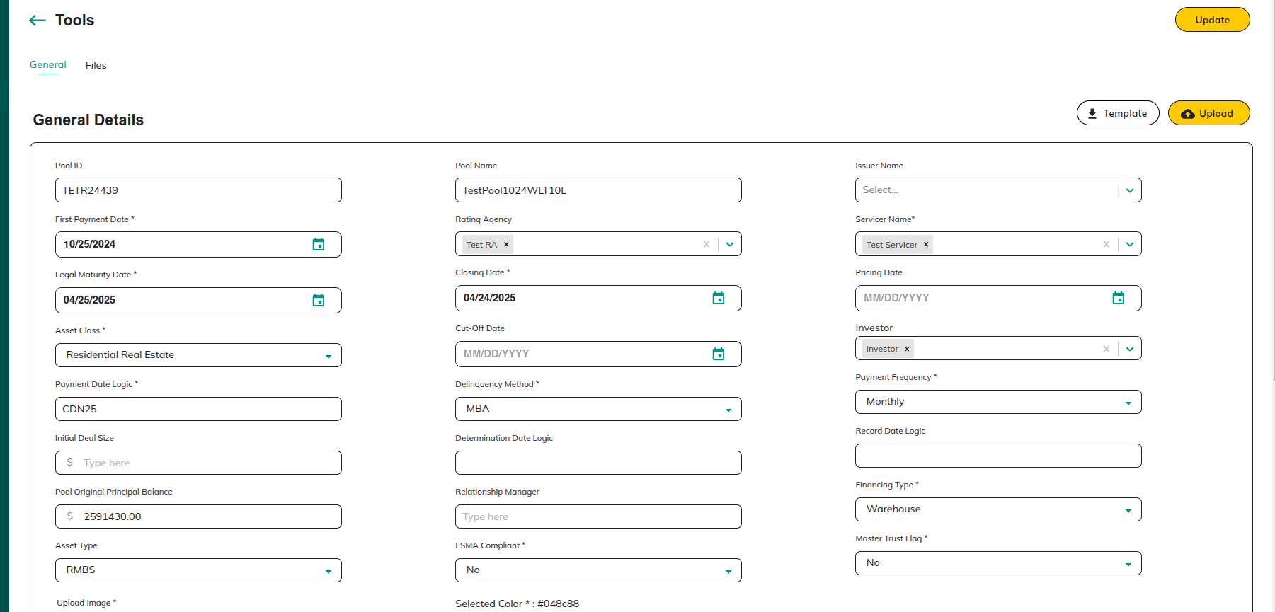

**Actions:**

* **Next**

Redirect to 2.3.1.2.9 Files

#### 2.3.2.2.2 Files

In the Files Rules section, where we need to Upload in the Files details.

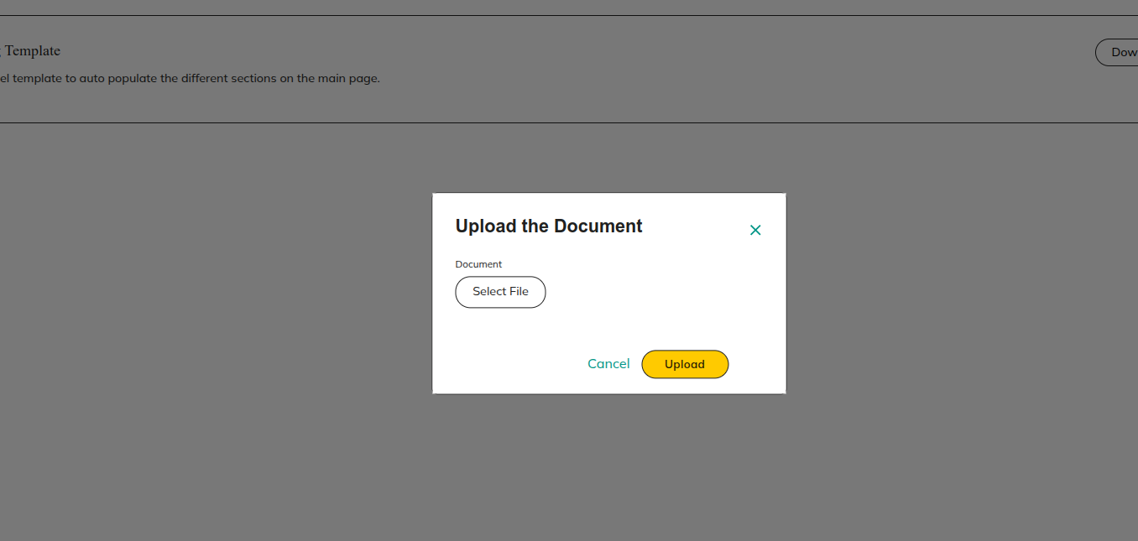

**Actions:**

* **Download**

Download the underwriter xl upload template

* **Upload**

Upload deal related xl

* **Publish Deal to Issuer**

Redirect to 2.3.1.2.2 Publish Deal to Issuer

##### 2.3.2.2.2.1 Publish Deal to Issuer

Using the **publish option**, the deal can be **submitted to the Issuer for approval**.



**Actions:**

* **Cancel**

Redirect to 2.3.1.2.1 Upload Deal Xl

* **Publish**

Redirect to 2.3.2.2 If Whole Loan deal:

### 2.3.3 More

Provides options to **view pool details, account details, and general settings**.

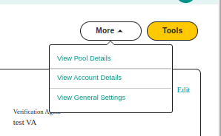

**Actions:**

* **View Pool Details**

Redirect to 2.2.1 View Pool Details:

* **View Account Details**

Redirect to 2.3.1.3.1 Account Details

* **View General Settings**

Redirect to 2.3.1.4 General Settings

#### 2.3.2.1 Account and Transaction Details

Manage **off-chain accounts** and **transaction records**, providing a clear overview of all **financial activities** related to the deal.

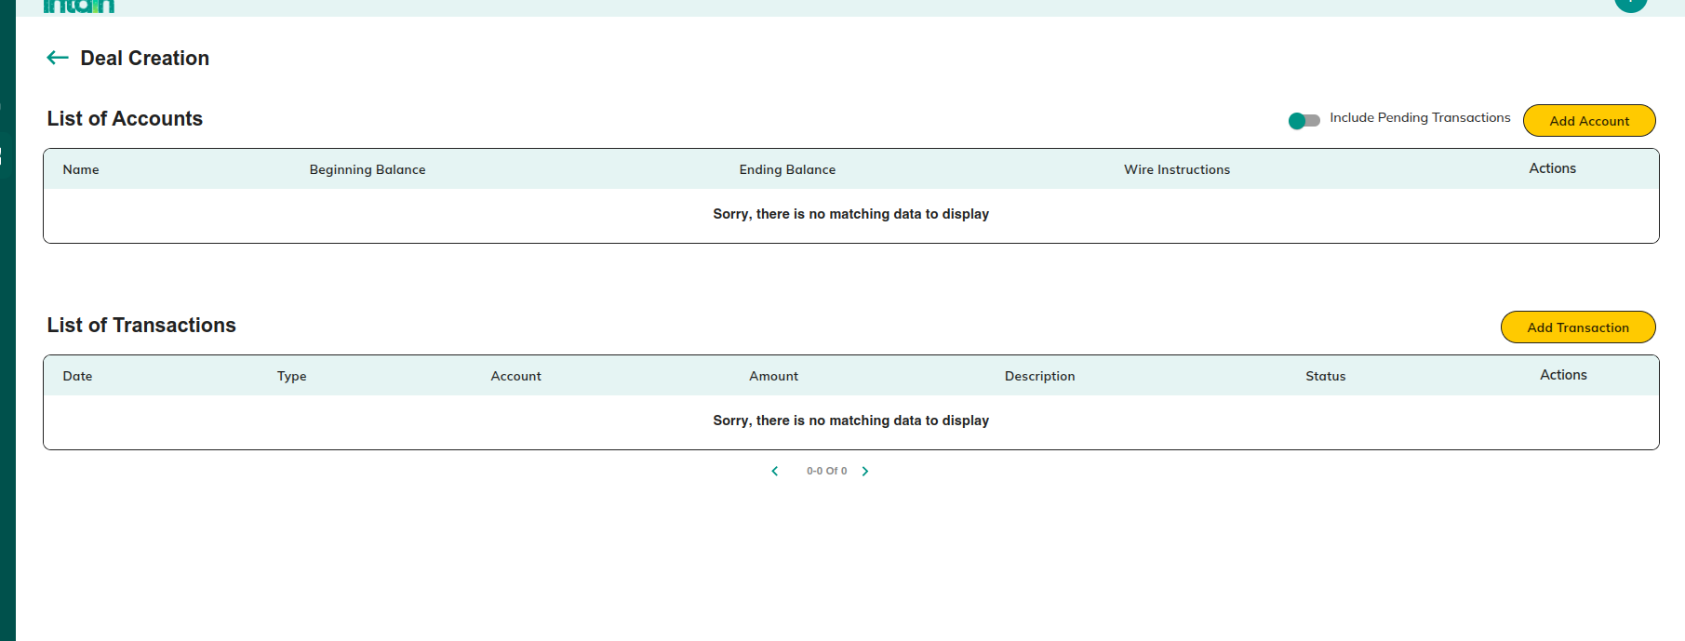

**Actions:**

* **Add Account**

Redirect to 2.3.1.3.2 Add Account

* **Edit Account**

Redirect to 2.3.1.3.3 Edit Account

* **Delete Account**

Redirect to 2.3.1.3.4 Delete Account

* **Add Transaction**

Redirect to 2.3.1.3.5 Add Transaction

* **Edit Transaction**

Redirect to 2.3.1.3.6 Edit Transaction

* **Delete Transaction**

Redirect to 2.3.1.3.7 Delete Transaction

#### 2.3.2.2 Add Account

Off-chain account information can be added using the Add Account option.

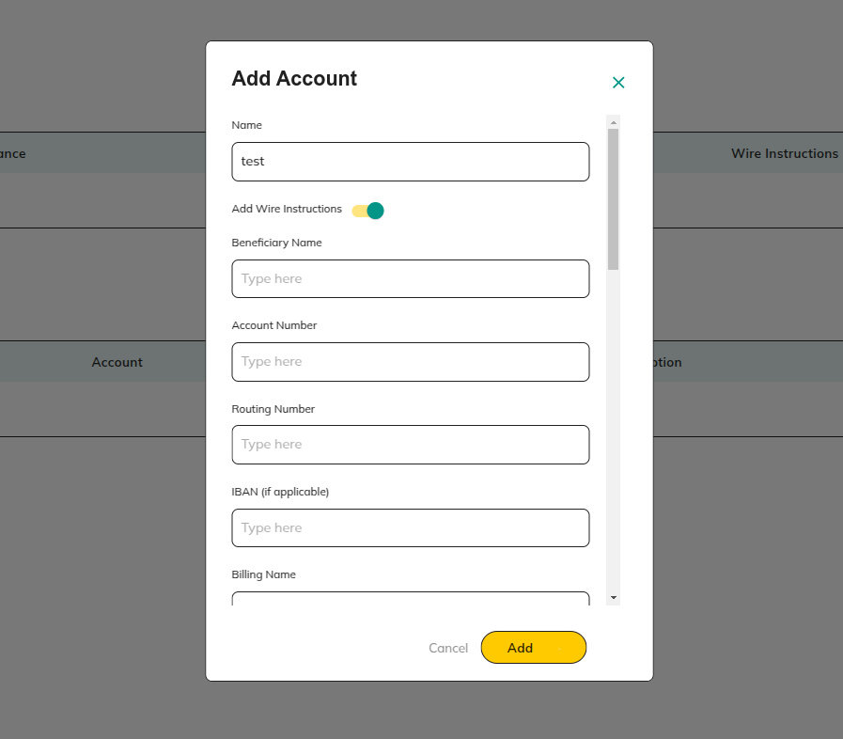

**Actions:**

* Cancel

Redirect to 2.3.1.3.1 Account Details

* Add

Redirect to 2.3.1.3.1 Account Details

#### 2.3.2.3 Edit Account

Using the edit option, off-chain account details can be edited.

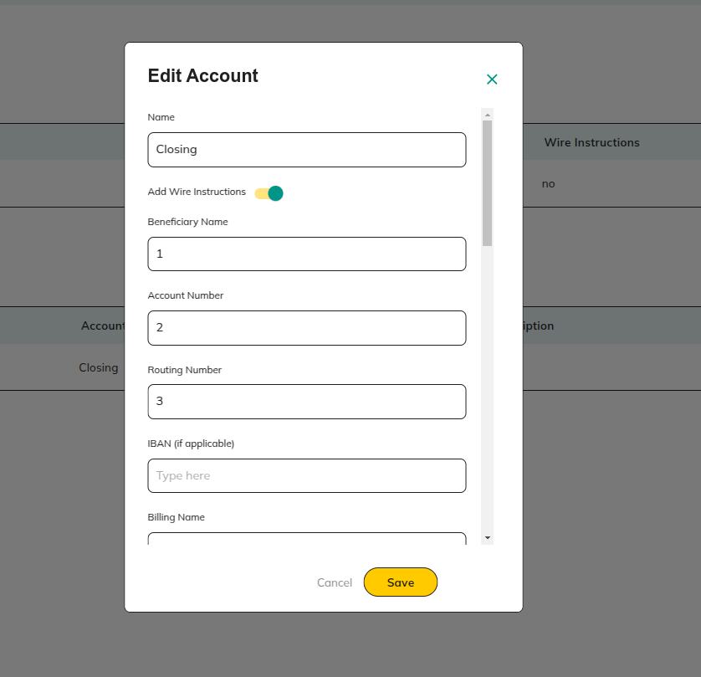

**Actions:**

* **Cancel**

Redirect to 2.3.1.3.1 Account Details

* **Save**

Redirect to 2.3.1.3.1 Account Details

#### 2.3.2.4 Delete Account

* Remove an **off-chain account** from the platform when it is no longer needed.

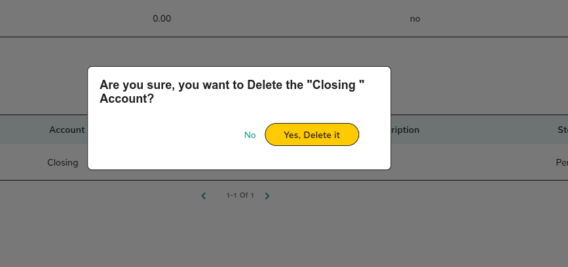

**Actions:**

* **No**

Redirect to 2.3.1.3.1 Account Details

* **Yes, Delete it**

Redirect to 2.3.1.3.1 Account Details

#### 2.3.2.5 Add Transaction

Off-chain transaction details can be added using **Add transaction** Option.

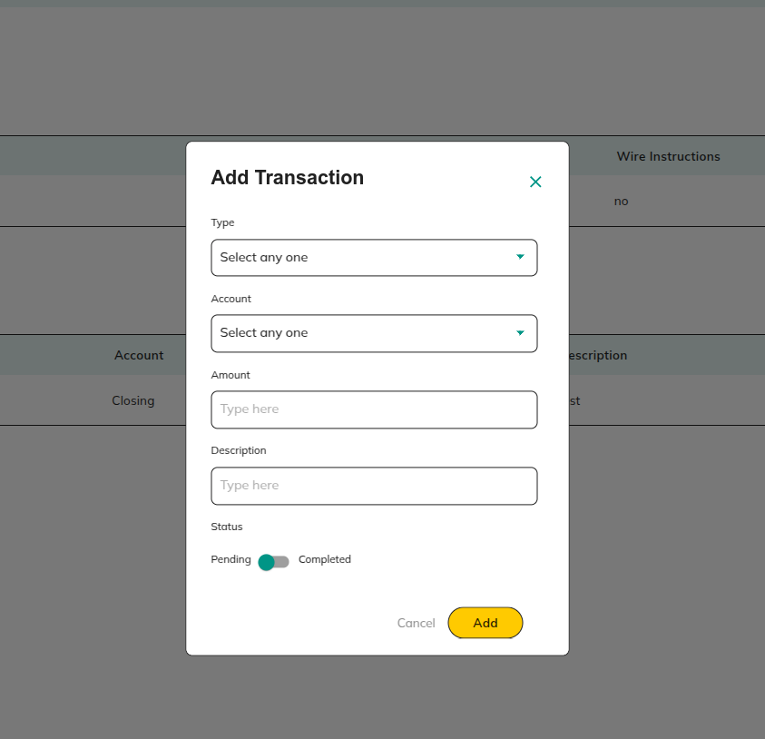

**Actions:**

* **Cancel**

Redirect to 2.3.1.3.1 Account Details

* **Add**

Redirect to 2.3.1.3.1 Account Details

#### 2.3.2.6 Edit Transaction

Using **Edit** **transaction**, added **off-chain** transaction details can be edited

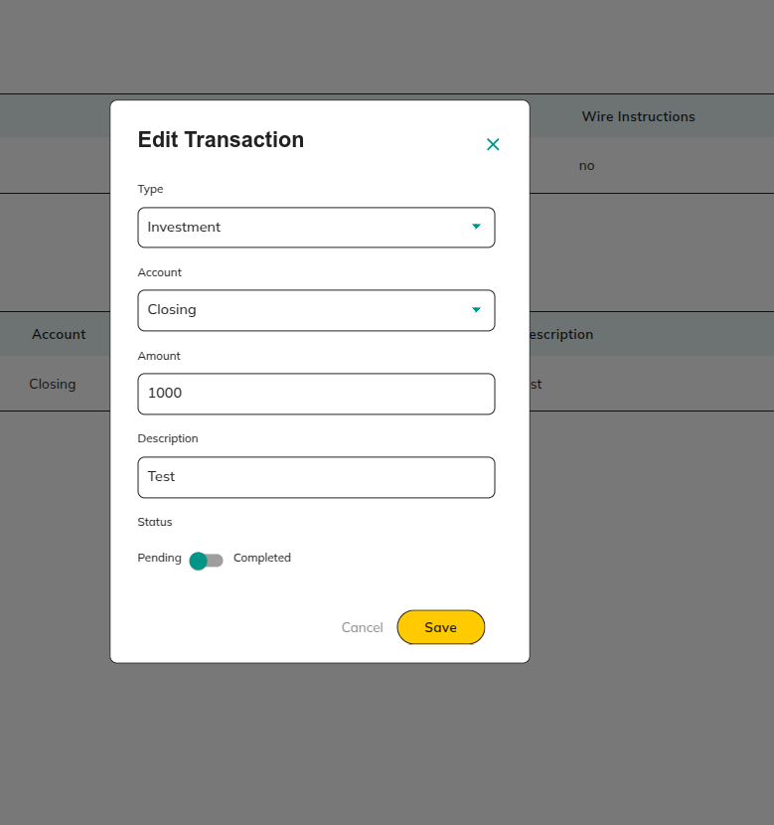

**Actions:**

* **Cancel**

Redirect to 2.3.1.3.1 Account Details

* **Save**

Redirect to 2.3.1.3.1 Account Details

#### 2.3.2.7 Delete Transaction

Using delete option, added off-chain transaction detail can be deleted

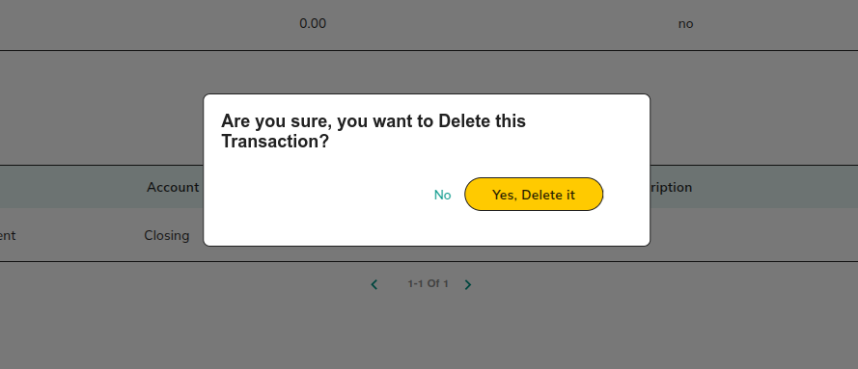

**Actions:**

* **No**

Redirect to 2.3.1.3.1 Account Details

* **Yes, Delete it**

Redirect to 2.3.1.3.1 Account Details

#### 2.3.2.8General Settings

Configure **deal-specific settings**, such as **transaction types** (off-chain/on-chain) and **investment states**, allowing for flexible deal management.

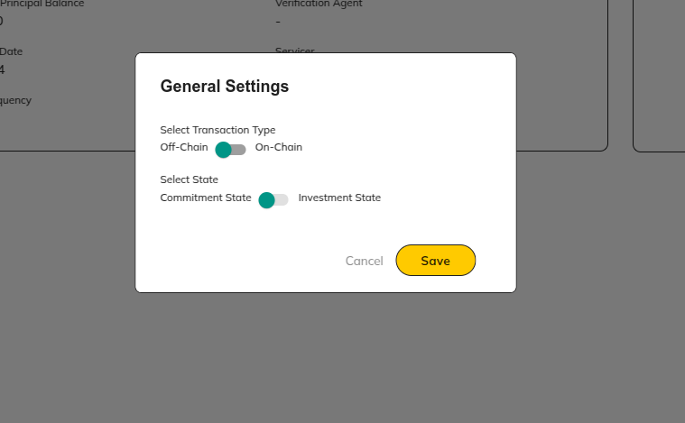

**Actions:**

* **Select Transaction Type**

Chooses off-chain or on-chain transactions.

* **Select State**

Initially the deal will be in the commit stage and once enough commitments have been made then underwriter can change from commit to invest stage.

* **Save**

Redirect to 2.3.1 View Deal Details

* **Cancel**

Redirect to 2.3.1 View Deal Details

# 3. Rating Agency

## 3.1 Preview - Pools

View a **list of pools** currently in the **Preview Stage**. This section enables rating agencies to **review pool details**, **accept or reject** pools, and navigate through related pool functionalities.

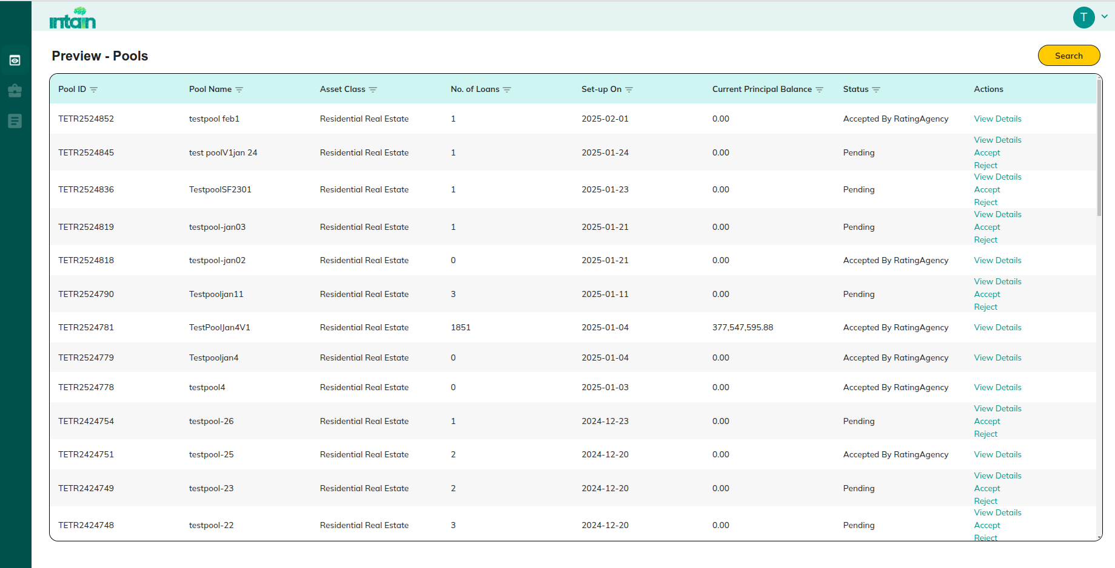

**Actions:**

* **View Details**

Redirect to 3.1.1 View Preview Pool Details:

* **Accept**

Redirect to 3.1 Preview - Pools

* **Reject**

Redirect to 3.1 Preview - Pools

* **Pools**

Redirect to **3.2 Pool**

* **Deals**

Redirect to 3.3 Deal

* **Filter**

Redirect to 1.2.3 Filter Option

### 3.1.1 View Preview Pool Details:

**Purpose**:

Provides **specific details** of a preview pool, including **loan compositions** and relevant **documents** for review.

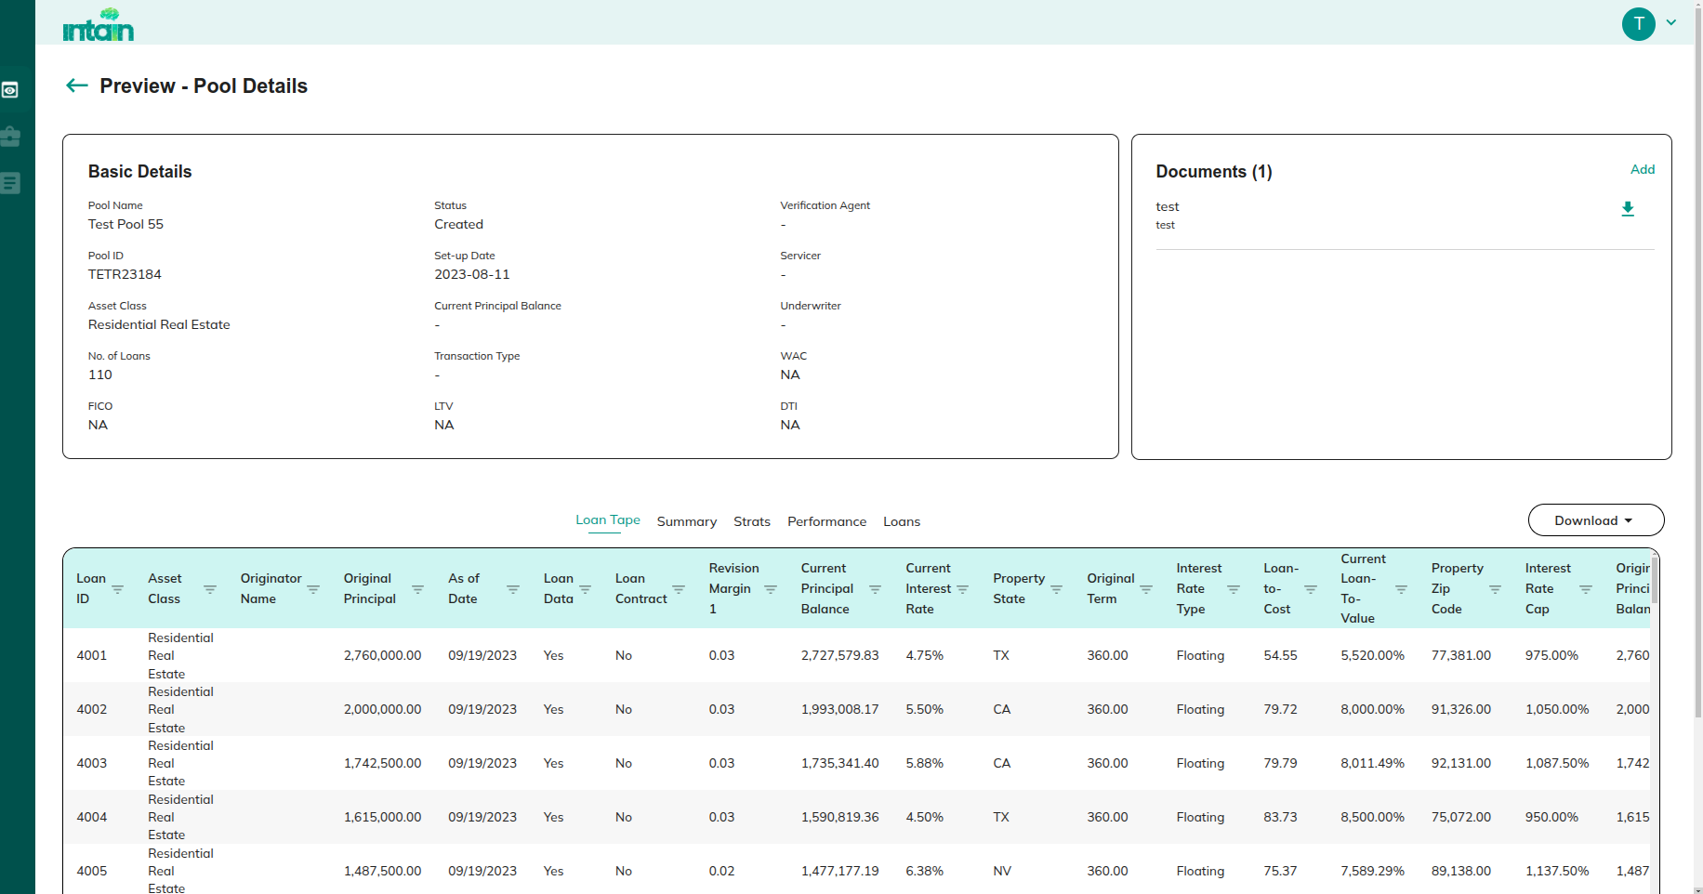

**Actions:**

* **Add Document: Uploads supporting documents to the pool.**
* **Download Document: Download the relevant documents associated with the pool.**
* **Download: Downloads complete pool details in XL/CSV format.**

## 3.2 Pool

View a **comprehensive list of pools** with detailed information, allowing rating agencies to **assess, approve, or reject** pools based on provided data.

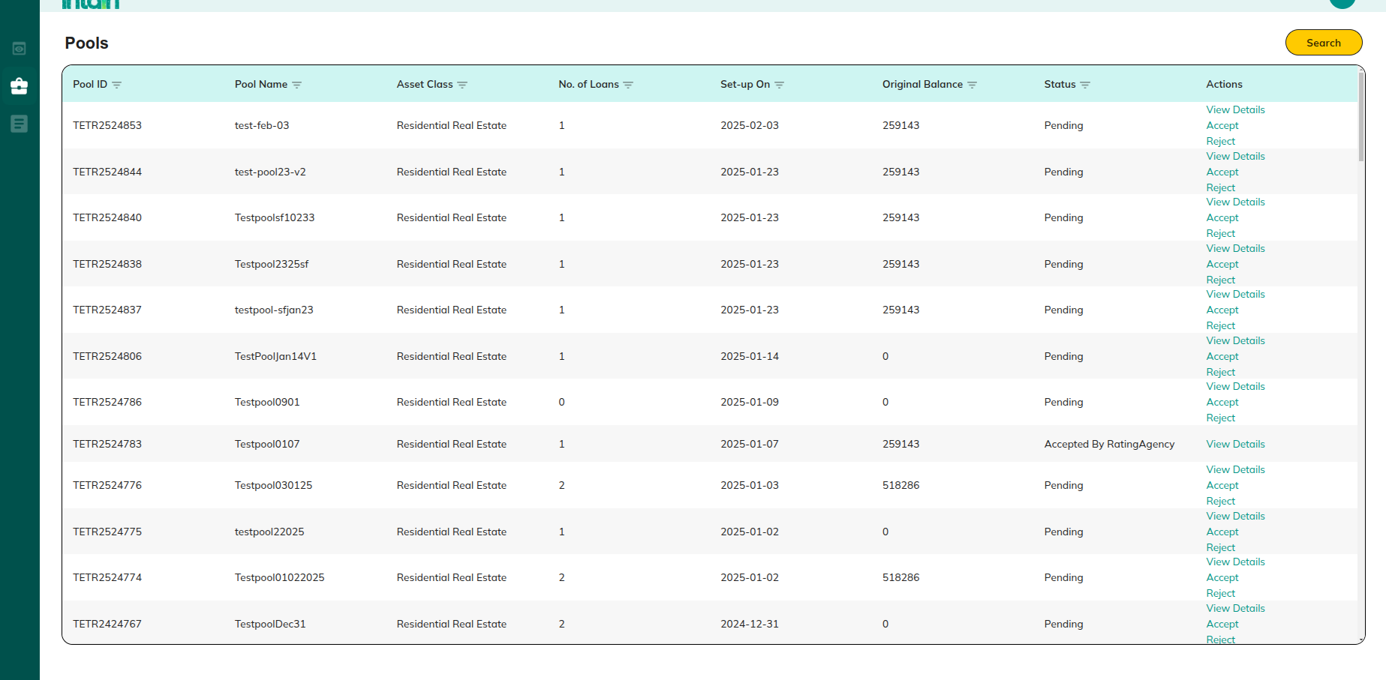

**Actions:**

* **View Details**

Redirect to 2.2.1 View Pool Details:

* **Accept**

Redirect to 3.2 Pool

* **Reject**

Redirect to 3.2 Pool

* **Filter**

Redirect to 1.2.3 Filter Option

* **Add Document: Uploads supporting documents to the pool.**
* **Download Document: Download the relevant documents associated with the pool.**
* **Download: Downloads complete pool details in XL/CSV format.**

## 3.3 Deal

**Purpose:**

This screen displays a list of all deals, allowing rating agencies to view and manage deal details.

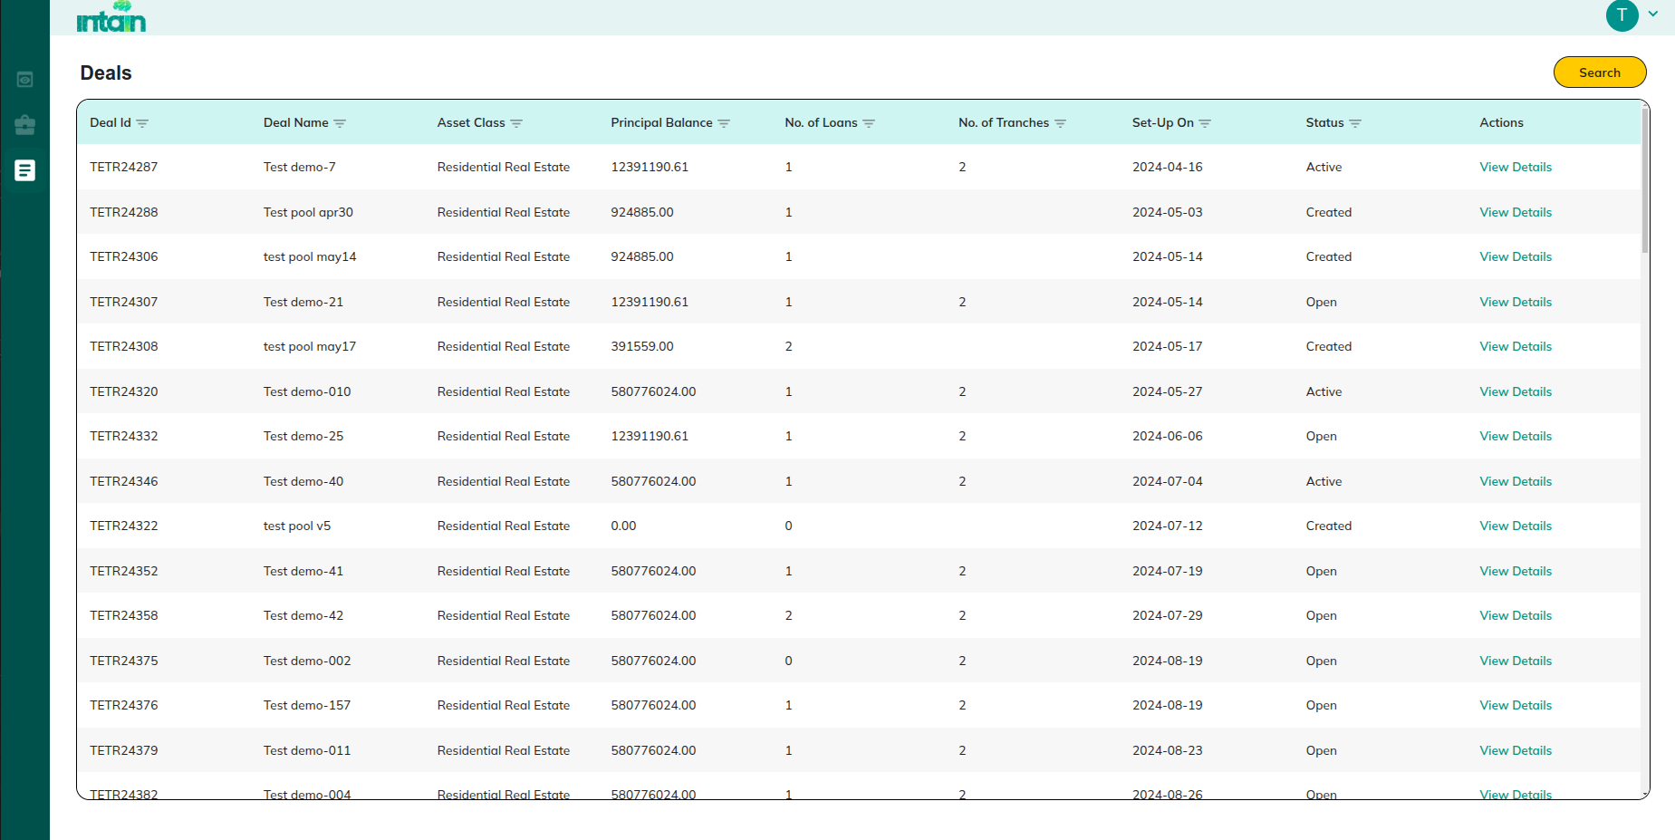

**Actions:**

* **View Details**

Redirect to 3.3.1 View Deals Details

### 3.3.1 View Deals Details

Provides **detailed information** about a specific deal, including **financial structures**, **tranche performance**, and associated pool details.

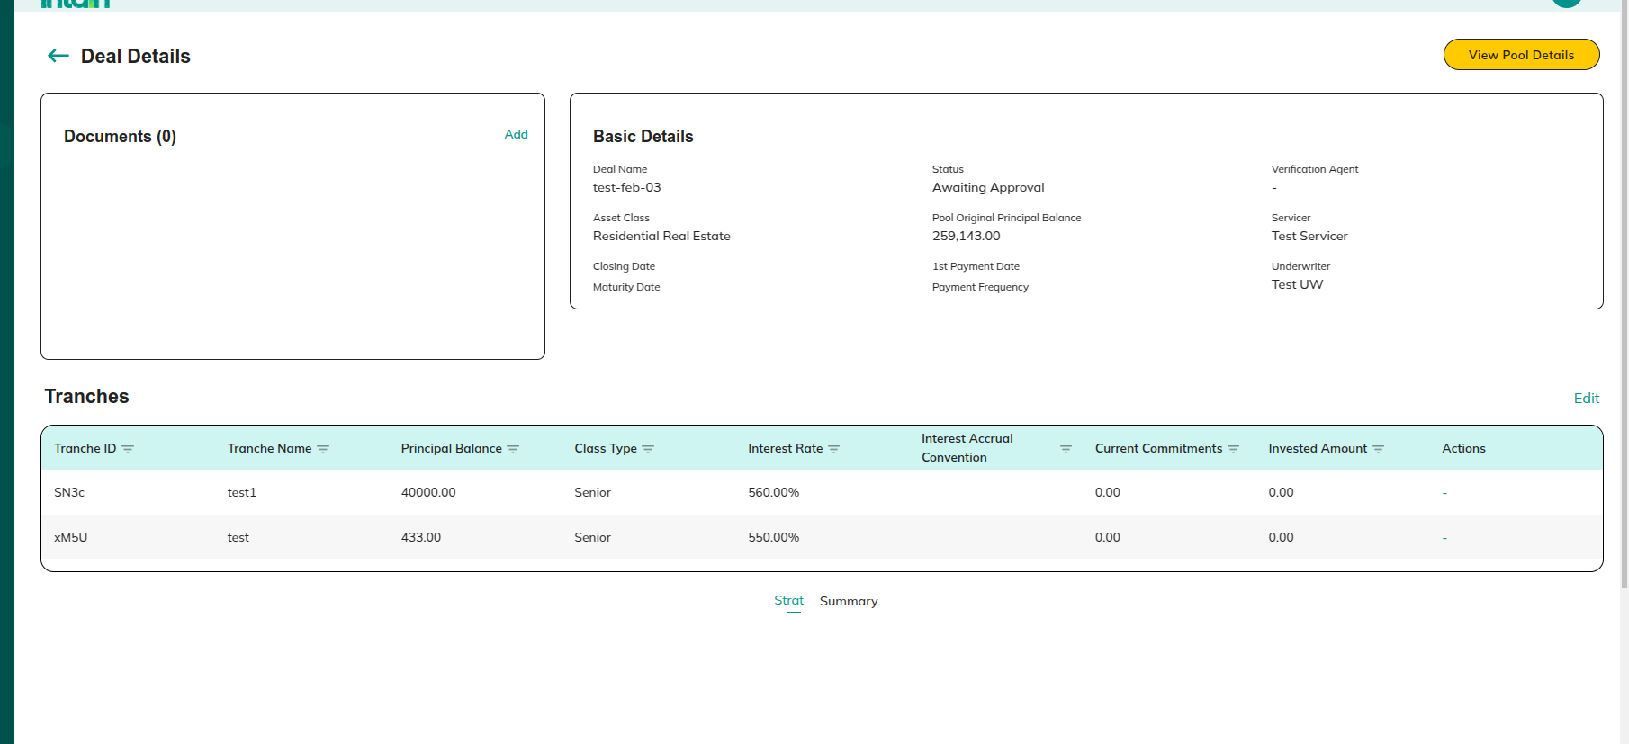

**Actions:**

* **View Pool details**

Redirect to 2.2.1 View Pool Details:

* **Add Document: Uploads supporting documents to the pool.**

# 4. Investor:

## 4.1 Preview Pools

View a **list of pools** currently in the **Preview Stage**. This section allows investors to **review pool details.**

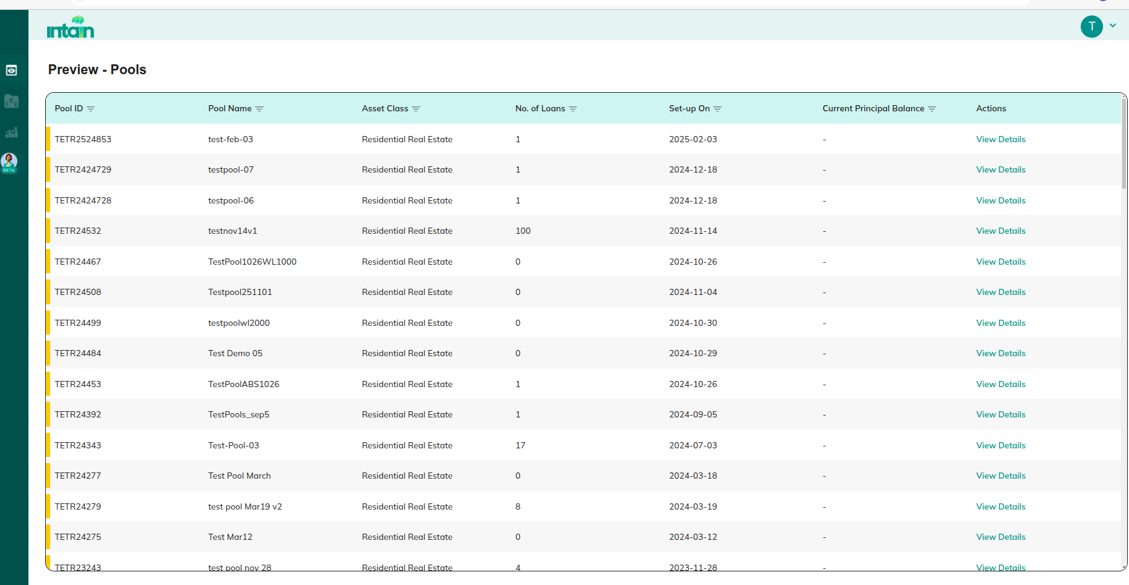

**Actions:**

* **View Details**

Redirect to 4.1.1 View Preview Pool Details

* **Portfolio**

Redirect to 4.2 Portfolio

* **Opportunities**

Redirect to 4.3 Opportunities

### 4.1.1 View Preview Pool Details

**Purpose:**

Provides **specific details** of a preview pool, allowing investors to review and provide feedback.

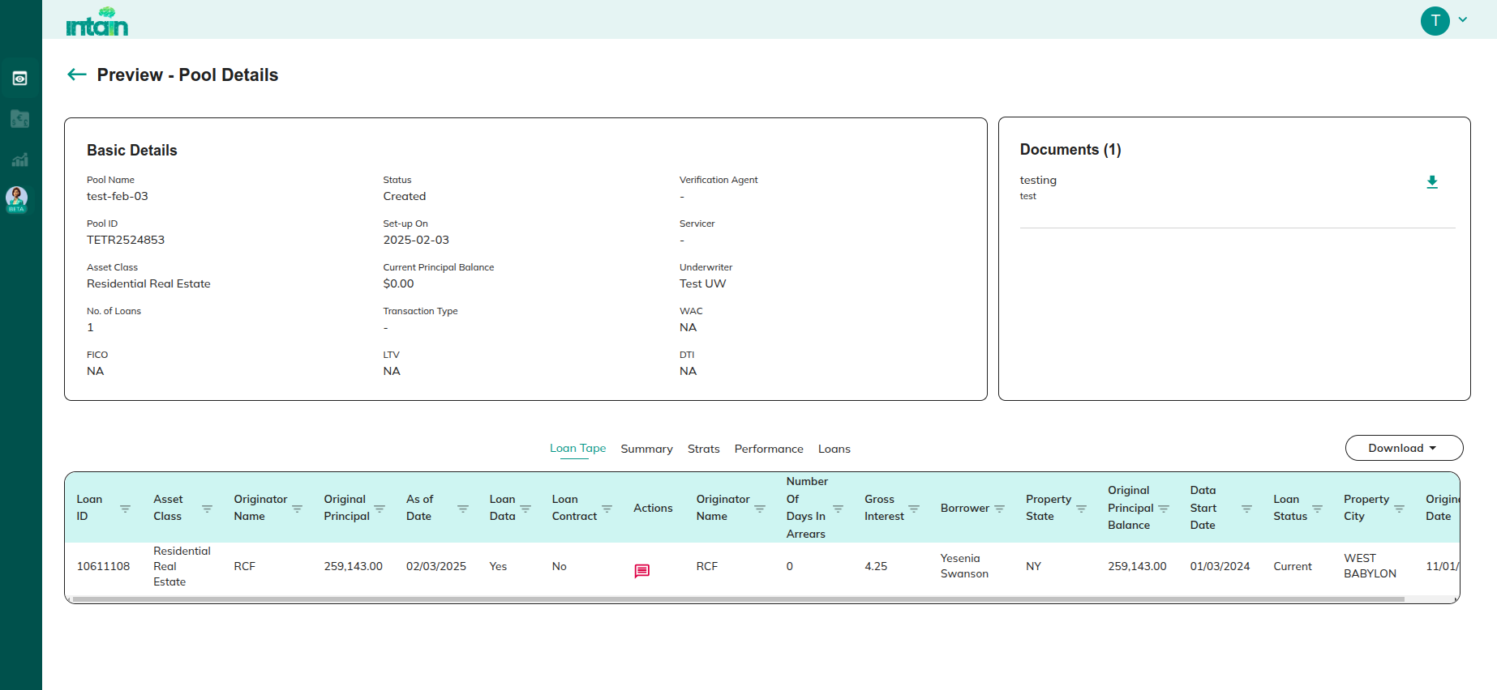

**Actions:**

* **Add / View Feedback**

1.1.2.3.3 Add / View the feedback

* **Download document**

2.1.1.1.1 Download Document

* **Download: Downloads complete pool details in XL/CSV format.**

## 4.2 Portfolio

**Purpose:**

Provides an **overview of the investor's portfolio**, displaying all active investments and their performance.

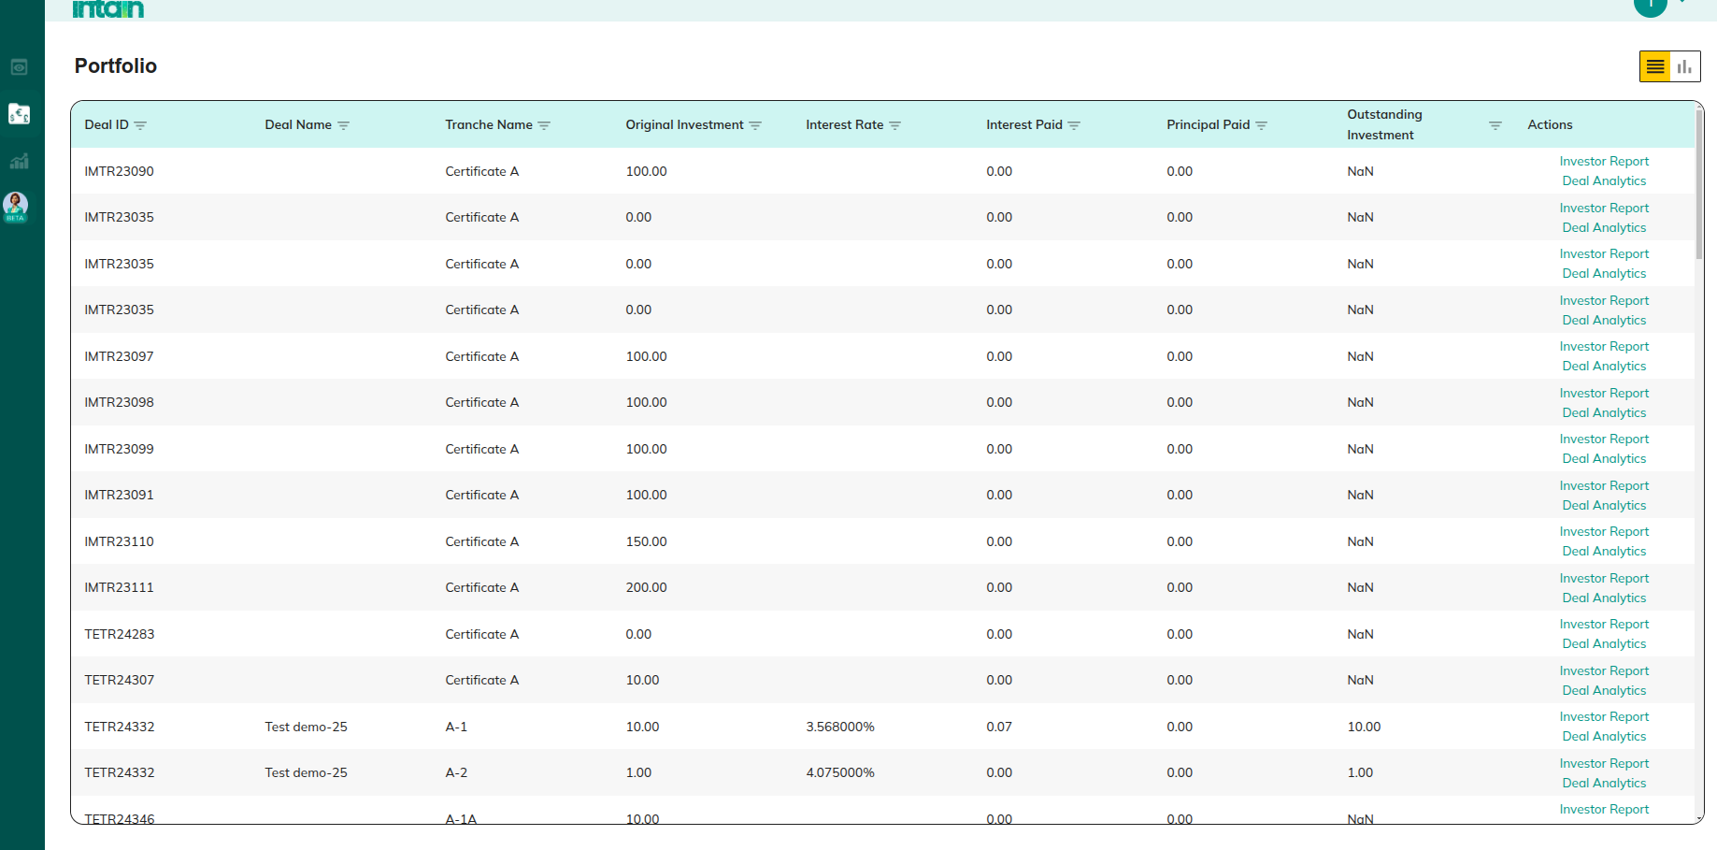

**Actions:**

* **Chart View**

Redirect to 4.2.1 Chart View

* **Investor Report**

Redirect to 4.2.2 Investor Report

* **Deal Analytics**

Redirect to 4.2.3 Deal Analytics

### 4.2.1 Chart View

Clicking on chart view connects to standard IA platform Viewing Portfolio analytics charts.

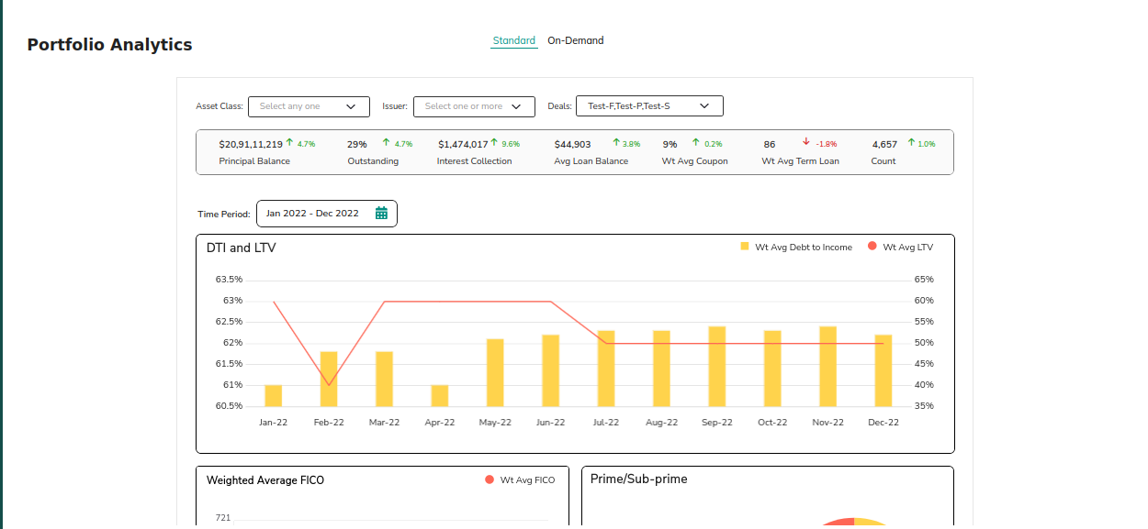

**Actions:**

* **Standard**

Analytical view of the investor Deals.

* **On-Demand**

Analytical view of the investor Deals.

### 4.2.2 Investor Report

**Purpose:**

This screen redirects to the **Standard IA Platform**, where investors can access detailed reports regarding their investments.

Clicking on investor Redirects to the **Standard IA Platform** to view detailed investor reports.

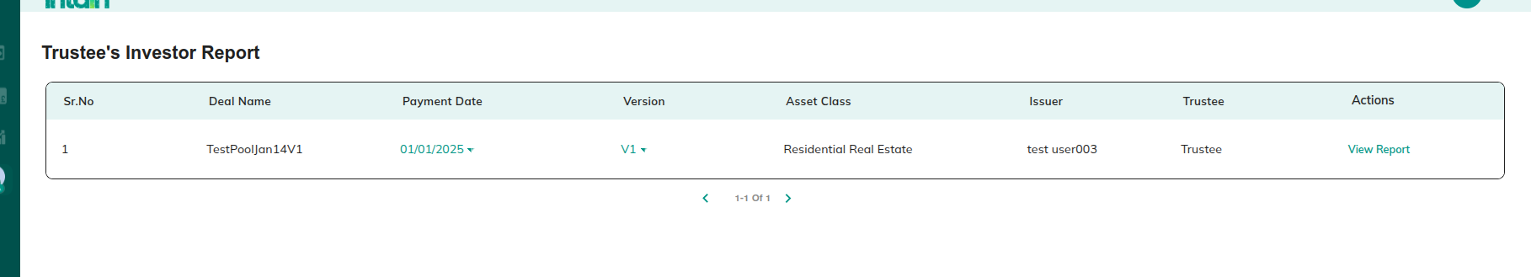

**Actions:**

* **View Report**

Redirect to 4.2.2.1 View Report

* **Payment date**

Here, based on the payment date, you can view the tranche investor report.

#### 4.2.2.1 View Report

Displays **specific investor report details**,

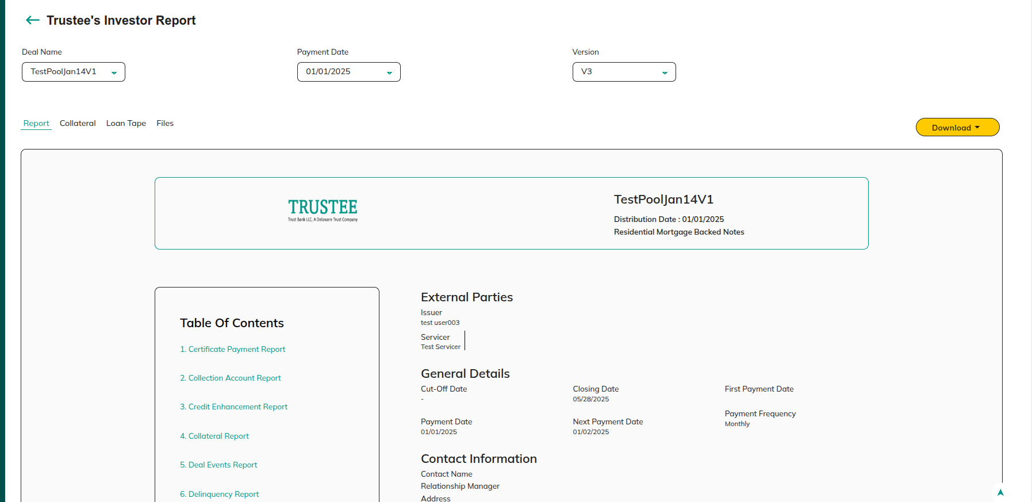

**Actions:**

* **Deal name**

Select the deal name in the Deal Name section. Based on the selected deal name, you can view the investor report.

* **Payment date**

Select the Payment Date in the Payment Date section. Based on the selected Payment Date, you can view the investor report.

* **Download**

Download the report in pdf or xl format.

### 4.2.3 Deal Analytics

Clicking on Deal analytics connect to standard IA platform viewing Deal analytics charts

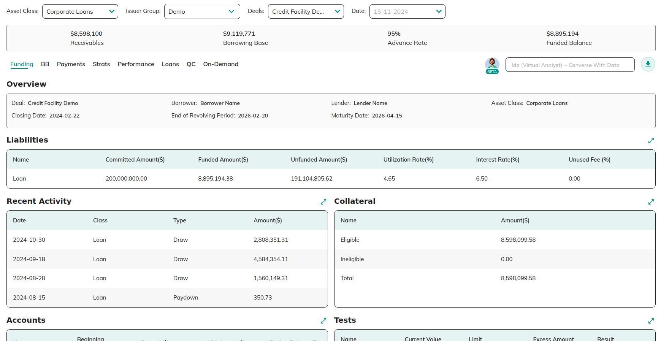

**Actions:**

* From the dropdown menu , the user can select **Asset type** , **Issuer group** and **deals** to view specific selected details.

## 4.3 Opportunities

**Purpose:**

This screen displays a list of deals published by issuers that are available for investor review and action. Investors can explore two types of deals:

1. **Securitization Deal**
2. **Whole Loan Deal**

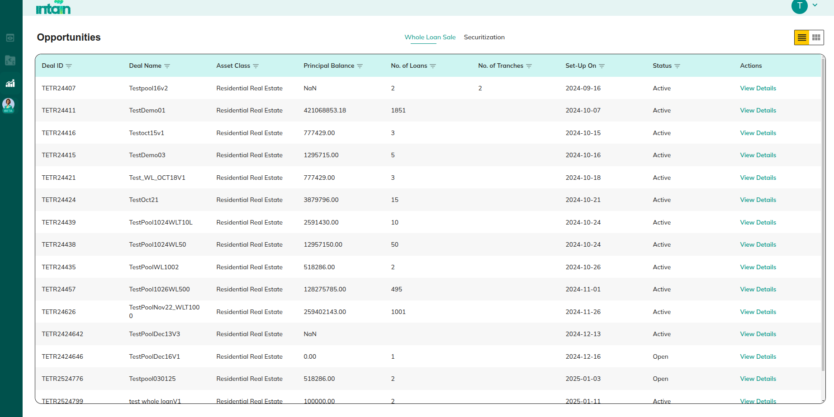

### 4.3.1 View Securitization Deal Details

**Purpose:**

This screen provides in-depth details of a securitization deal, including investment options and related pool data. Investors can commit funds, invest, view pool details, or download relevant documents for further analysis.

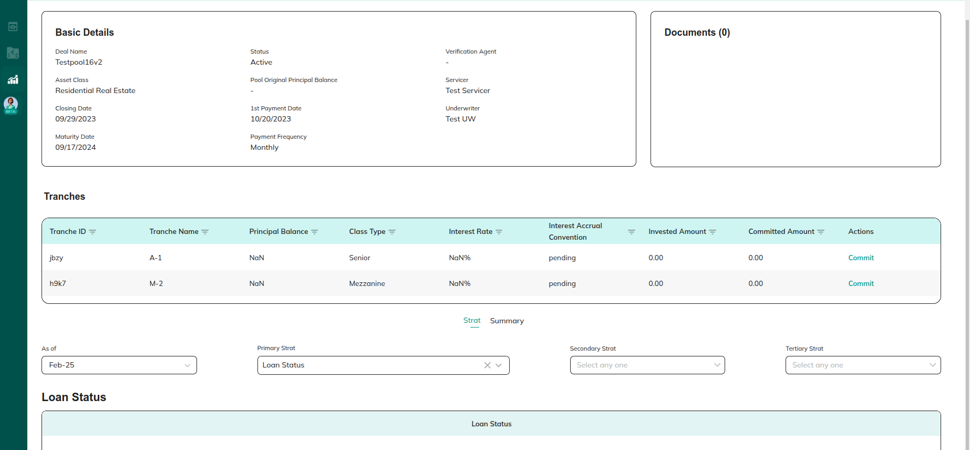

**Actions:**

* **Commit / Edit Commit**

Redirect to 4.3.2 View Deal Details

* **Invest**

Redirect to 4.3.4 Invest

* **View Pool details**

Redirect to 3.1.1 View Preview Pool Details:

* **Download document**

Redirect to 2.1.1.1.1 Download Document

#### 4.3 1.1 Commit

**Purpose:**

This screen allows investors to enter and confirm the amount they wish to commit to a securitization deal.

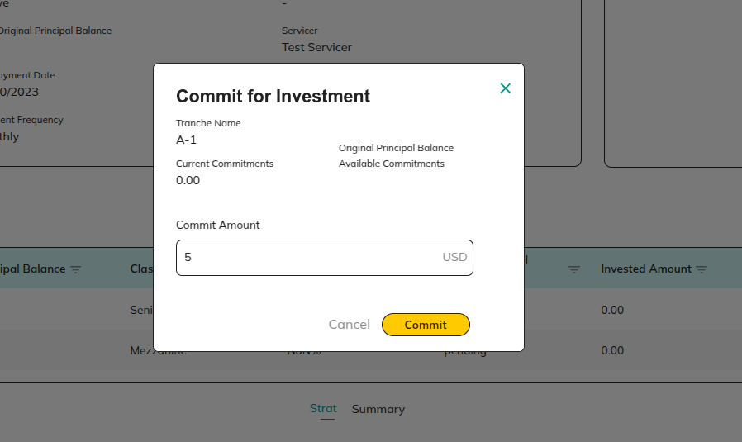

**Actions:**

* **Commit**

Redirect to 4.3 Opportunities

* **Cancel**

Redirect to 4.3 Opportunities

#### 4.3.1.2 Invest

During the investment stage, the investor can invest the committed amount. The user needs to make the payment in off-line using the wire instructions displayed in the popup. And once the transaction is completed then click on completed.

Later, the transaction will be verified by the Paying agent and FT’s will be transferred back.

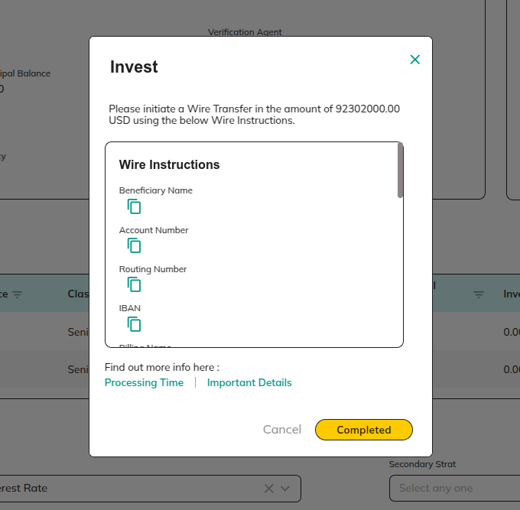

**Actions:**

* **Cancel`**

Redirect to [4.3.2 View Deal Details](https://docs.google.com/document/d/1YhbEes8AEAzp13QS6QHfZjBtCCSb0vYA0LjwGQO0i1w/edit?pli=1#heading=h.v65o4o6ubtn3)

* **Completed**

Redirect to [4.3.2 View Deal Details](https://docs.google.com/document/d/1YhbEes8AEAzp13QS6QHfZjBtCCSb0vYA0LjwGQO0i1w/edit?pli=1#heading=h.v65o4o6ubtn3)

### 4.3.2 View Whole Loan Deal:

**Purpose:**

This screen provides details of a **Whole Loan Deal**, which does not include tranches. Investors can review deal-related documents and evaluate the loan purchase opportunity.

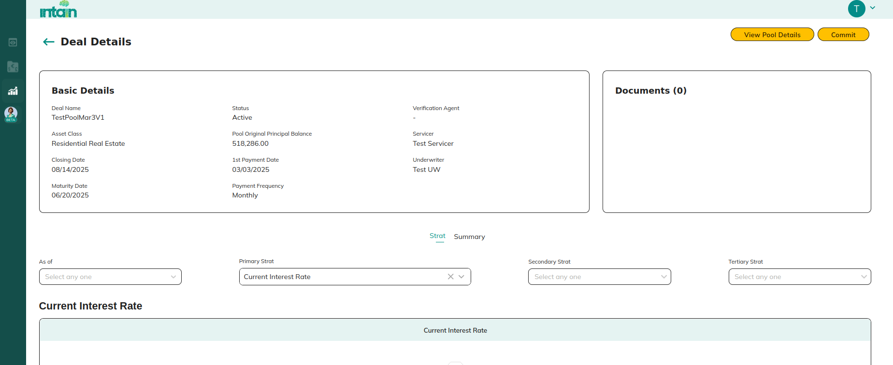

**Actions:**

* **Download document**

Redirect to 2.1.1.1.1 Download Document

* **View Pool Details**

Redirect to [3.1.1 View Preview Pool Details:](https://docs.google.com/document/d/1YhbEes8AEAzp13QS6QHfZjBtCCSb0vYA0LjwGQO0i1w/edit?pli=1#heading=h.dxhft5feuvmj)

* **Commit / Invest**

If commit stage Redirect to 4.3.2.1 Commit

If invest stage Redirect to 4.3.1.2 Invest

#### 4.3.2.1 Commit

**Purpose:** During the commit stage, investors can commit the whole amount in the deal.

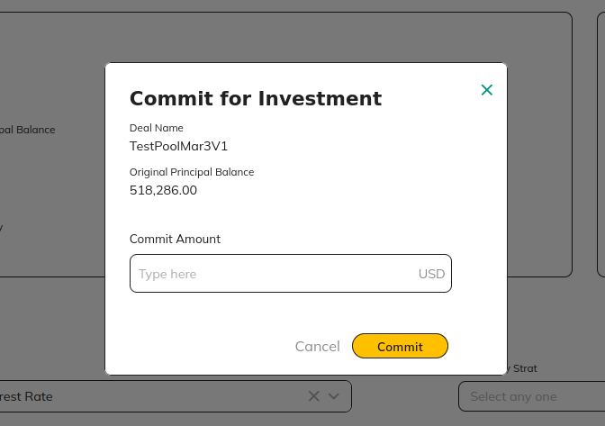

**Actions:**

* **Cancel**

Redirect to 4.3.2 View Whole Loan Deal:

* **Commit**

Redirect to [4.3.2 View Whole Loan Deal:](https://docs.google.com/document/d/1YhbEes8AEAzp13QS6QHfZjBtCCSb0vYA0LjwGQO0i1w/edit?pli=1&tab=t.0#heading=h.rfbk4whebm0x)

# 5. Servicer:

## 5.1 Deals

**Purpose:**

This screen provides a list of deals available on the **Servicer Dashboard**. Servicers can process loan tapes, view deal details, and View aggregate summaries for better monitoring and reporting.

### 5.1.1 If Securitization Deal

View a **list of deals** in the **Servicer Dashboard**. This section enables servicers to **process loan tapes**, **view deal details**, and **View Aggregate Summary**

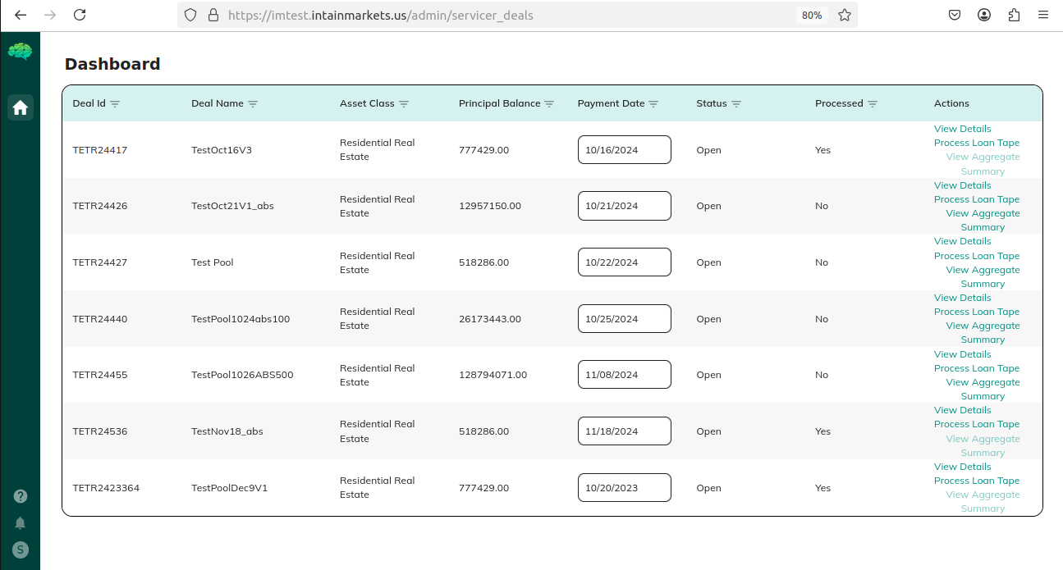

**Actions:**

* **View details**

Redirect to 4.3.2 View Deal Details

* **Process Loan Tape**

Redirect to 5.1.1 Process Loan Tape:

* **View Aggregate Summary**

Redirect to  5.1.5 Summarize

#### 5.1.1.1 Process Loan Tape:

**Purpose:**

This screen allows servicers to upload a **loan tape (Excel file)** for a specific payment date. The uploaded file ensures accurate loan data processing for securitization and whole loan deals before being committed to the **Digital Ledger**.

Clicking on process tape redirects to a screen where the servicer can upload a loantape for a specific payment date.

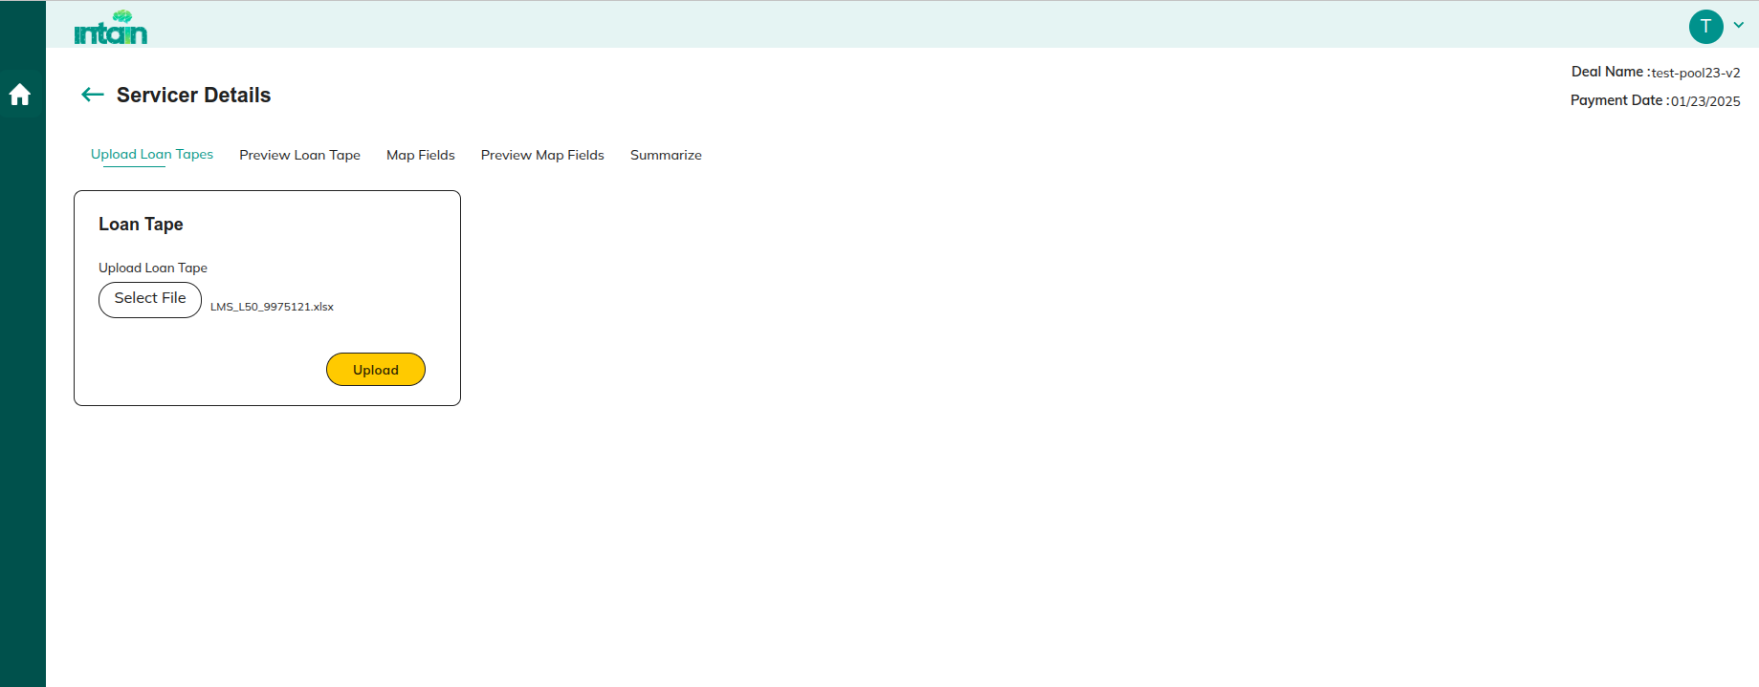

**Actions:**

* **Upload**

Upload Servicer loantape xl for a specific payment and clicking on upload redirect to  5.1.2 Preview Loantape

* **Preview Loan Tape**

Redirect to  5.1.2 Preview Loantape

* **Map Fields**

Redirect to 5.1.3 Map Fields

* **Preview Map fields**

Redirect to 5.1.4 Preview Map Fields

* **Summarize**

Redirect to  5.1.5 Summarize

#### 5.1.1.2 Preview Loantape

**Purpose:**

Displays the details of the uploaded loan tape before processing further. This screen allows servicers to validate the data before mapping fields.

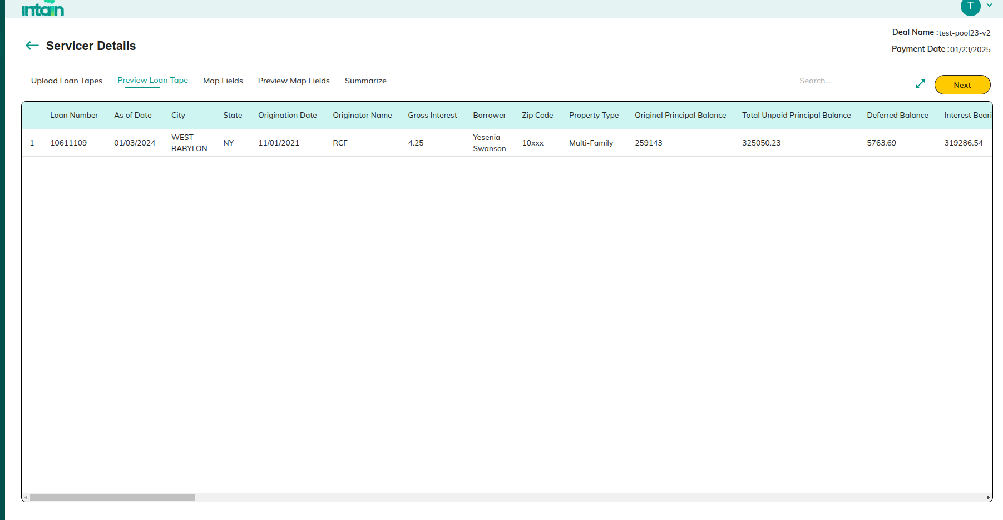

**Actions:**

* **Upload Loan Tape**

Redirect to 5.1.1 Process Loan Tape:

* **Map Fields**

Redirect to 5.1.3 Map Fields

* **Preview Map fields**

Redirect to 5.1.4 Preview Map Fields

* **Summarize**

Redirect to  5.1.5 Summarize

* **Next**

Redirect to 5.1.3 Map Fields

#### 5.1.1.3 Map Fields

**Purpose:**

This screen allows servicers to map raw loan tape fields to **standard Intain fields**.

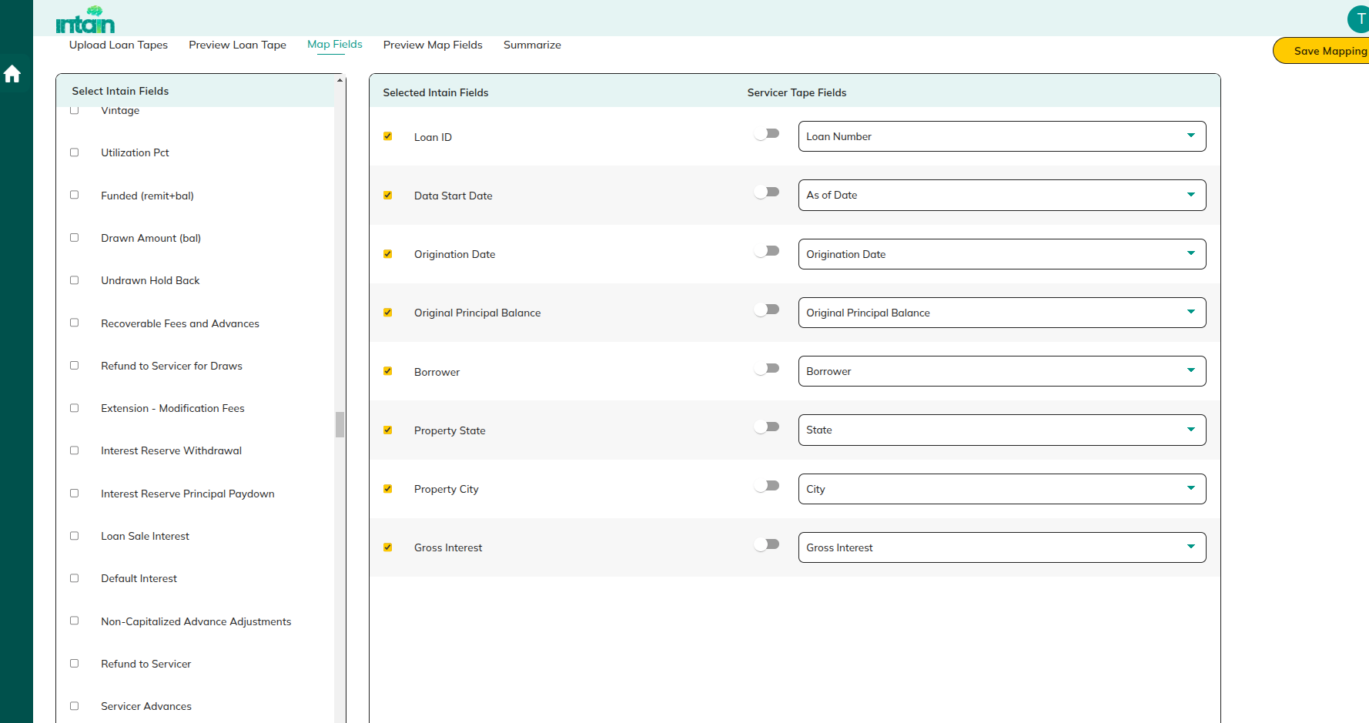

**Actions:**

* **Upload Loan Tape**

Redirect to 5.1.1 Process Loan Tape:

* **Preview Loan Tape Fields**

Redirect to  5.1.2 Preview Loantape

* **Preview Map fields**

Redirect to 5.1.4 Preview Map Fields

* **Summarize**

Redirect to  5.1.5 Summarize

* **Save Mapping**

Save the details in db and redirects to 5.1.4 Preview Map Fields

#### 5.1.1.4 Preview Map Fields

**Purpose:**

Mapped standard fields are displayed in **Preview Map** fields. Users can switch back to the Map fields section and **edit the Mapping** whenever required.

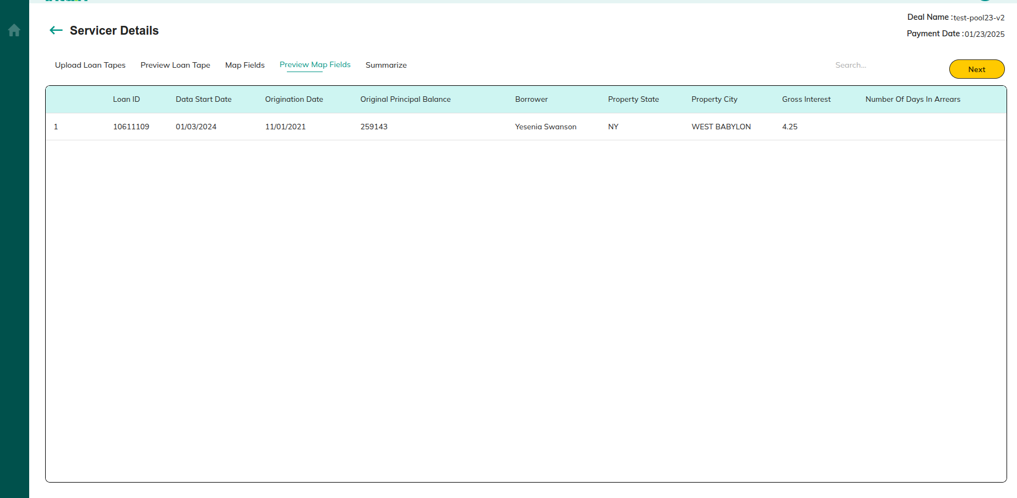

**Actions:**

* **Upload Loan Tape**

Redirect to 5.1.1 Process Loan Tape:

* **Preview Loan Tape Fields**

Redirect to  5.1.2 Preview Loantape

* **Map fields**

Redirect to 5.1.3 Map Fields

* **Summarize**

Redirect to  5.1.5 Summarize

* **Next**

Preview the details and clicking on next redirect to Redirect to  5.1.5 Summarize

#### 5.1.1.5 Summarize

**Purpose:**

**Servicer summary details** will be calculated and displayed on the screen. Servicer can commit the details to the blockchain by clicking on “**Commit to Digital Ledger**”

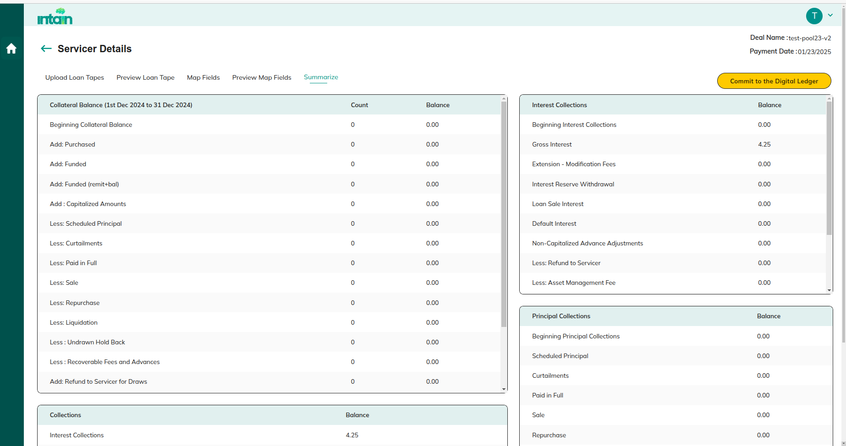

.

**Actions:**

* **Upload Loan Tape**

Redirect to 5.1.1 Process Loan Tape:

* **Preview Loan Tape Fields**

Redirect to  5.1.2 Preview Loantape

* **Map fields**

Redirect to 5.1.3 Map Fields

* **Preview Map fields**

Redirect to 5.1.4 Preview Map Fields

* **Commit To Digital Ledger**

The details will be committed to digital ledger.

# 6. Paying Agent

**Purpose:**

This section allows you to view a list of current paying agents, manage deal recurrence, and view deal details.

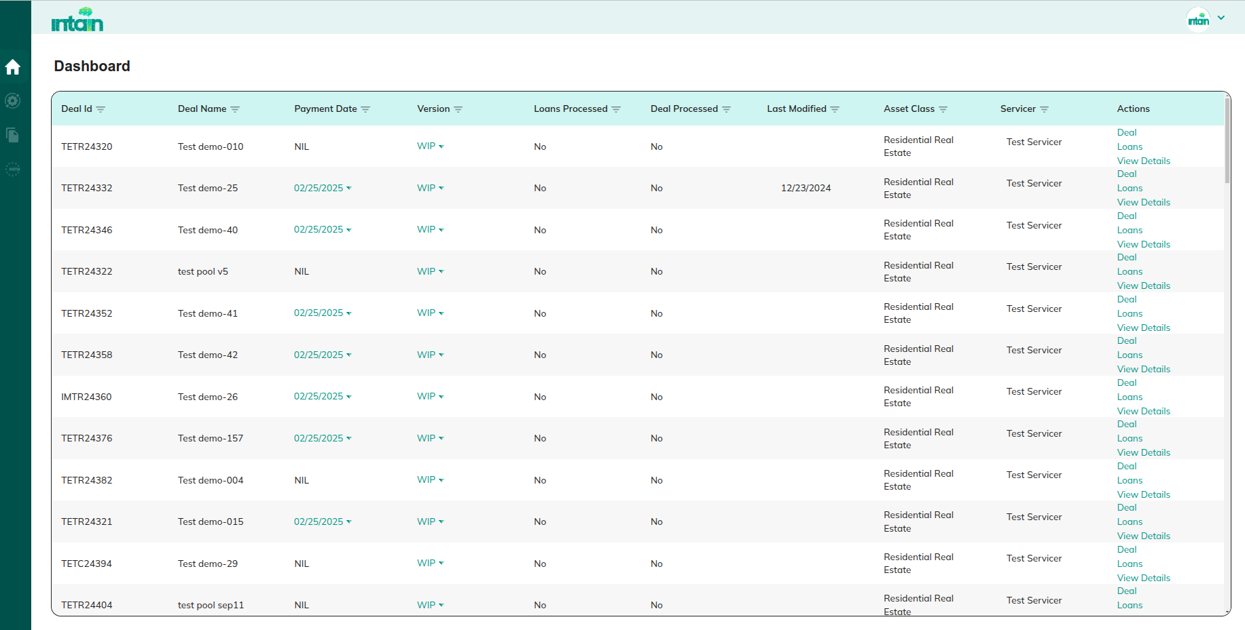

**Actions:**

* **Deals**

Redirect to 6.4 Deal Recurring

* **Loans**

Redirect to 6.3 Loans

* **View Details**

If securitization Redirect to 6.1 View Deal Details

If whole loan Redirect to 6.2 View whole loan Deal details

## 6.1 View Securitization Deal Details

**Purpose:**

This screen displays **detailed deal information**, including **payment status, investor** information**, and related documents**

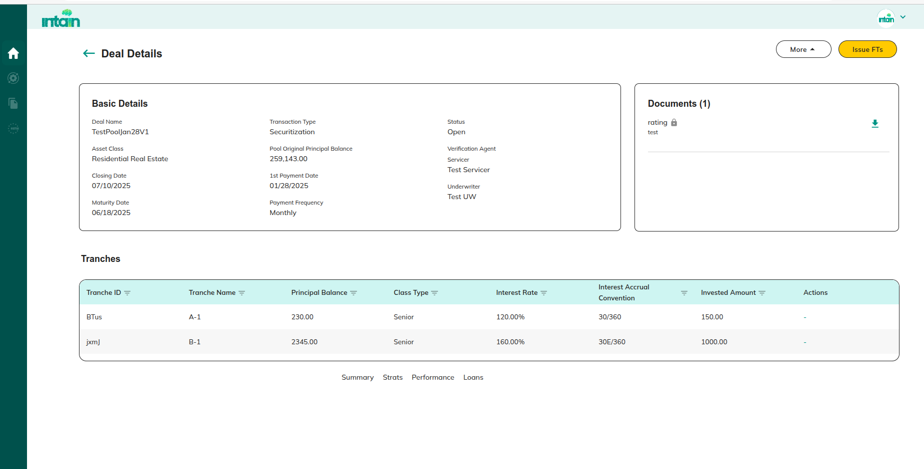

**Actions:**

* Issuer FT’s

Redirect to 6.1.1 Issue FT

* More
  + View pool Details

Redirect to 2.1.3 View Pool Details:

* + View Account Details

Redirect to 2.3.2.1 Account Details

* + View General Settings

Redirect to 2.3.2.8 General Settings

* Download document

Redirect to 2.1.1.1.Download Document

### 6.1.1 Issue FT

Once paying agents receive the investments from all the investors. FT’s will be transferred to the Investor individual account.

**Note**: After the Issue FT, the deal related details will be shared with the standard IA module.

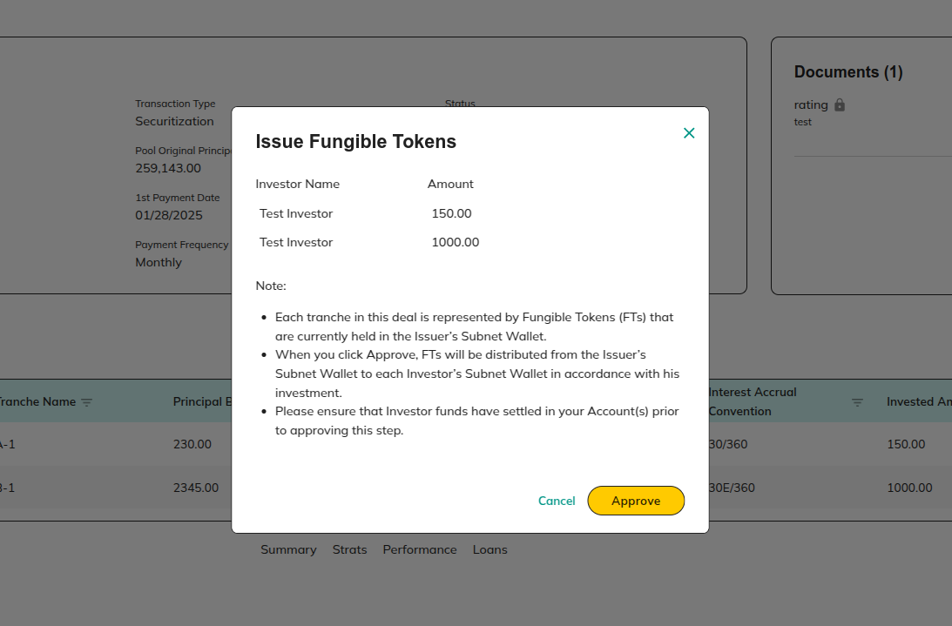

**Actions**

* **Cancel**

Redirect to 6.1.1 View Deal Details

* **Approve**

Redirect to 6.1.1 View Deal Details

#### 

## **6.2 View Whole Loan Deal details**

**Purpose:**

This screen displays **detailed deal information**, including **payment status, investor** information**, and related documents**

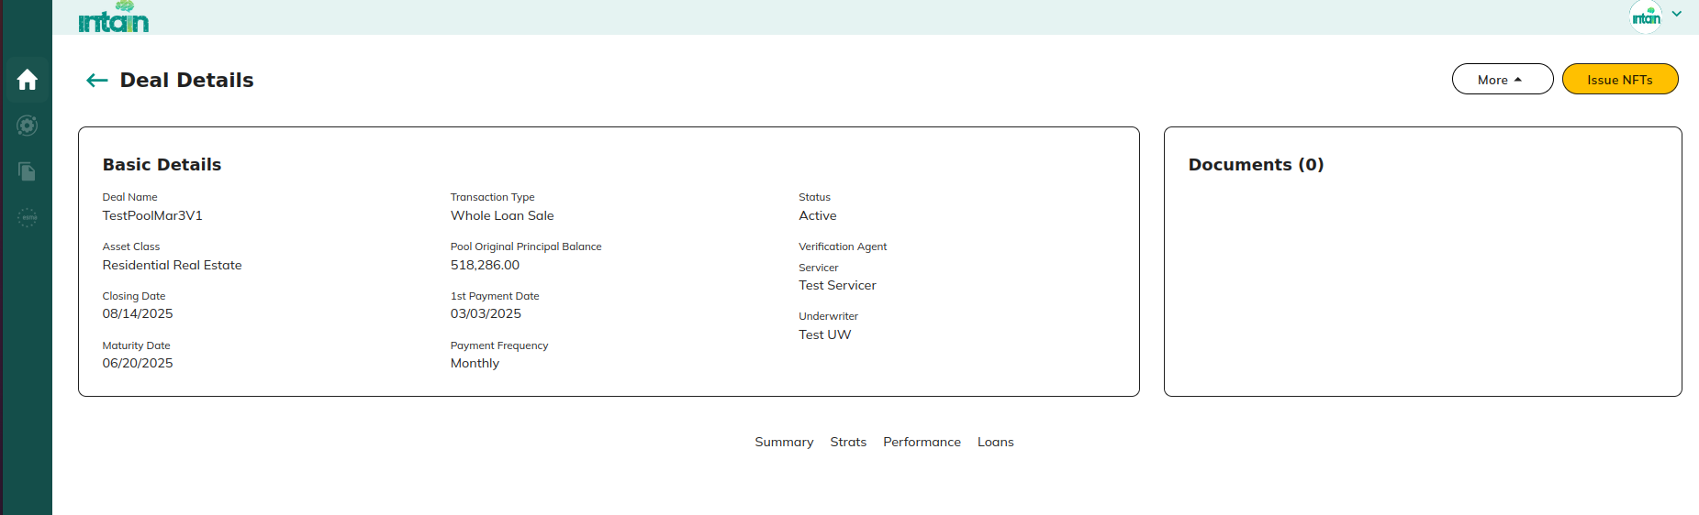

**Actions:**

* **Issue NFT’s**

### **6.2.1 Issue NFT**

This screen allows paying agent to transfer NFT’s on behalf on issuer

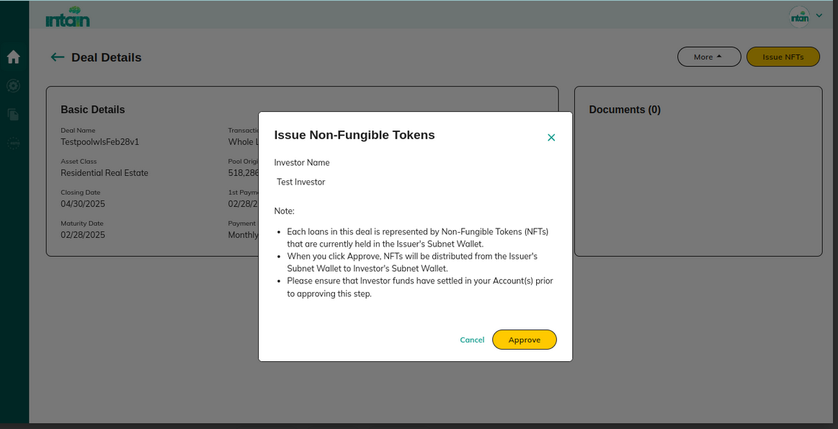

**Actions**

* **Cancel**

Redirect to 6.2 View Whole Loan Deal details

* **Approve**

Redirect to [6.2 View Whole Loan Deal details](https://docs.google.com/document/d/1YhbEes8AEAzp13QS6QHfZjBtCCSb0vYA0LjwGQO0i1w/edit?pli=1&tab=t.0#heading=h.r37so56jprt9)

## 6.3 Loans

View the **list of servicers** associated with a specific deal.

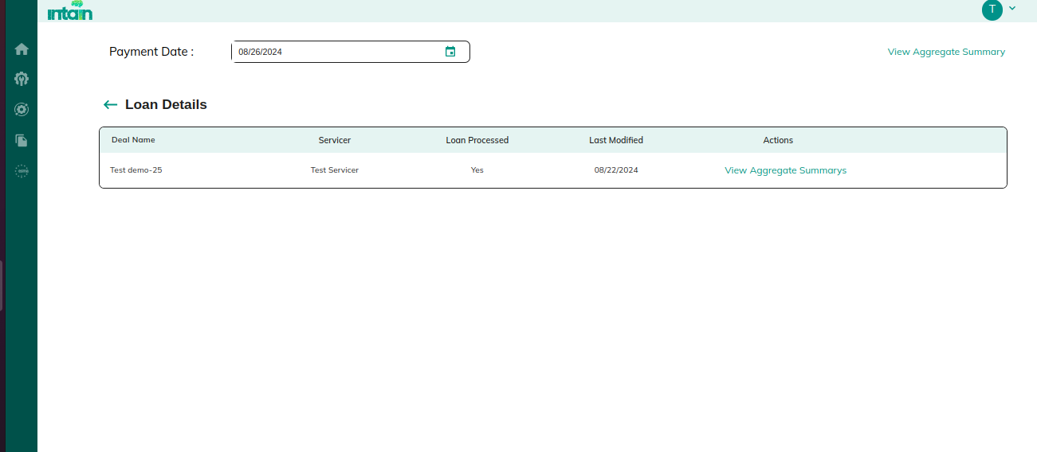

**Actions:**

* **Loan Details :- View Aggregate Summary**
* **View Aggregate Summary**

Redirect to 6.3.1 View Aggregate Summary

### 6.3.1 View Aggregate Summary

View the **overall aggregate summary details** related to the loan performance.

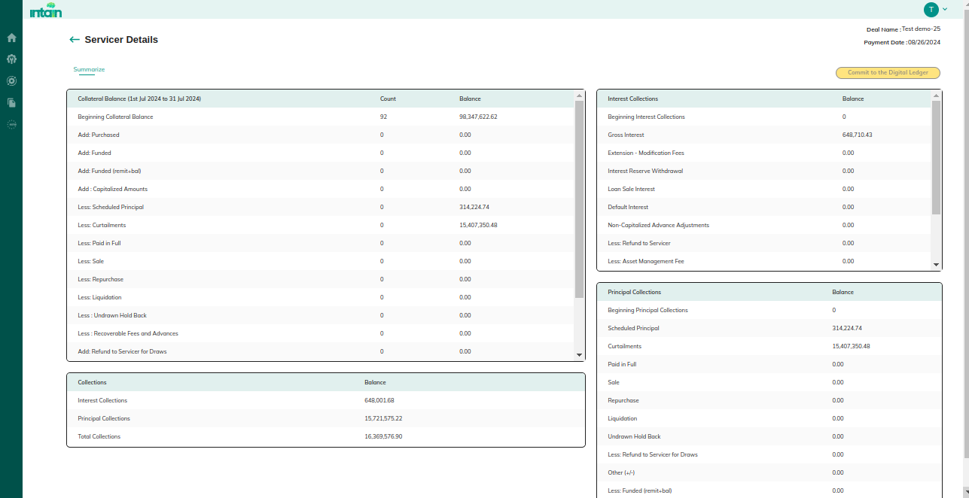

**Actions :**

* **Commit to Digital ledger**

Redirect to 6.1.2.1 View Aggregate Summary

## 6.4 Deal Recurring

* Connects to **Standard IA Applications**, allowing the **Paying Agent** to interact with and generate **Investor Reports**.

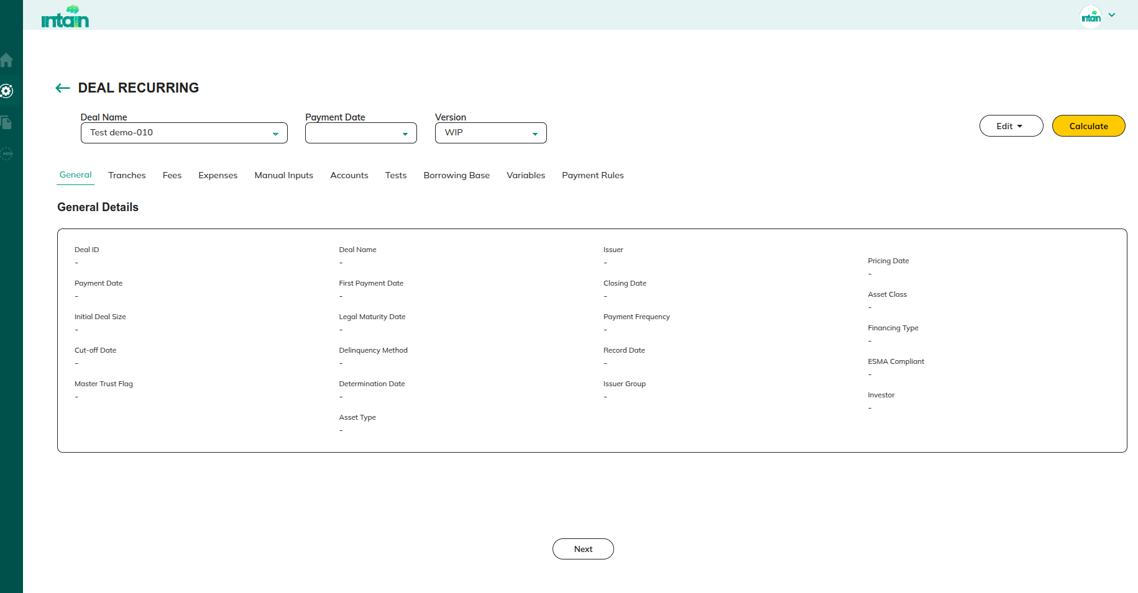

**Actions:**

* **Edit >> Deal**

Redirect to 6.5 Deal Creation

* **Calculate**

## 6.5 Deal Creation

**Purpose:**

Allows paying agents to **edit and manage deal creation details**, including tranches, fees, accounts, and payment rules.

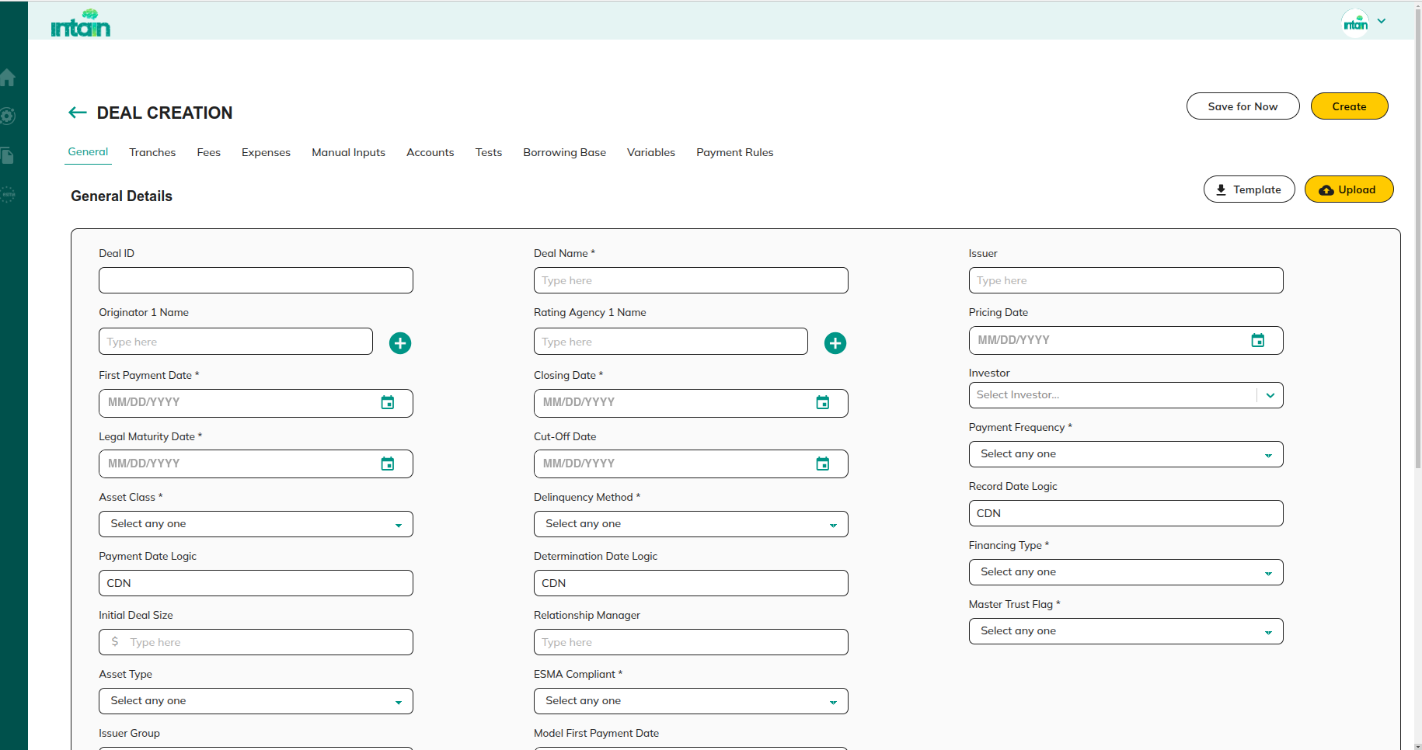

**Actions:**

**Edit**

* **general**

Redirect to 2.3.1.2.1 General

* Tranches

Redirect to 2.3.1.2.2 Tranches

* Fee

Redirect to 2.3.1.2.3 Fees

* Expenses

Redirect to 2.3.1.2.4 Expenses

* Manual Inputs

Redirect to 2.3.1.2 Tools

* Accounts

Redirect to 2.3.1.2.5 Account

* Tests

Redirect to 2.3.1.2.6 Tests

* Borrowing Base

Redirect to 2.3.1.2 Tools

* Variables

Redirect to 2.3.1.2.7 Variable

* Payment Rules

Redirect to 2.3.1.2.7 Payment Rules

### 6.5.1 Reporting

View **report details** generated for a specific **deal payment date**.

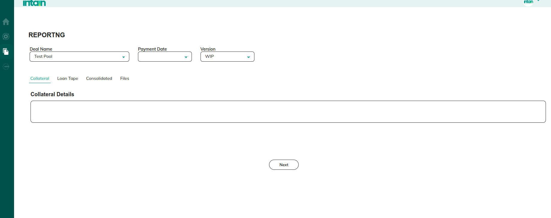

**Actions:**

* View **Collateral Report** details
* View **Loan Tape** details
* View **Consolidated** details
* **Files**

# 7. Verification agent

**Purpose:**This section enables the **Verification Agent (VA)** to review, verify, and certify loans associated with the batch. The VA is responsible for checking loan details, validating them against system records, and certifying loans before they move to the further processing.

## 7.1 Batch

**Purpose:**This screen provides a **list of loan details associated with the batch**. The VA can review loan data, accept or reject batches, verify individual loans, and download a VA certificate upon successful verification.

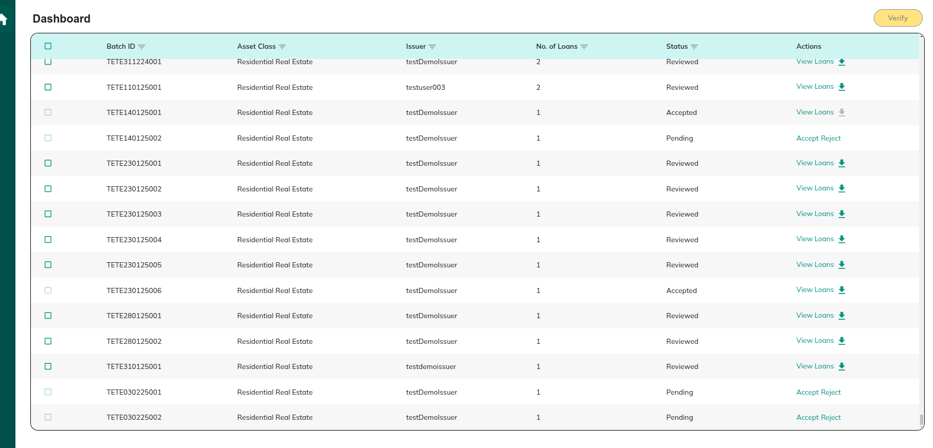

**Details:**

* **Accept/Reject**

Redirect to 7.1 Pool

* **View Loans**

Clicking on view loans connect to standard VA module to verify and certify loans.Redirect to 7.1.1 View Loans

* **Submit for Verification**

Redirect to 7.1.4 Verify

* **Download**

Download VA certificate

### 7.1.1.Accept

**Purpose:**This screen allows the VA to accept or reject a batch of loans for validation. Accepted loans move forward for verification, while rejected loans are returned to the issuer.

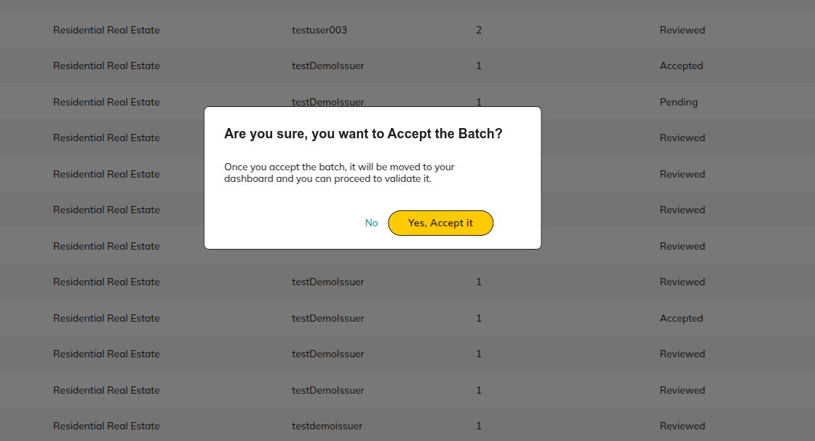

**Actions:**

* **Accept**

Redirect to 7.1 Pool

* **No**

Redirect to 7.1 Pool

### 7.1.2 Reject

**Purpose:**

If the VA determines that a batch does not meet verification standards, they can reject it. A reason for rejection can be added before sending it back to the issuer.

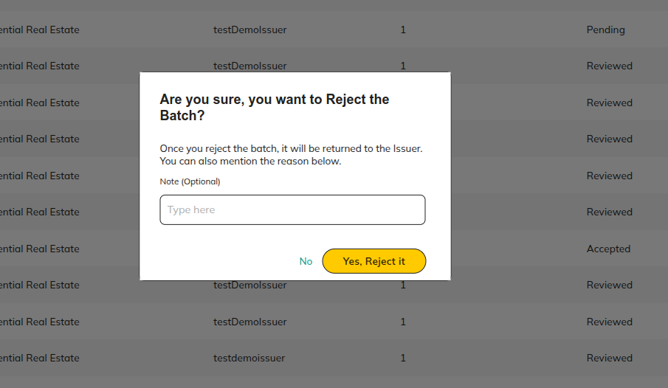

**Actions:**

* **Yes Reject it**

Redirect to 7.1 Pool

* **No**

Redirect to 7.1 Pool

### 7.1.3 View Loans

**Purpose:**

This screen connects the VA to the **Standard VA Module**, where they can check the **match and mismatch status** of individual loans. The VA can compare loan data with contract details, edit mismatches, and proceed with certification.

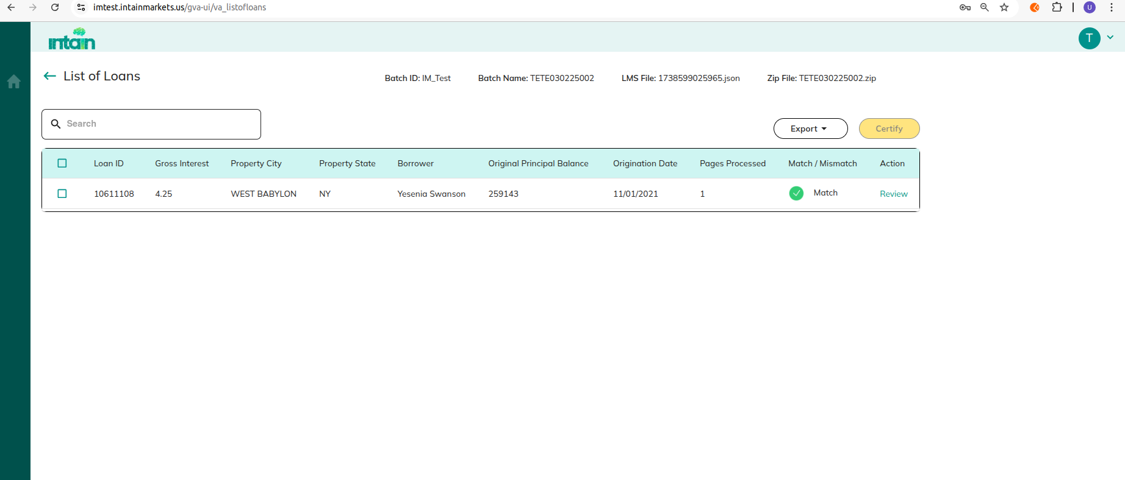

**Actions:**

* **Certify**

Redirect to 7.1.1.2 Certify

* **Back**

Redirect to 7.1.1 View Loans

* **Export**

Redirect to 7.1.1 View Loans

* **Review**

Redirect to 7.1.1.1 Review

#### 7.1.3.1 Review

**Purpose:**

This screen displays a **comparison of Loan Management System (LMS) and contract data**, highlighting matches and mismatches. The VA can edit incorrect data before saving.

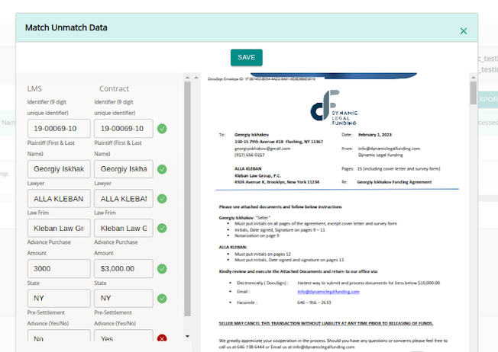

**Actions:**

* **Save**

Redirect to 7.1.1 View Loans

#### 7.1.3.2 Certify

**Purpose:**Once all loans in a pool have been reviewed and verified, the VA can certify the pool using the Certify option. Before certification, the VA must upload their signature to authenticate the process.

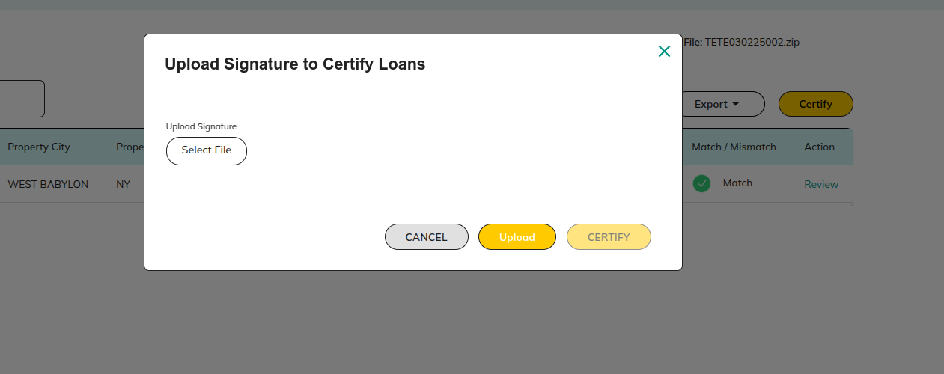

**Actions:**

* **Cancel**

Redirect to 7.1.1 View Loans

* **Upload**

The Certify button will be enabled after the signature upload.

* **Certify**

Redirect to 7.1.1 View Loans

### 7.1.4 Verify

**Purpose:**Submitting verification means the **Verification Agent's job is done**. The verified loans will be sent to the **Issuer for underwriting**, moving them to the next step in the approval process.

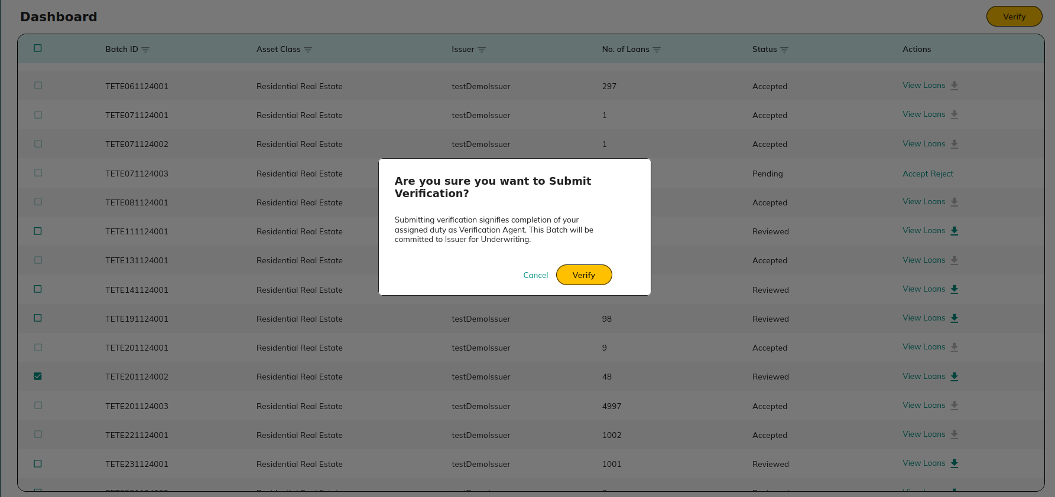

**Actions:**

* **Cancel**

Redirect to 7.1 Pool

* **Verify**

Redirect to 7.1 Pool

# 8. Registration:

## 8.1 **Sign In**

This section allows users to sign in to their respective accounts to access the platform's features.

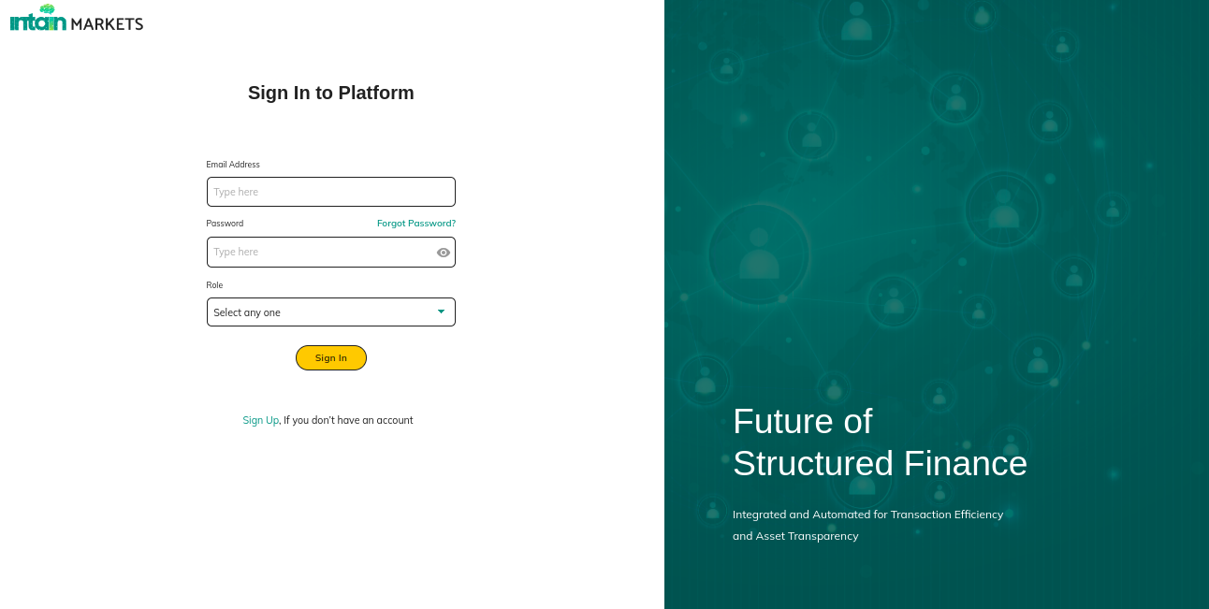

**Description:**

Intain Markets Login page.

**Actions:**

**Sign In:** Logs the user into their **respective account**.

## 8.2 Sign up

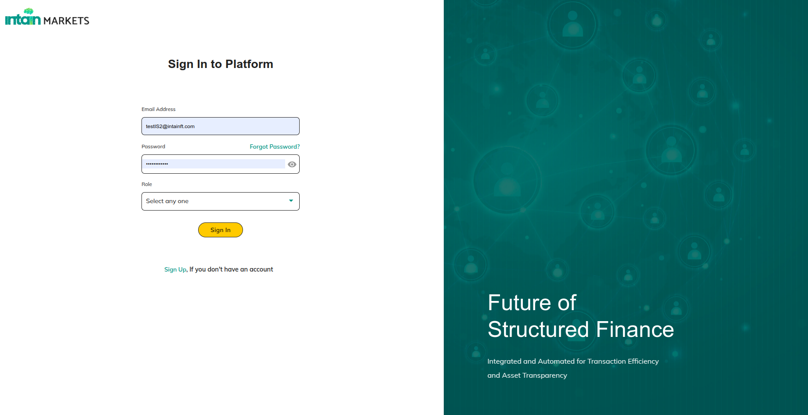

A new user needs to sign up first, before he can sign in to the platform. The user can click on the “Sign Up” link, as shown in above.

### 8.2.1 Create Account (⅓) :- User Role

The User begins by selecting their role from a dropdown menu.

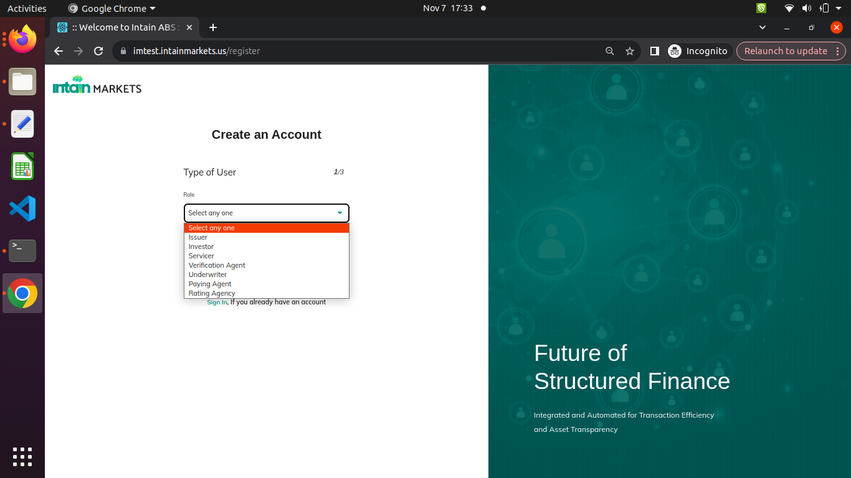

**Actions:**

* **Select User Type:** Choose the type of user before proceeding with the sign-up process.
* **Next**  Redirects to 8.2.2 Create Account(⅔) - Personal Information

### 8.2.2 **Create Account(⅔) - Personal Information**

**Purpose:** In this section, users fill in the Issuer Admin details required for account creation.

**Fields:**

* First Name
* Last Name
* Email Address
* Password
* Confirm Password

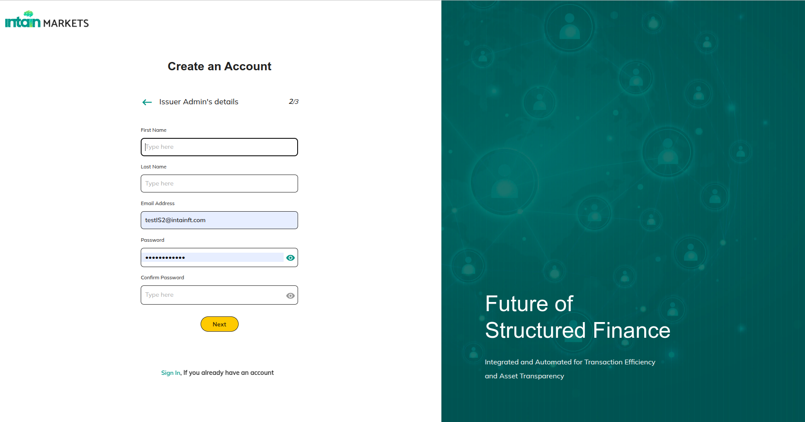

**Actions:**

* **Next** if Underwriter Redirects to 8.2.3 Create Account(3/3) - Organizational Details (Underwriter)
* Else Redirects to 8.2.3 Create Account(3/3) - Organizational Details (All Users except Underwriter)

### 8.2.3 Create Account(3/3) - Organizational Details (All Users except Underwriter)

**Purpose:** After entering the Issuer Admin details, users must provide organization-related details.

**Fields:**

* Organization Name
* Country of Registration
* Is this a Publicly Traded Company? (Yes/No)
* Years in Operation
* Primary Business

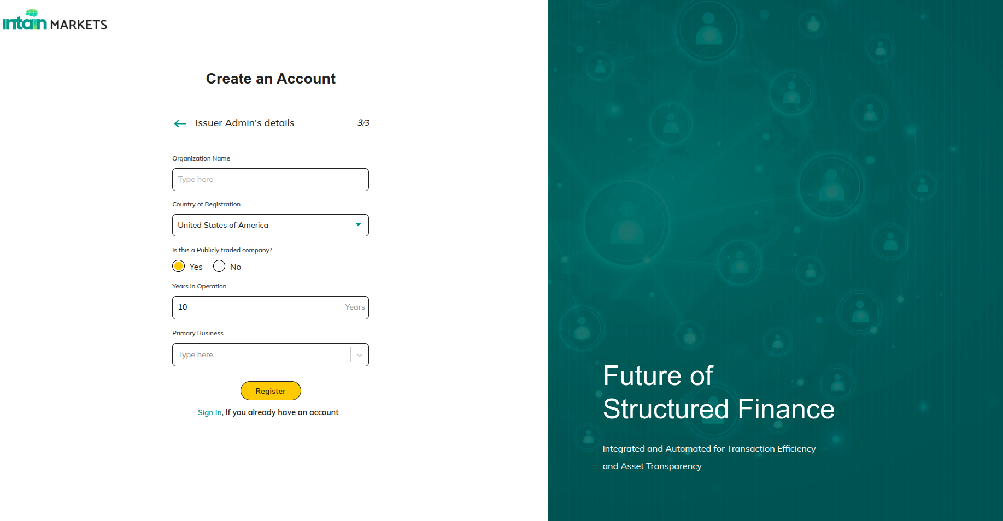

**Actions:**

* **Register:** **Terms of document link :** [Terms of Service (clickwrap agreement).docx](https://docs.google.com/document/d/1U_nmt5I8BZSlpniSfLH62gPJmzSD0Qoa/edit?usp=drive_link&ouid=103545209352060096847&rtpof=true&sd=true)

### **8.2.3 Create Account(3/3) - Organizational Details (Underwriter)**

**Note**: For Underwriter users, whether it is a Publicly Traded Company and Primary Business details not required.

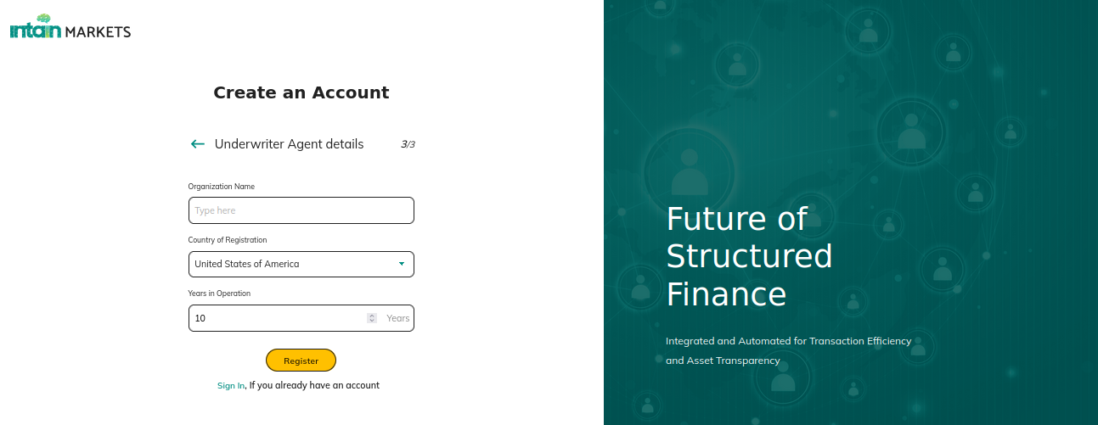

**Actions:**

* **Register:** **Terms of document link :** [Terms of Service (clickwrap agreement).docx](https://docs.google.com/document/d/1U_nmt5I8BZSlpniSfLH62gPJmzSD0Qoa/edit?usp=drive_link&ouid=103545209352060096847&rtpof=true&sd=true)

### 8.2.4 Terms and Conditions

**Purpose:** After registration, the user is prompted with a Terms of Service popup, where they can agree, disagree, or upload a signed copy of the Terms of Service.

Mail will be sent to the registered email id and clicking on the link, the user will be redirected to the page below.

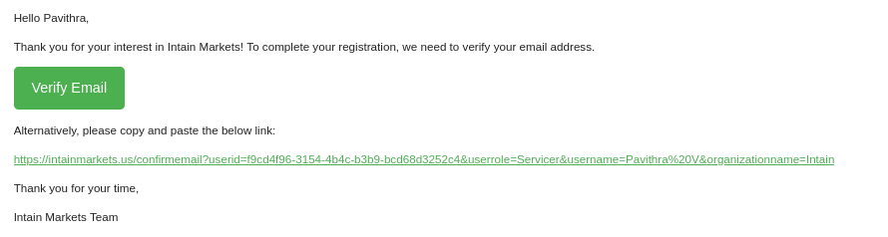

**Actions:**

* **Verify Email** redirects to 8.2.4.1 Welcome Page

#### 8.2.4.1 Welcome page

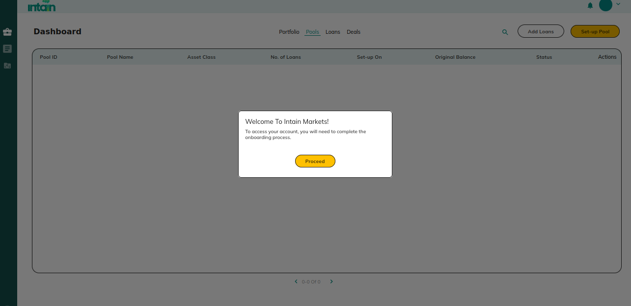

**Actions:**

* **Proceed** redirects to 8.2.4.2 Attestations

#### 8.2.4.2 Attestations

**Purpose**: The user must provide the Date, Name, and Title as part of the attestation process.

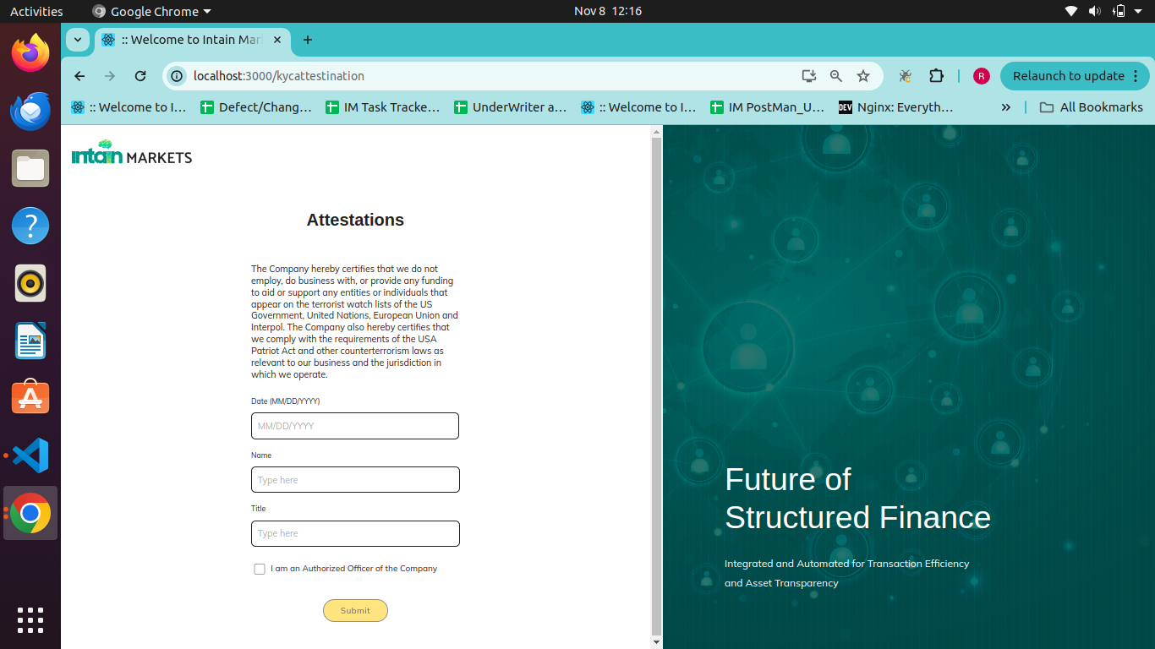

**Actions:**

* If an investor then , the user will be redirected to below popup(8.2.3.1 Type Of Investor),
* Else users will be redirected to the 8.2.3.3 Default Popup screen.

#### 8.2.4.2 Type Of Investor

**Purpose**: For investor users, additional verification steps are required after submitting the attestation.

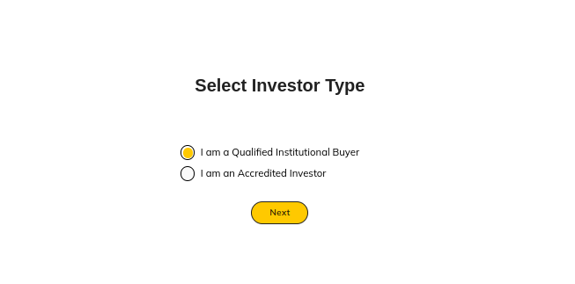

**Actions:**

* If Investor user selects **“Qualified Institutional buyer”** then user is redirected to 8.2.4.2.1 Qualified Institutional buyer
* If Investor user selects “**Accredited Investor**” , then user is redirected to

8.2.4.2.2 Accredited Investor

##### 8.2.4.2.1 Qualified Institutional buyer

**Purpose**: Investors selecting this option undergo additional verification for eligibility as Qualified Institutional Buyers.

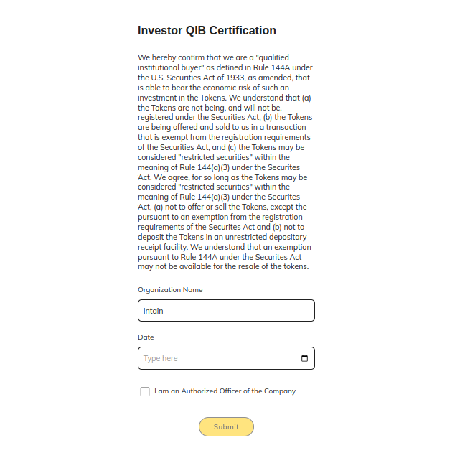

**Actions:**

* **Submit** redirects to 8.2.4.3 Default Popup

##### 8.2.4.2.2 Accredited Investor

**Purpose**: Investors selecting this option undergo additional verification for eligibility as Accredited Investors

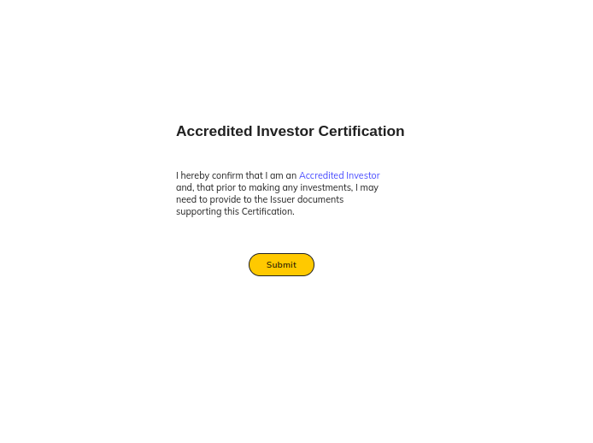

**Actions:**

* **Submit** redirects to 8.2.4.3 Default Popup

#### 8.2.4.3 Default Popup

**Purpose**

The user account is locked until Intain verifies and unlocks the account by collecting and verifying KYC details offline.

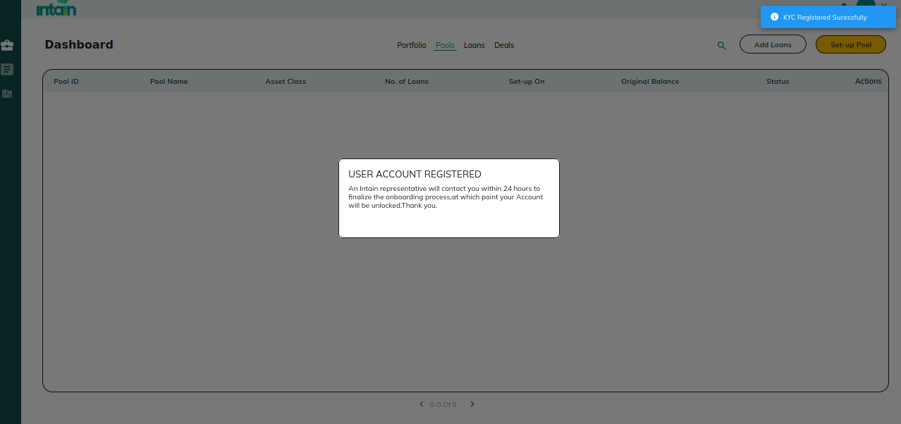

# **9. OverAll Flow**

## **9.1. Preview Flow**

| **S.No** | **Role** | **Section** | **Flow** | **Flow description** |
| --- | --- | --- | --- | --- |
| 1 | Issuer / Investor / Paying Agent | 1.4.1 | **Payment Settings** | Add bank and c-chain account related details for off-chain account transaction and FT’s/NFT’s transfer |
| 2 | Issuer | 1.1 | **Create Pool** | Create pool using setup pool option |
| 3 | 1.2.1 | **Add And Map Loans** | Navigate to Loan section, and click on ADD Loans to onboard loans using xl upload and followed by mapping of raw tape fields with standard Intain Fields |
| 4 | 1.2.2 - 1.2.3 | **Filter Loans and Map to Pool** | After onboarding the loans, Filter the loans to map it to a pool |
| 5 | 1.1.2 | **View Specific Pool** | After creating pool and adding the details, the details can be viewed using view specific pool details |
| 6 | 1.1.4.1 | **Submit for Preview** | The created pool can be submitted for preview to the investor / Underwriter / Rating Agency. |
| 7 | Underwriter | 2.1 | **Preview issuer submitted pool** | Underwriter previews the submitted pool. |
| 1.1.2.7 | **Add / view the feedback** | For the submitted pool, view list of all the loans and add /view the feedback for individual loans |
| 2.1.1.2 | **Reject the loans** | Underwriter can reject the loans |
| 2.1.1.3 | **Submit to investors** | Underwriter can share the preview pool with registered investor users |
| Investor | 4.1 | **Preview pools** | Investor preview underwriter / Issuer submitted pool |
| 1.1.2.7 | **view the feedback** | For the submitted pool, view list of all the loans and add /view the feedback for individual loans |
| Rating Agency | 3.1 | **Preview pools** | Rating agency can preview the submitted pool. |
| 1.1.3.1 | **Add document** | Rating agency can upload pool rating related documents. |

## **9.2.Verification Flow**

| **S.No** | **Role** | **Section** | **Flow** | **Flow description** |
| --- | --- | --- | --- | --- |
| 1 | Issuer | 1.2 | **Select Loans** | Issuer can select loans to submit to VA |
|  | | 1.2.3.2 | **Submit for verification** | Selected loans can be submitted as batch for VA verification. |
| 2 | Verification agent | 7.1 | **View submitted Batch** | Va can view the submitted batch for verification. |
|  | 7.1.3 | **View Loans** | Click “View Loans” for a specific pool to connect to standard VA module and verify loans |
|  | 7.1.3.1 | **Review** | Review each loan and save the details if any data mismatch between loan and contract data.. |
|  | 7.1.3.2 | **Certify** | Once all the loans are reviewed, click on certify. |
|  | 7.1.4. | **Verify** | Once the certificate is generated , the download icon will be enabled in the batch section to download the VA certificate. And can be verified to mint the NFT for the verified loans. |

## **9.3.Securitization Flow**

| **S.No** | **Role** | **Section** | **Flow** | **Flow description** |
| --- | --- | --- | --- | --- |
| 1 | Issuer | **1.1.4.2** | **Submit for Underwriter** | After the preview stage, the pool can be submitted to the underwriter.  Note: The loans in the pool must be verified to submit to the underwriter. |
| 2 | UnderWriter | **2.1.1** | **View Submitted pool** | Underwriter view submitted pool in “Pool” section. And should accept or reject the Pool. Once accepted , pool will be converted to deal |
|  | **2.3 .1** | **View Deal** | View Deal list in “Deal” section. |
|  | **2.3.1.1** | **View specific Deal details** | View specific deal details using”View Deal details” |
|  | **2.3.2.2** | **Add off-chain account details** | Navigate to More >> Accounts and Transaction section. Add off-chain account details. Usually closing account details will be added for the investor to transfer funds. |
|  | **2.3.4** | **Tools** | Using the tools section, update the deal creation page with deal related details and tranche related details. |
|  | **2.3.2.3.1** | **Publish deal to issuer** | Navigate to Tools >> Files >> Publish to issuer for FT approval.As the owner of the FT will be issuer and now issuer need to provide approval to intain account to transfer FT’s on behalf of him |
| 3 | Issuer | **1.3** | **View deals** | View “Deal section” in issuer login. |
|  | **1.3.1** | **Approve the tranches** | Approve each tranche by clicking on the approve button. Enter the C-chain private key or wallet file to approve the transaction. |
|  | **1.3.4** | **Publish to investors** | Once all the tranches are approved, click on "Publish to investor “ which will publish the deal to all the investors. |
| 4 | Investor | **4.3.1** | **View deal in opportunities** | Investors can view the published deal in the “Opportunities” section. |
|  | **4.3.1.1** | **Commit the amount** | View specific Deal and commit amount at the commit stage. |
| 5 | UnderWriter | ***2.3.2.8*** | **Change to Invest stage** | Once enough commitments are received , the underwriter can change the commit to invest stage using the toggle option. |
| 6 | Investor | **4.3.1.2** | **Invest the amount** | When in the Invest stage, Investors can invest the committed amount.At this stage, FT’s will not be transferred until paying agent confirm and issue FT’s. |
| 7 | Paying agent | **6.1** | **View deals** | Paying agent view Deal list. |
|  | **2.3.2.1** | **Verify off-chain transactions** | Navigate to More >> Account and transaction section to view and approve off-chain investor transactions. Verify and change the transaction status. |
|  | **6.1.1.1** | **Issue FT’s** | Once all the transactions are verified, Issue FT’s. This is the trigger point where the deal details will be shared with “Standard IA module”. |
|  | **6.5** | **Deal Creation** | Navigate to Deal >> Deal Recurring >>Edit >> Deal which redirects to deal creation page. Add required deal related details in deal creation tabs. After this, the servicer can start uploading the monthly loan tape details . |
| 8 | Servicer | **5.1** | **View deals** | View Deal list from the “Deal” section. |
|  | **5.1.1.1** | **Process tape** | For a specific deal upload loantape for a specific payment date. |
|  | **5.1.1.2** | **Preview loantape** | Next screen which shows the preview loantape details. |
|  | **5.1.1.3** | **Map fields** | Next screen redirect to Map fields where Raw fields in the xl needs to be mapped with standard Inatin Fields. |
|  | **5.1.1.4** | **Preview Map fields** | Next screen will be Previewing the mapped Intain standard field details. |
|  | **5.1.1.5** | **Summarize** | Finally, in “summarize” the servicer summary will be calculated and calculated values will be displayed. Users can review and commit the details to the ledger. |
| 9 | Paying agent | **6.1** | **View deals** | View deal list in pa login |
|  |  | **6.3** | **View Loans** | Clicking on “View Loans” for a specific payment date displays a servicer list with option to view individual aggregate summary . |
|  |  | **6.3.1** | **Commit to consolidated Aggregate Summary** | View consolidated aggregate summary details and commit to ledger. After this, for a specific payment date, the deal processed will be changed to “YES”. |
|  |  | **6.4** | **Deal Recurring** | When the Loan status changed to “YES” in PA deal page , then click on DEAL to generate the report which redirects to deal recurring screen. Calculate and generate the report |
|  |  | **6.5.1** | **Reporting** | View Investor generated report |

## **9.4.Whole Loan flow**

| **S.No** | **Role** | **Section** | **Flow** | **Flow description** |
| --- | --- | --- | --- | --- |
| 1 | Issuer | **1.1.4.2** | **Submit for Underwriting** | Issuer can submit the the whole loan pool for underwriting |
| 2 | Underwriter | **2.1.2** | **View Pool** | View submitted pool and accept / reject the submitted pool. If accepted, pool will be converted to deal |
|  |  | **2.3.1.2** | **View Deal details** | Navigate to deal section >> view deal details |
|  |  | **2.3.2.2.1** | **Deal creation** | Navigate to tools >> General tab and update deal related details |
|  |  | **2.3.2.2.2.1** | **Publish deal to issuer** | Publish deal to issuer for NFT approval |
| 3 | Issuer | **1.3.2** | **View Deal** | View specific deal details |
|  |  | **1.3.3** | **Approve Deal** | Approve the deal by clicking on the approve button. Enter the C-chain private key or wallet file to approve the transaction. At this step,the Issuer provides NFT transfer access to the Intain account. |
|  |  | **1.3.4** | **Publish to investors** | After the approval , publish to Investors |
| 4 | Investor | **4.3.2** | **View Deal** | View published deal details |
|  |  | **4.3.2.1** | **Commit amount in deal** | Commit the principal balance amount in the deal |
| 5 | Underwriter | **2.3.2.8** | **Change to Invest stage** | .Once commitments are received , the underwriter can change the commit to invest stage using the toggle option by navigating to View details >>more >> View account details. |
| 6 | Investor | **4.3.1.2** | **Invest in deal** | During the investment stage, invest in the committed deal. Transfer the amount to the displayed wire instruction.  **Note:** At this point NFT’s will not be transferred after the investment , after PA confirms the off-chain transaction, NFT’s will be transferred |
| 7 | Paying agent | **2.3.2.6** | **Approve off-chain transaction** | Navigate to view details >> more >> view account details .View offchain transactions and verify the details by changing the pending to completed status. |
|  |  | **6.2.1** | **Transfer NFT’s** | Once the transaction is verified click on “Issue NFT” which will transfer NFT ownership to invested investors. |

# **10. Status**

## **10.1 Loan Status**

| **S No** | **Status UpdatedTo** | **Trigger for Update** |
| --- | --- | --- |
| 1 | Unmapped | When LMS xl sheet is initially uploaded (as the loans are not yet mapped to a pool) |
| 2 | Mapped | When the loans have been mapped to a pool, by the issuer |
| 3 | Reconsider | In Preview stage, when the loan is rejected by underwriter |

## **10.2 Loan Verified and Batch Status**

| **S No** | **Actions** | **User** | **Description** | **Loan Verified Status Updated To** | **Batch Status Updated To** | **Loan Verified Status Displayed in** | **New Loan Verified Status Change** |
| --- | --- | --- | --- | --- | --- | --- | --- |
| 1 | Loan uploaded by Issuer | Issuer | When the issuer uploads a loantape and maps it with a standard field. | No | NA | Issuer | No |
| 2 | Loans submitted to VA (third party VA / Self) as batch | Issuer | Issuer selects loans and submit it to VA | No | Pending | 1) Issuer  2) Underwriter /Rating agency / Investor | **Not finalized** |
| 3 | Batch accepted by VA (third party VA / Self) | VA | When VA accepts the submitted batch | No | Accepted | 1) Issuer  2) Underwriter /Rating agency / Investor | **Not finalized** |
| 4 | Batch rejected by VA (third party VA / Self) | VA | When VA reject the submitted batch | No | Rejected | 1) Issuer  2) Underwriter /Rating agency / Investor | **Not finalized** |
| 5 | Batch certified by VA (third party VA / Self) | VA | When VA certify the submitted batch | No | Reviewed | 1) Issuer  2) Underwriter /Rating agency / Investor | **Not finalized** |
| 6 | Batch verified by Third party VA | VA | When VA (third party user) Verify(NFT) the batch | Certified | Verified | 1) Issuer  2) Underwriter /Rating agency / Investor | **Certified** |
| 7 | Batch verified by Self | VA | When VA (same submitted issuer acting as VA)(Verify(NFT) the batch | Self-Verified | Verified | 1) Issuer  2) Underwriter /Rating agency / Investor | **Self-Certified** |

## **10.3 Pool Status**

| **S No** | **Status UpdatedTo** | **Entry Point** |
| --- | --- | --- |
| 1 | Created | After Pool creation by issuer |
| 2 | Pending | When Issuer submits the pool to underwriter |
| 3 | Accepted by Underwriter | When the Underwriter clicks the Accept button; at this stage, a Deal is created. |
| 4 | Rejected by Underwriter | When Underwriter clicks Reject button |
| 5 | Closed | When whole loan pool is transferred to issuer login from investor |

## **10.4 Deal Status**

| **S No** | **Status UpdatedTo** | **Entry Point** |
| --- | --- | --- |
| 1 | Created | When pool is converted to deal |
| 2 | Active | When Deal Creation details are updated |
| 3 | Awaiting Approval | When Underwriter publish deal to issuer |
| 4 | Open | When Issuer has approved each tranche |
| 5 | Closed | When the whole loan deal is transferred to the issuer login from investor login. |

## 